Supplementary Information

Effects of iron oxide on crystallization behavior and spatial distribution of spinel in stainless steel slag
Zihang Yan^{1,2)}, Qing Zhao^{1,2),}, Chengzhi Han^{1,2)}, Xiaohui Mei^{1,2)}, Chengjun Liu^{1,2)}, and Maofa Jiang^{1,2)}
1) Key Laboratory for Ecological Metallurgy of Multimetallic Mineral (Ministry of Education), Northeastern University, Shenyang 110819, China
2) School of Metallurgy, Northeastern University, Shenyang 110819, China
 Corresponding author: Qing Zhao E-mail: zhaoq@smm.neu.edu.cn

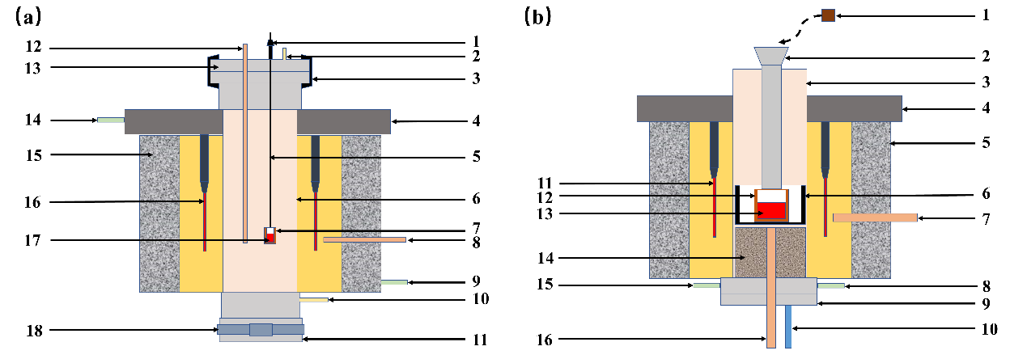
Fig. S1. Experimental apparatus used in the study. (a) High temperature quenching furnace. 1–fixed valve; 2–gas outlet; 3–airtight valve; 4–furnace cover; 5–molybdenum wire; 6–corundum tube; 7–MgO crucible; 8–thermocouple A; 9–water outlet; 10–gas inlet; 11–sealing cover A; 12–thermocouple B; 13–sealing cover B; 14–water inlet; 15–insulation layer; 16–heating elements; 17–sample; 18–sealing clip. (b) High temperature tube furnace. 1–sample; 2–charging cylinder; 3–corundum tube; 4–furnace cover; 5–insulation layer; 6–graphite crucible; 7–thermocouple A; 8–water outlet; 9–furnace base; 10–gas inlet; 11–heating elements; 12–MgO crucible; 13–sample; 14–refractory; 15–water inlet; 16–thermocouple B;

Fig. S2. XRD patterns of water quenched slag samples (1600°C) with 8wt% and 18wt% FeO contents.

