Supplementary Information

Reduced graphene oxide aerogel decorated with Mo₂C nanoparticles toward multifunctional properties of hydrophobicity, thermal insulation and microwave absorption
Yahui Wang^{1,2,3,4)}, Minghui Zhang²⁾, Xuesong Deng^{1,3,4)}, Zhigang Li^{1,3,4}, Zongsheng Chen^{1,3,4)}, Jiaming Shi^{1,3,4),}, Xijiang Han²⁾, and Yunchen Du^{2),}
- Key Laboratory of Infrared and Low Temperature Plasma of Anhui Province, National University of Defense Technology, Hefei 230037, China
- MIIT Key Laboratory of Critical Materials Technology for New Energy Conversion and Storage, School of Chemistry and Chemical Engineering, Harbin Institute of Technology, Harbin 150001, China
- State Key Laboratory of Pulsed Power Laser Technology, National University of Defense Technology, Hefei 230037, China
- Anhui Provincial Laboratory of Advanced Laser Technology, National University of Defense Technology, Hefei 230037, China
Corresponding authors: Jiaming Shi E-mail: shijiaming17@nudt.edu.cn; Yunchen Du E-mail: yunchendu@hit.edu.cn

Characterization
An X’PERT PRO MPD X-ray diffractometer was employed to record X-ray diffraction (XRD) data with a Cu Kα radiation source (40.0 kV, 40.0 mA). FT-IR spectra were obtained on a Fourier Transform Infrared Spectrometer (Thermo Fisher scientific Nicolet iS5). Raman spectra were detected on a confocal Raman spectroscopic system (Renishaw, In Via) using a 532 nm laser. The HELIOS NanoLab 600i (FEI) was employed to obtain scanning electron microscopy (SEM) images. The mercury injection porosimetry (MIP) measurement were recorded on an Autopore Ⅳ 9500 V9620. Transmission electron microscopy (TEM) images and high-resolution TEM (HRTEM) images were recorded on a Tecnai F20 operating at an accelerating voltage of 200 kV. The thermogravimetric (TG) analysis was determined on an SDT Q600 TGA (TA Instruments) in the temperature range of room temperature to 700°C at a heating rate of 10°C/min under the air atmosphere. The infrared imaging camera (FOTRIC 225s#L24) was employed to visualize the infrared radiation intensity of these aerogels on a heating platform. The WCA data were measured through a goniometer instrument equipped with a heating platform (JC 2000C, ZhongChen, China). Thermal conductivity was measured by a laser flash method (NETZSCH LFA 467, Germany). An Agilent PNA-N5244A vector network analyzer (Agilent, USA) was applied to determine the relative permeability (μ_{r}) and permittivity (Ԑ_{r}) in the frequency range of 2.0-18.0 GHz for the calculation of RL. A sample containing 9 wt% of the obtained composites was pressed into a ring with an outer diameter of 7.0 mm, an inner diameter of 3.0 mm, and a thickness of 2.0 mm for microwave measurement in which paraffin wax was used as a binder.
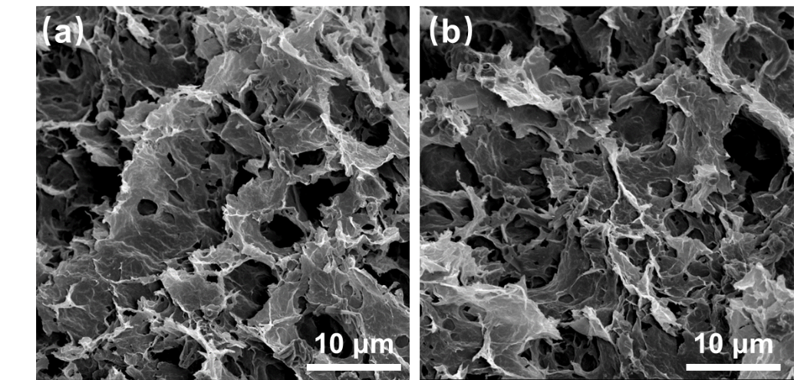
Fig. S1. The SEM images of pristine rGO aerogel (a) and GL-Mo/GO (b)
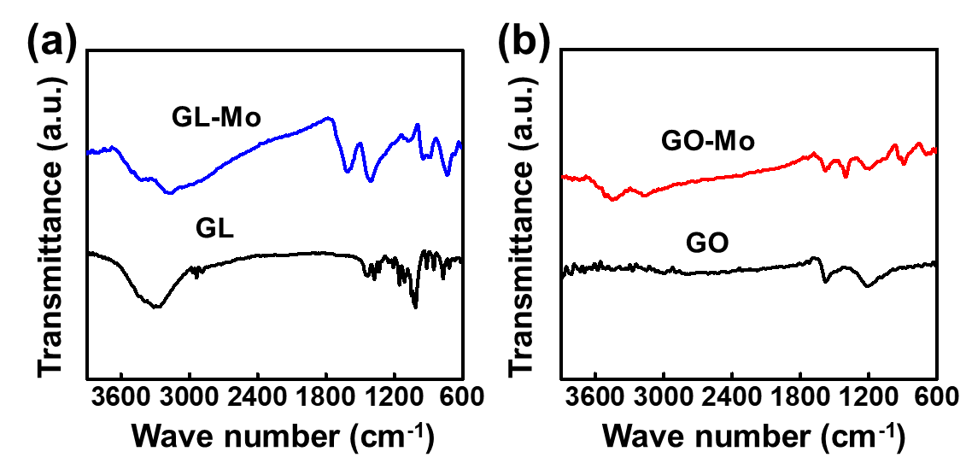
Fig. S2. FT-IR spectra of GL-Mo and pristine GL (a), and FT-IR spectra of hydrothermal GL-Mo and GO (b).
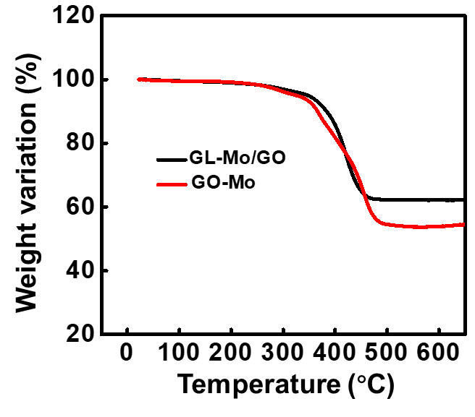
Fig. S3. The TG curves of GL-Mo/GO and GO-Mo.
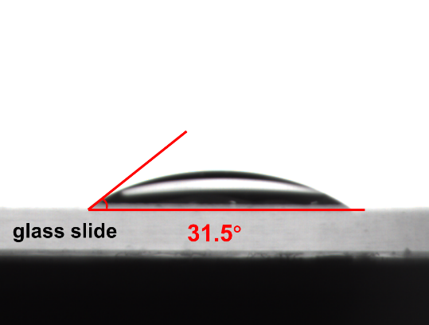
Fig. S4. The WCA measurement of glass slide.
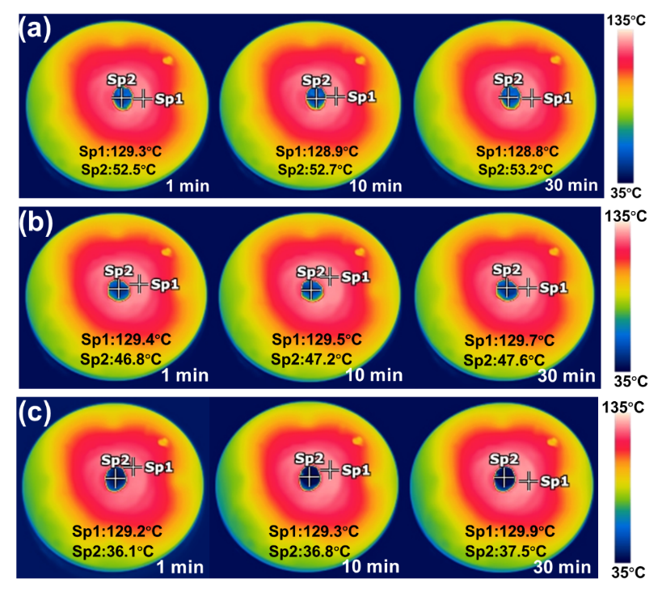
Fig. S5. The thermal infrared images of rGO aerogel (a), Mo/GA-0.5 (b), and Mo/GA-2.0 (c) captured at 1, 10, and 30 min, respectively.
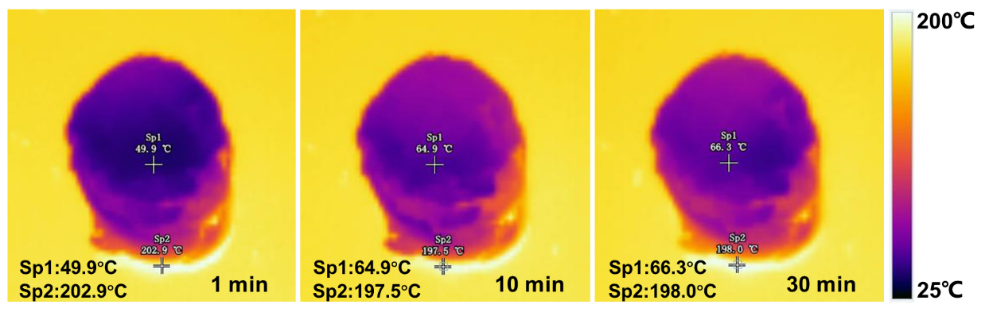
Fig. S6. The thermal infrared images of Mo/GA-1.0 are captured at 1, 10, and 30 min, respectively.

Fig. S7. Real parts (a) and imaginary parts (b) of the complex permeability of rGO, Mo/G-0.5, Mo/G-1.0, and Mo/G-2.0 at the range of 2.0-18.0 GHz.
Table S1. The information of macroporous structure for rGO aerogel and Mo₂C/GA.
Samples | Saturated intrusion volume / (mL⋅g⁻¹) | Density / (mg⋅cm⁻³) | Porosity / %
rGO | 28.6 | 10.2 | 98.9
Mo₂C/GA-0.5 | 11.6 | 15.3 | 95.1
Mo₂C/GA-1.0 | 10.6 | 18.6 | 94.1
Mo₂C/GA-2.0 | 3.2 | 23.5 | 85.9

Table S2. The thermal conductivity of rGO aerogel and Mo₂C/GA.
Sample | rGO | Mo₂C/GA-0.5 | Mo₂C/GA-1.0 | Mo₂C/GA-2.0 | paraffin wax
Thermal conductivity  (mW m⁻¹ K⁻¹) | 0.308 | 0.304 | 0.284 | 0.279 | 0.305
Before the measurement, 18 wt% of the obtained composites and 82 wt% of molten paraffin wax were adequately grinded for about 30 min to obtain a uniformly mixture, and then the mixture was collected in a square mold with a side length of 10 mm and a thickness of 2.4 mm for pressing into a square sheet through a tablet machine.

