**Supplementary Materials**

Enhanced ferroelectric and improved leakage of BFO-based thin films through increasing entropy strategy

Dongfei Lu, Guoqiang Xi,Hangren Li, Jie Tu, Xiuqiao Liu, Xudong Liu, Jianjun Tian, and Linxing Zhang🖂

Institute for Advanced Materials Technology, University of Science and Technology Beijing, Beijing 100083, China

**Conformational entropy of the films**

**Table S1 Atomic configuration entropy *S*config of these films**

|  |  |  |  |  |  |  |
| --- | --- | --- | --- | --- | --- | --- |
| Film | BFO | Sm-0 | Sm-Co | Sm(Eu/La)-CoCu(Mn) | Sm-CoCuMn | SmLa(Eu)-CoCu |
| *S*config | 0 | 0.3*R* | 0.5*R* | 0.5*R* | 0.6*R* | 0.6*R* |

**Positive-up-negative-down (PUND) process**

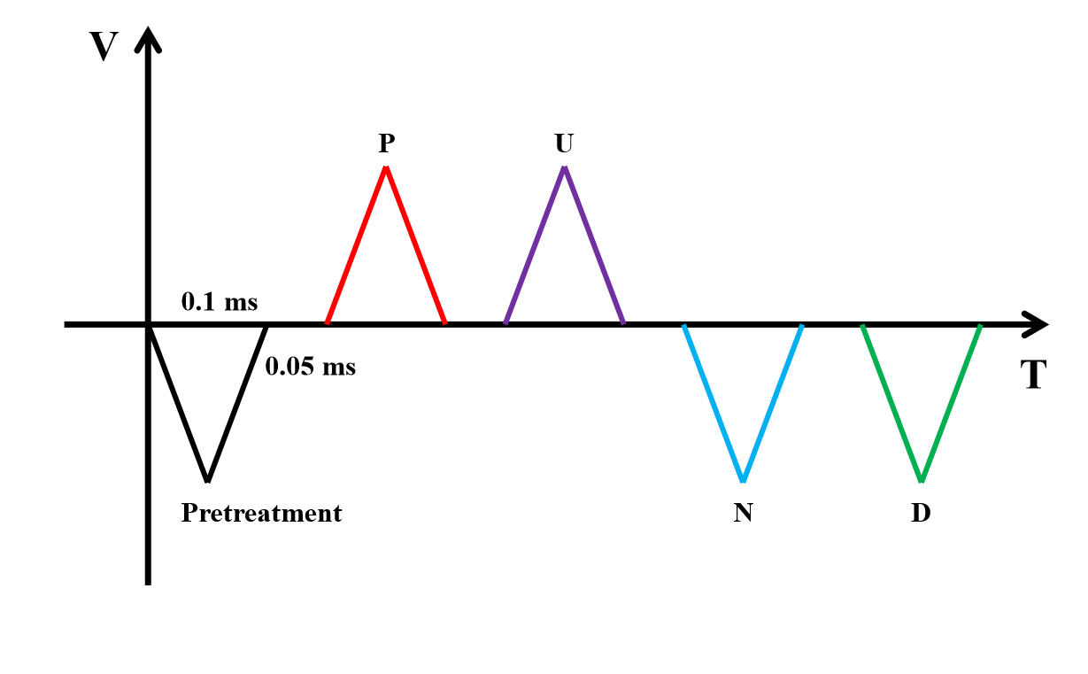

**Fig. S1. Applied voltage waveform used for the PUND procedure.**

**Ferroelectric properties**

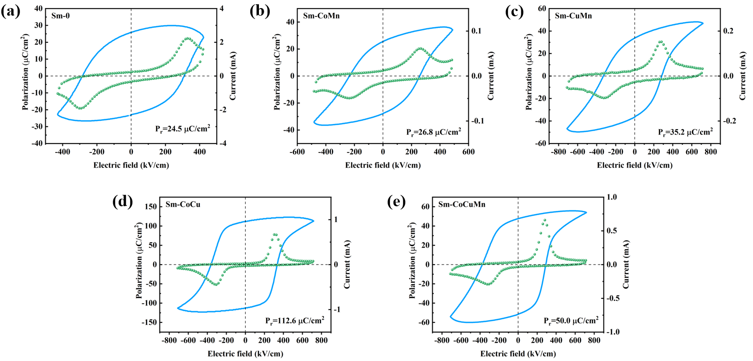

**Fig. S2. Dynamic hysteresis measurement ferroelectric hysteresis loops of Sm-0, Sm-CoMn, Sm-CuMn, Sm-CoCu, and Sm-CoCuMn films (5 kHz).**

**Phase structure, ferroelectricity and leakage properties of the second set of samples** 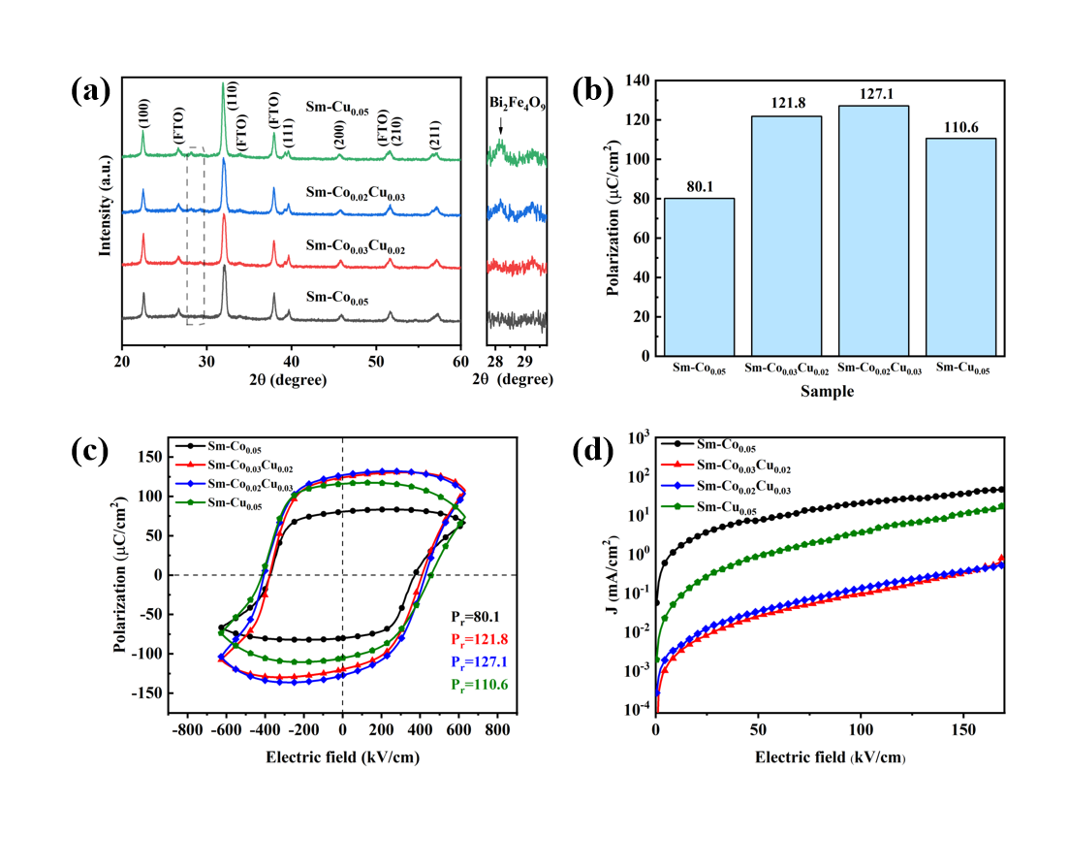

**Fig. S3.** **(a) XRD pattern of Sm-Co0.05, Sm-Co0.03Cu0.02, Sm-Co0.02Cu0.03, and Sm-Cu0.05. (b) Histograms of the remnant polarization of these films. (c) Ferroelectric hysteresis loops of these films. (d) Leakage current density of these films.**

The XRD spectra of these four samples are shown in Fig. S3(a), with a magnification near 2*θ* = 28°–29° on the right. The same diffraction peaks as Fig. 1(a) can be clearly observed, indicating that it is still a rhombohedral perovskite structure, but the diffraction peaks of the secondary phase Bi2Fe4O9 appeared with the increase of Cu content. And the weak heterogeneous peaks were also observed in Sm-Co0.03Cu0.02, but the Sm-Co0.02Cu0.02 of the first set of experiments was a pure phase, which indicates that both Co and Cu substitution content can both only be controlled around 2%. The variation of the remnant polarization and the hysteresis loop diagram are shown in Fig. S3(b-c), the remnant polarization of the Sm-Co0.05 film is 80.1 µC/cm2, and the *P*r increases with the increase of Cu content (121.8 µC/cm2 for Sm-Co0.03Cu0.02 and 127.1 µC/cm2 for Sm-Co0.02Cu0.03). However, when the Cu content is 5%, the *P*r decreases to 110.6 µC/cm2 and the hysteresis return line is more rounded, which indicates that the leakage current is larger, and this phenomenon is supposed to be caused by the excess of secondary phase Bi2Fe4O9. The density of the leakage current is depicted in Fig. S3(d), where it decreases with the addition of Cu and then begins to increase with the addition of heterogeneous phases.

**Ferroelectric properties**

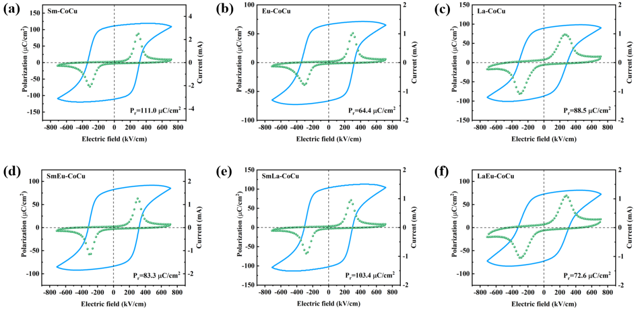

**Fig. S4.** **Raw data ferroelectric hysteresis loops of Sm-CoCu, Eu-CoCu, La-CoMn, SmEu-CoCu, SmLa-CoCu and Sm-CoCuMn films (5 kHz).**

The ferroelectric hysteresis loops were tested at a frequency of 5 kHz.

**Grain size statistics**

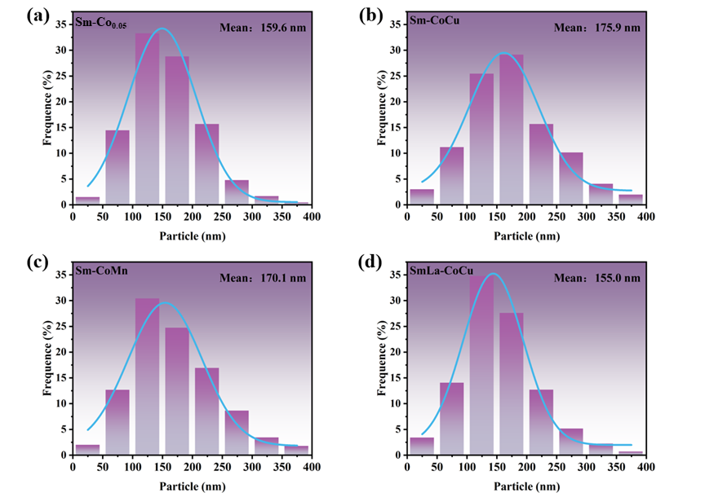

**Fig. S5. Grain size statistics of Sm-Co0.05 (a), Sm-CoCu (b), Sm-CoMn (c) and SmLa-CoCu (d) films.**

Grain size: 155.0 nm (SmLa-CoCu) <159.6 nm (Sm-Co) <170.1 nm (Sm-CoMn) <175.9 nm (Sm-CoCu). Coercive field: 323kV/cm (SmLa-CoCu) < 345kV/cm (Sm-Co) < 366kV/cm (Sm-CoMn) < 376kV/cm (Sm-CoCu). This indicates that the larger the grain size, the larger the coercive field. This can be attributed to the fact that the larger the grain size, the larger the domains are, which require a larger voltage to flip. The grain size of Smla-CoCu is relatively small and therefore the coercive field is relatively low.

**PFM images of Sm-CoCu, Sm-CoMn, SmLa-CoCu**

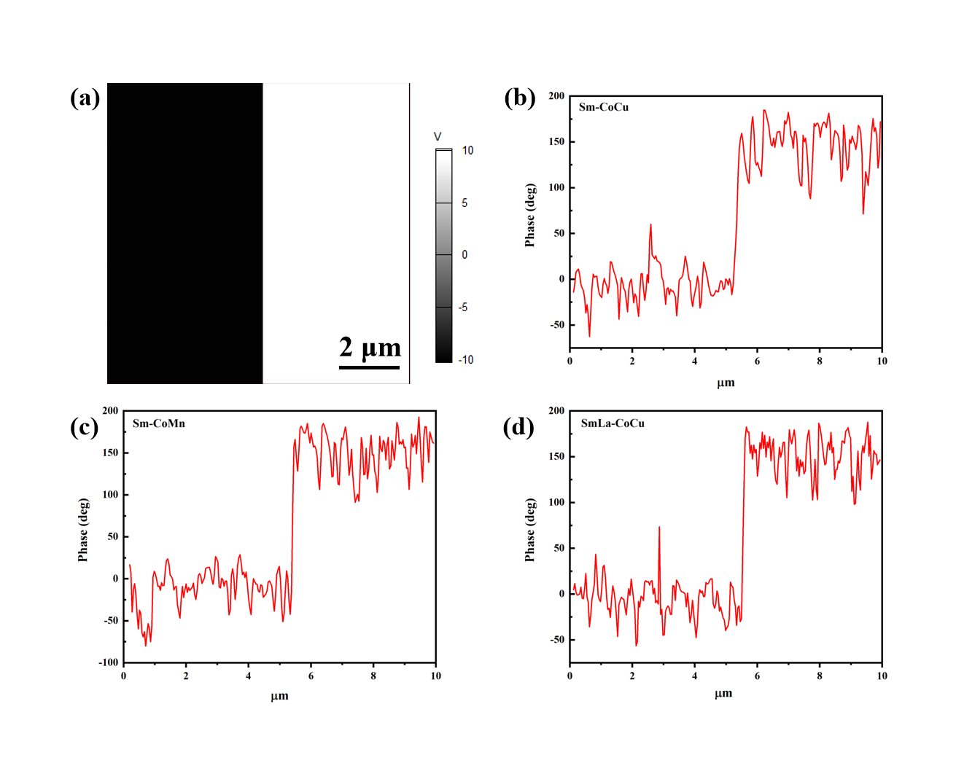

**Fig. S6. (a) Bias voltage of ± 10 V. (b-d) The PFM phase flip signal of Sm-CoCu, Sm-CoMn, and SmLa-CoCu. Apply a bias voltage of half +10 V and half -10 V across a 100 µm2 area.**

**EDS spectroscopy**

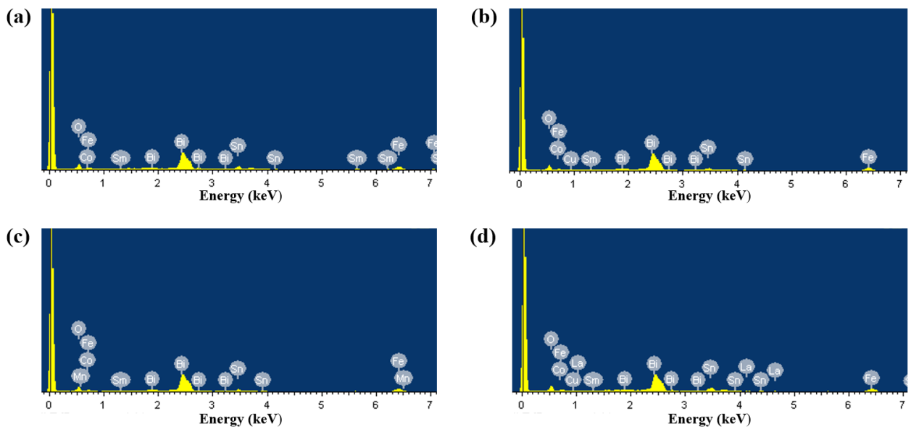

**Fig. S7.** **EDS spectroscopy pattern of these films. (a) Sm-Co0.05, (b)Sm-CoCu, (c) Sm-CoMn, and (d)SmLa-CoCu.**

**EDS: Percentage of elements**

**Table S2 Element percentage of Sm-Co0.05, Sm-CoCu, Sm-CoMn, and SmLa-CoCu shown in Fig. S7** at%

|  |  |  |  |  |  |  |  |  |  |  |  |  |  |  |  |
| --- | --- | --- | --- | --- | --- | --- | --- | --- | --- | --- | --- | --- | --- | --- | --- |
| Sample | O | Fe | | | Co | | | Sn | | | | Sm | | | Bi |
| Sm-Co0.05 | 60.35 | 16.17 | | | 1.16 | | | 7.05 | | | | 1.71 | | | 13.55 |
| Sample | O | Fe | | Co | | | Cu | | | Sn | | | Sm | | Bi |
| Sm-CoCu | 59.32 | 17.81 | | 0.79 | | | 0.80 | | | 4.64 | | | 1.26 | | 15.38 |
| Sample | O | Fe | | Co | | | Mn | | | Sn | | | Sm | | Bi |
| Sm-CoMn | 59.37 | 17.23 | | 0.25 | | | 0.65 | | | 5.03 | | | 1.35 | | 16.12 |
| Sample | O | Fe | Co | | | Cu | | | Sn | | La | | | Sm | Bi |
| SmLa-CoCu | 61.52 | 15.67 | 0.58 | | | 0.67 | | | 6.71 | | 0.41 | | | 1.04 | 13.40 |

The table shows the proportions of the content of each element, with some error present, but the overall proportions are consistent with the proportions of the metal ions used in the raw material configuration. The results presented are consistent with XRD and XPS measurements.

**XPS spectra**

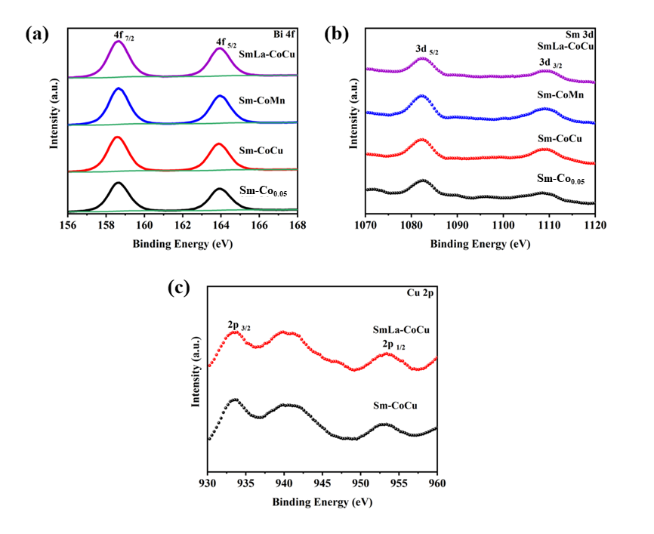

**Fig. S8.** **XPS spectra of these thin films: (a) Bi 4f spectrum, (b) Sm 3d spectrum, and (c) Cu 2p spectrum.**