**Supporting Information**

**Shear mechanical properties and fracturing responses of layered rough jointed rock-like materials**

*Xinxin Nie*1), *Qian Yin*1,2,3),🖂, *Manchao He*2), *Qi Wang*2), *Hongwen Jing*1), *Bowen Zheng*3), *Bo Meng*1), *Tianci Deng*1), *Zheng Jiang*1), *and Jiangyu Wu*1,4),🖂

1) State Key Laboratory for Geomechanics & Deep Underground Engineering, China University of Mining and Technology, Xuzhou 221116, China

2) State Key Laboratory for Geomechanics & Deep Underground Engineering, China University of Mining and Technology (Beijing), Beijing 100083, China

3) Key Laboratory of Shale Gas and Geoengineering, Institute of Geology and Geophysics, Chinese Academy of Sciences, Beijing 100029, China

4) Department of Materials, University of Oxford, Oxford OX1 3PH, UK

🖂Corresponding authors: Qian Yin E-mail: [Jeryin@foxmail.com](mailto:Jeryin@foxmail.com); Jiangyu Wu E-mail: wujiangyu@cumt.edu.cn

**The development process of rock-like materials:**

As a commonly used rock-like material, cement has mechanical properties similar to natural rocks [1–3]. According to the geological investigation data from the engineering site, the uniaxial compressive strength (UCS) of the sandy mudstone in the matrix of the layered rocks ranges from 13.5 to 28.5 MPa, with elastic modulus (*E*) between 7.3 and 11.4 GPa. As for the weak interlayer, the UCS of the mudstone varies from 6.2 to 15.4 MPa, with *E* ranging from 5 to 7.8 GPa. Based the study conducted by Yin *et al*. [4], in this experiment, PC 42.5 composite Portland cement was chosen as the rock-like material to simulate the hard rock matrix, fly ash (Class Ⅰ) and PP 32.5 volcanic ash cement were selected to prepare cementitious material to simulate the weak interlayer. The purpose of using fly ash is to replace part of cement, thereby improving the fluidity of the cementitious material [5]. The compositions and corresponding mass ratio of the two rock-like materials are shown in Table S1. The standard cylindrical samples used to represent the hard matrix and weak interlayer were subjected to uniaxial compression tests after being cured at a constant temperature of 25°C in the curing box for 7 d. The measured strength parameters are close to the real layered rocks in the engineering site, which indicates that the two rock-like materials can effectively replicate the mechanic characteristics of the layered rocks (Table S2).

**Table S1.** Compositions and corresponding mass ratio for hard matrix and weak interlayer

|  |  |
| --- | --- |
| Rock-like materials | Mass ratio |
| Hard matrix | Cement (PC 42.5): water = 2:1 |
| Weak interlayer | Cement (PP 32.5): fly ash: water = 9:1:6 |

**Table S2.** Strength parameters for the hard matrix and weak interlayer

|  |  |  |
| --- | --- | --- |
| Rock-like materials | UCS / MPa | *E* / GPa |
| Hard matrix | 12.9 | 8.6 |
| Weak interlayer | 6.4 | 4.9 |

**The fabrication process of layered samples:**

Based on the five typical roughness profiles, 3D digital models in STL format that can be recognized by a 3D printer were established (Fig. 2(b)). Pouring templates with standard JRC values were printed using a Fortus380mc 3D printer (Fig. 2(c)). Polylactic acid (PLA) was chosen as the printing material, which possesses excellent mechanical properties and a low thermal expansion coefficient, enabling it to resist the extrusion stress caused by volume expansion of rock-like materials during the hydration process [6]. In order to easily distinguish the templates with different JRC values, different colors were used for identification. Specifically, templates with JRC = 2–4 were marked in white, JRC = 6–8 in yellow, JRC = 10–12 in red, JRC = 14–16 in blue, and JRC = 18–20 in cyan (Fig. 2(d)). Additionally, stainless steel molds suitable to the pouring templates sizes were customized (Fig. 2(e)).

The pouring process of the layered samples is mainly divided into two major parts: casting the layered hard matrix and processing the weak interlayer. After assembling the molds, templates with the same JRC were inserted into the grooves of the customized molds, and lubricating oil was applied to the inner surfaces of both the templates and the molds to facilitate demolding (Fig. 2(f)). Then, according to the proportions of rock-like materials shown in Table S1, the corresponding quantities of water and cement were accurately weighed. After that, a high-speed mixer was used to obtained a homogeneous cement slurry. Subsequently, the cement slurry was poured into the molds, and after waiting for 24 h for it to solidify, the demolding process was carried out (Fig. 2(g)). The obtained hard matrix plates with standard JRC values for rough surfaces were placed in a curing chamber with a temperature of 25°C and humidity of 95% for 7 d. When the cement-fly ash slurry simulating the weak interlayer was prepared, the cured hard matrix plates were immersed in the slurry, ensuring that the slurry fully and evenly wrapped the surfaces of the plates. Through precisely stacking up the hard matrix plates by layers, the plates were bonded together with the weak interlayers (Fig. 2(h)). The large-scale model was then placed in a curing chamber with a temperature of 25°C and humidity of 95% for 7 d. A total of 125 cubic layered samples with rough joint surfaces, each measuring 100 mm × 100 mm × 100 mm, were obtained by being cut along the square contour on the surface of the large-scale model using a high-precision water jet system (Fig. 2(i)). The anisotropic angle (*α*) of the weak interlayer, which is the angle between the interlayer and the lower boundary of the sample, ranges from 15° to 75° at intervals of 15°, and the JRC values of the joint surfaces covers a range from 2 to 20 (Fig. 2(j)). It should be noted that to reduce the impact of heterogeneity of the layered samples, strict control was applied during the pouring process. The parallelism and perpendicularity of the opposing surfaces of the layered samples were controlled within ±0.02 mm, and the angle errors between adjacent surfaces were controlled within 0.25°.



**Fig. S1.** Stress–strain curves of rock-like materials under uniaxial compression tests.

**The steps for conducting the experiment, based on the test program, are as follows:**

(i) Prior to shear tests, a white coating was sprayed on the surface of the layered samples as the background, and after complete drying of the coating, black speckles were uniformly sprayed. The purpose of spraying black speckles is to utilize digital image correlation algorithms to match deformation points on the sample’s surface, thereby obtaining the coordinates of measurement points and calculating the strain field.

(ii) The AE transducer was attached to the surface of the sample, and Vaseline was uniformly applied at the interface between the AE transducer and the sample to ensure smooth transmission of AE signals. Besides, the position, angle, aperture, and focal length of the high-definition camera needed to be adjusted.

(iii) The sample was placed at the loading position, and the shear box was installed, ensuring that the shear box was tightly fitted to the surfaces of the sample.

(iv) In the force control loading mode, the normal force was loaded to 0.5 kN for normal preloading, ensuring tight contact between the normal loading platen and the upper end of the shear box. Then, the normal loading was applied at a rate of 300 N/s until the target normal stress *σ*n was reached.

(v) In the force control loading mode, the tangential force was loaded to 0.1 kN for tangential preloading, ensuring tight contact between the tangential loading platen and the side end of the shear box. Subsequently, the loading mode was switched to displacement control, and tangential loading was applied at a rate of 0.5 mm/min, with a maximum shear displacement of 15 mm set for this experiment.

(vi) During the tests, the shear system, high-definition camera system, and AE system should be started and stopped simultaneously.

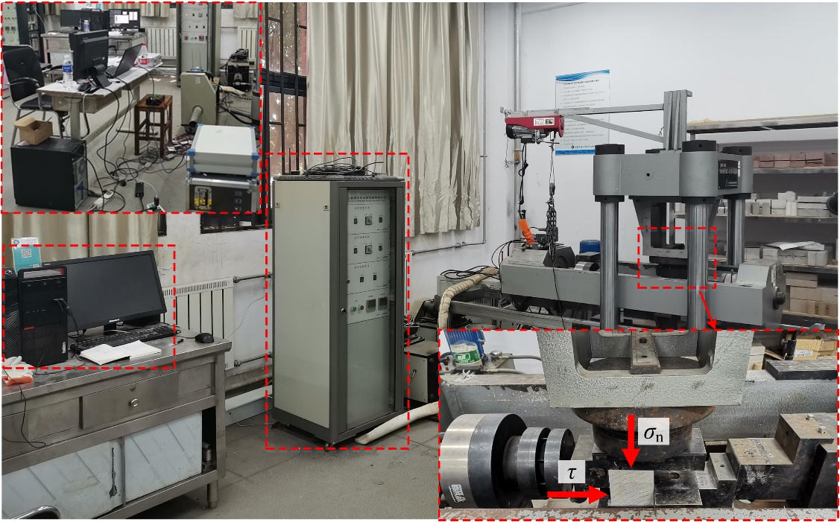

Layered sample

Mechanical loading terminal

EDC full-digital servo controller

Microcomputer control terminal

AE monitoring system

High-definition camera system

Data acquisition system

**Fig. S2.** JAW600 rock shear testing system.

**Table S3.** Test program for layered samples

|  |  |  |
| --- | --- | --- |
| JRC | *α* / (º) | *σ*n / MPa |
| 2– 4 | 15º–75º  (At intervals of 15°) | 1–4  (At intervals of 1 MPa) |
| 6–8 |
| 10–12 |
| 14–16 |
| 18–20 |



**Fig. S3.** Typical shear stress–shear displacement variation curve of the layered sample.

**References**

[1] R.H. Cao, P. Cao, H. Lin, C.Z. Pu, and K. Ou, Mechanical behavior of brittle rock-like specimens with pre-existing fissures under uniaxial loading: experimental studies and particle mechanics approach, *Rock Mech. Rock Eng.*, 49(2016), No. 3, p. 763.

[2] G. Wang, Y.Z. Zhang, Y.J. Jiang, P.X. Liu, Y.S. Guo, J.K. Liu, M. Ma, K. Wang, S.G. Wang, Shear behaviour and acoustic emission characteristics of bolted rock joints with different roughnesses, *Rock Mech. Rock Eng.*, 51(2018), No. 6, p. 1885.

[3] J.W. Fu, H. Haeri, V. Sarfarazi, M. Mehri, K. Asgari, M.F. Marji, Effects of transversely isotropic layers on failure mechanism of non-homogeny concrete-soil specimens, *Geomech. Geophys. Geo Energy Geo Resour.*, 8(2022), No. 5, art. No. 163.

[4] Q. Yin, X.X. Nie, J.Y. Wu, T.C. Deng, H.W. Jing, B. Meng, L.Y. Yu, Fracturing evolution and strain characteristics of layered rock-like materials with rough interfaces, *J. Mater. Res. Technol.*, 24(2023), p. 49.

[5] Y.M. Wang, J.Y. Wu, D. Ma, S. Yang, Q. Yin, Y.Y. Feng, Effect of aggregate size distribution and confining pressure on mechanical property and microstructure of cemented gangue backfill materials, *Adv. Powder Technol.*, 33(2022), No. 8, art. No. 103686.

[6] C.A. Murphy, M.N. Collins, Microcrystalline cellulose reinforced polylactic acid biocomposite filaments for 3D printing, *Polym. Compos*., 39(2018), No. 4, p. 1311.