Supplementary Information

An integrated and efficient process for borax preparation and magnetite recovery from soda-ash roasted ludwigite ore under CO–CO₂–N₂ atmosphere
Jinxiang You¹⁾, Jing Wang¹⁾, Mingjun Rao^{1),}, Xin Zhang¹⁾, Jun Luo²⁾, Zhiwei Peng¹⁾, and Guanghui Li^{1),}
1) School of Minerals Processing and Bioengineering, Central South University, Changsha 410083, China
2) College of Chemistry and Chemical Engineering, Central South University, Changsha 410083, China

Table S1
Table S1. Particle size distribution of the grinding products under different grinding time
Grinding time / min | Yield / %
 | +0.038 mm | −0.038 mm
3 | 23.00 | 77.00
5 | 13.10 | 86.90
10 | 3.75 | 96.25
15 | 1.23 | 98.77
20 | 0.14 | 99.86
25 | 0.00 | 100.00
As shown in Table S1, the mass proportion of particles smaller than 0.038 mm increased with increasing grinding time. Specifically, the percentage of grinding products with a particle size smaller than 0.038 mm increased from 77.00% to 99.86% when the grinding time was extended from 3 to 20 minutes. The prolonged grinding time was found to support mineral dissociation.

Figure S1
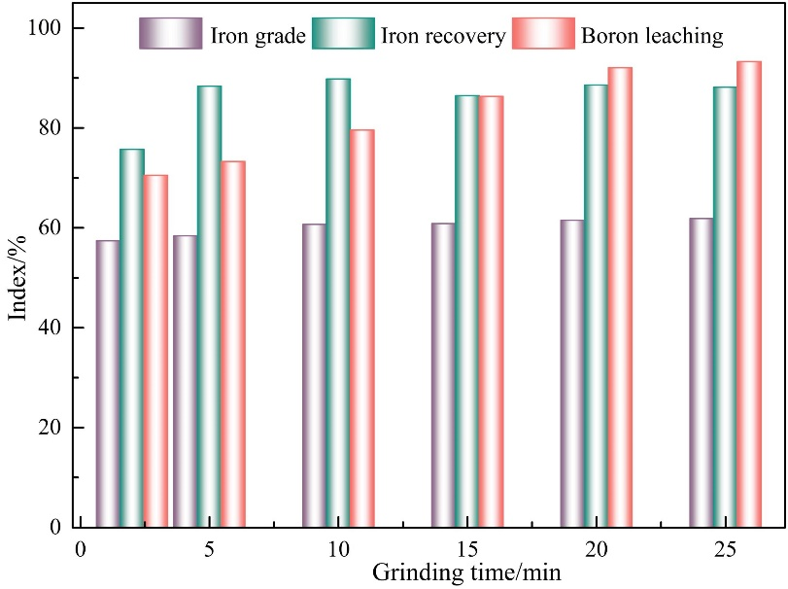
Fig. S1. Effect of grind-leaching time on the boron/iron separation indexes.
Fig. S1 illustrates that boron leaching efficiency increased from 70.50% to 93.27% as the grind-leaching time increased from 2 to 25 min and reached a plateau at 20 min.

