Supplementary Information

Electrochemically triggered decoupled transport behaviors in intercalated graphite: From energy storage to enhanced electromagnetic applications

Ya Chen^{1,2),*}, Kai-Lun Zhang^{1,2),*}, Na Li^{1,2)}, Wei Guan³⁾, Zhiyuan Li^{1,2)}, Haosen Chen^{1,2),}, Shuqiang Jiao³⁾, and Wei-Li Song ^{1,2),}

1) Institute of Advanced Structure Technology, Beijing Institute of Technology, Beijing 100081, China.
2) Beijing Key Laboratory of Lightweight Multi-Functional Composite Materials and Structures, Beijing Institute of Technology, Beijing 100081, China
3) State Key Laboratory of Advanced Metallurgy, University of Science and Technology Beijing, Beijing 100083, China.
* These authors contributed equally to this work.

Corresponding authors:
Weili Song E-mail: weilis@bit.edu.cn Haosen Chen E-mail: chenhs@bit.edu.cn

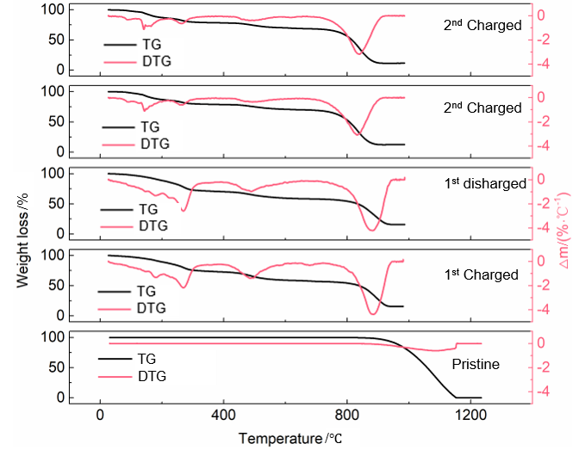

Fig. S1. Thermogravimetry (TG) and derivative thermogravimetry (DTG) curves of PG-AlCl— 4 in various charging and discharing states through the 1st and 2nd cycle.

After calcination of a fully charged PG electrode, the sample completely transformed into white foam made of aluminium oxide.

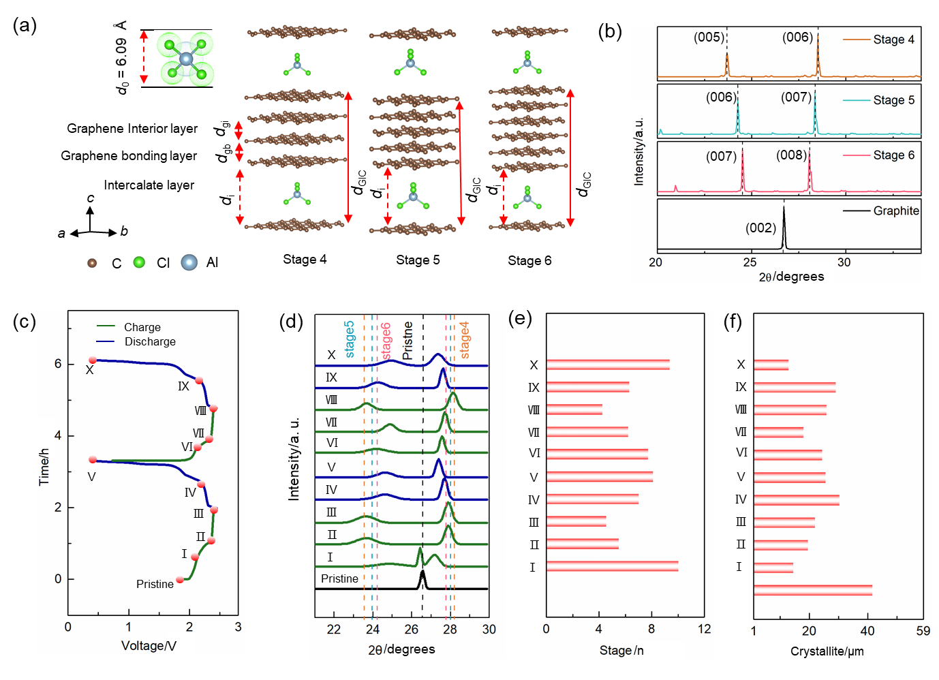

Fig. S2. Atomic structural transitions of PG-AlCl— 4 during the 1st and 2nd charging/discharging cycles: (a) Atomic structures of the stage n PG-AlCl— 4. d_{GIC} and d_{i} represent the periodic repeat distance and intercalant gallery height, respectively. d_{gb}, d_{gi}, d_{GIC}, d_{i} represent the distance of graphene bonding layers, the distance of graphene interior layers, periodic repeat distance and intercalant gallery height, respectively; (b) simulated X-ray diffraction (XRD) peaks of stage n GICs. XRD measurements at different charging and discharing states during the 1st and 2nd cycle; (c) galvanostatic charge and discharge profiles at a current density of 50 mA·g⁻¹; (d) ex-situ XRD patterns of PG; (e) calculated stages based on experimental values; (f) crystallite grain size derived from Scherrer equation in various charging and discharging states.

To mark atomic structural transitions of PG-AlCl— 4, the ex situ X-ray diffraction (XRD) measurements and the first first-principle calculations based on DFT were performed, and typical stages, including n =4, 5 and 6 (Fig. S2(a)) of PG-AlCl— 4 GICs were calculated. When a single AlCl— 4 is intercalated into graphite, two Cl ions of AlCl— 4 would interact with the graphene sheet [1]. Thus, the periodic repeated distance (d_{GIC}, lattice constant of GICs) could be calculated as:
d_{GIC} = (n - 2) d_{gi} + d_{gb} + d_{i} = (n - 1) c₀ + d_{i} = nc₀ + d_{0,} | (S1)
where c₀ ≈ d_{gi} ≈ d_{gb}, and n, d₀, and d_{i} were the stage index, size of AlCl— 4 (0.609 nm) and the distance of intercalate layers (d_{i} = c₀ + d₀), respectively [2].
Due to the fact that the graphene bonding layers screen the AlCl— 4 from interior graphene layers, the calculated distance of interior graphene layers (d_{gi}) from DFT remains almost the same as the initial, which is independent on the stages (Table S1) [3]. The calculated d_{gi} reached ca. 0.334 nm, which was in agreement with the experimentally reported value (c₀ = 0.336 nm) [4]. On the contrary, the calculated distance of bonding layers between graphene (d_{gb}) equals 0.338 ~ 0.342 nm because of charge transfer between graphene bonding layers and intercalated AlCl— 4(Fig. 3(a)).
Based on the relaxed structures with AlCl— 4 density of 3×3 on the ab plane from the DFT calculations, the XRD patterns was simulated (Fig. S2(b)). The simulated XRD peaks exhibited two dominant peaks for (00l) reflections and (00l+1) reflections [4].
The calculated XRD spectra were compared with the measured XRD results to further understand the stage transition in the PG-AlCl— 4GICs. In the electrochemical charge/discharge cycles (Fig. S2(c)), the pristine PG and PG-AlCl— 4GICs at different platform voltages (2.11, 2.37, and 1.9 V) and cut-off voltages (2.45 and 0.4 V) were selected, and the corresponding ex-situ XRD results were given in Fig. S2(d). The pristine PG exhibited a conventional (002) peak at 2θ ≈ 26.57°, which belongs to highly pristine graphite and agree well with the calculated XRD result in Fig. S2(b) (2θ ≈ 26.65°).
Upon anion intercalation of AlCl— 4, the sharp pristine PG foil peak at 26.57° was found to vanish, while new peaks appeared for the presence of (00l) reflections and (00l+1) reflections, shifted with the stage transition of PG-AlCl— 4GICs. The dominant stage index could be calculated from ex-situ XRD results. The crystalline interplanar spacing d_{00l} of graphite (P6₃/mmc space group) could be expressed as
d_{00l} = d_{GIC}/l, (S2) (S2)
where l value is the Miller index of (00l) plane along the stacking orientation obtained from the following equation from Bragg’s law [5–6]:
2 d_{00l} sinθ_{00l} = 2 d_{00l+1} sinθ_{00l+1} = λ. (S3) (S3)
Combining equations (S2) and (S3), we can obtain
$\text{l }\text{=}\frac{\text{1}}{\frac{\text{sin}{{\text{θ}}_{\text{00}\text{l}\text{+}\text{1}}}}{\text{sin}{{\text{θ}}_{\text{00}\text{l}}}}-\text{1}}$. | (S4)
Substitute equation (S3) and (S4) into equation (S2), we could yield
${\text{d}}_{\text{GIC}}\text{=}\frac{\text{λ}}{\text{2 }\text{(sin}{\text{θ}}_{\text{00l+}\text{1}}-\text{sin}{\text{θ}}_{\text{00l}}\text{)}}$. | (S5)
From equation (S1), the stage index n can be expressed as:
$\text{n=}\frac{\text{1}}{{\text{c}}_{\text{0}}}(\frac{\text{λ}}{\text{2(}\text{sin}{\text{θ}}_{\text{00l+}\text{1}}\text{-sin}{\text{θ}}_{\text{00l}}\text{)}}\text{-}{\text{d}}_{\text{0}}\text{)}$. | (S6)
Equation (S6) revealed that the appearance of new peak demonstrates the production of new stage caused by the intercalation of AlCl— 4 anions.
During the intercalation of AlCl— 4anions, the (00l) peak at lower 2θ values was found to shift left while the (00l+1) peak at higher angel was observed to shift right, which offered larger values in (sinθ_{00l+1} - sinθ_{00l}). Subsequently, the PG-AlCl— 4GICs transformed from higher stages to lower stages according to equation (S6). On the contrary, de-intercalation of AlCl— 4 anions resulted in right shift in (00l) peak and left shift in (00l+1) peak, which leads to transformed PG-AlCl— 4GICs from lower stages to higher stages. As plotted in Fig. S2(e), the dominant stage index changed periodically upon the 1st and 2nd charge/discharge cycles. Nevertheless, irreversible microstructure transformation could be observed in the charge/discharge cycles. As described by the Daumas-Hérold model (Fig. 1(e)), residual disorder and strain in the PG-AlCl— 4 GICs result in amorphization in the stacking of graphene sheets, leading to broader XRD peaks than those in the pristine PG. The (002) peak of the PG-AlCl— 4GICs upon 1st and 2nd^{nd} discharge (Ⅴ and Ⅹ in Fig. S2(e)) did not fully recover in comparison with the pristine PG, mainly due to the partially trapped anions in the graphene sheets. The residual AlCl— 4 anions in PG-AlCl— 4 GIC (Ⅴ in Fig. S2(e)) form stage 7 compounds (average estimation) at discharge cut-off voltages (0.4 V), revealing irreversible microstructure transition.
To examine the irreversibility of microstructure transition, average thickness (D) of PG-AlCl— 4 GICs was obtained using the Scherrer’s equation [7]:
$\text{D}\text{=0.9}\text{λ/β}\text{cos}\text{θ}$, | (S7)
where λ is the wavelength of the X-ray radiation (0.15418 nm for Cu Kα), β the full width at half-maximum values of (00l+1) peak, θ the Bragg angle. After the initial intercalation of AlCl— 4, the average thickness of PG-AlCl— 4GICs presented an irreversibly decrease (ca. 25 nm) in comparison with the pristine PG (ca. 41 nm). This is mainly due to the fact that the partially closed interlayer gaps were re-opened in the subsequent cycles [8].

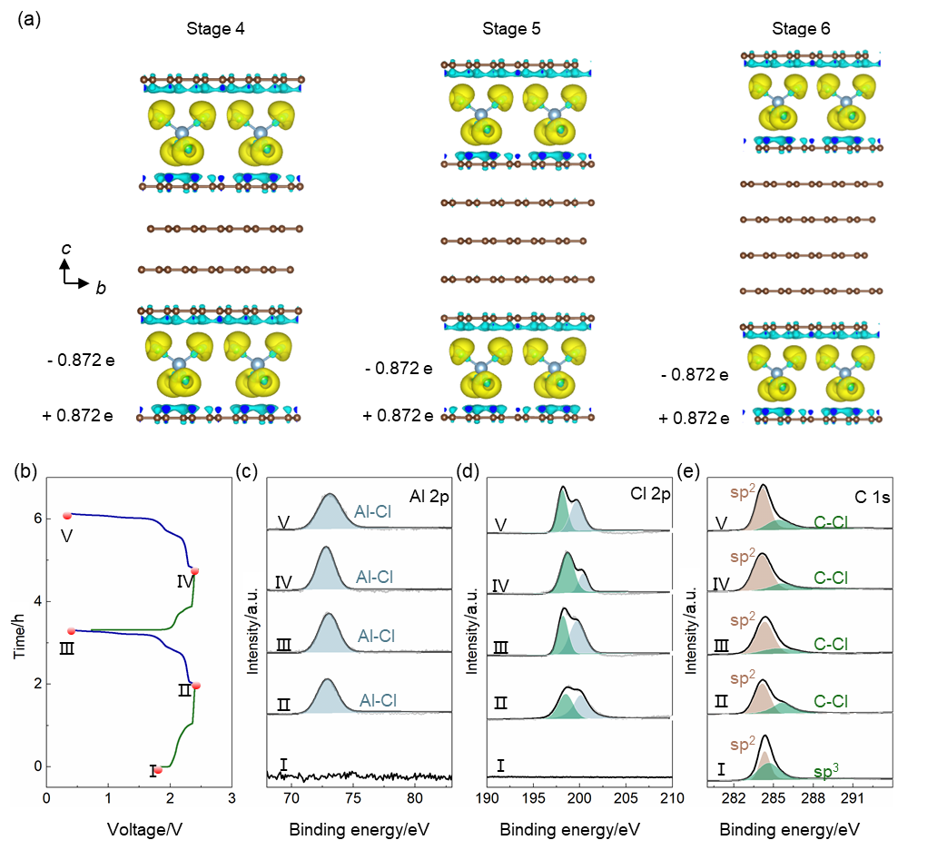Fig. S3. Charge transfer between the graphene sheets and the AlCl— 4 anions: (a) charge difference in the interface of stage n PG-AlCl— 4 CICs based on the first principle calculation, yellow and cyan regions represent electron accumulation and depletion, respectively, with the isosurface plotted at a value of 0.001 |e| Å⁻³. Ex-situ X-ray photoelectron (XPS) test at various charging at discharging states for the first two cycles; (b) galvanostatic charge and discharge profiles at a current density of 50 mA·g⁻¹ for XPS test; XPS spectra of the (c) Al 2p, (d) Cl 2p, and (e) C 1s peaks of PG-AlCl— 4 CICs in various charging and discharging states through the 1st and 2nd cycle.
Besides atomic structural transitions, DFT calculations were used to model the charge transfer between the graphene sheets and the intercalated AlCl— 4 anions. According to the XRD results, PG-AlCl— 4 GICs with the same typical stage index of 6, 5, 4 were selected in the electronic density calculation. As exhibited in Fig. S4(a), the charge transfer is visualized by calculating the electronic density difference (Δρ), which is the difference between the electronic densities of PG-AlCl— 4 GICs (ρ_{GIC}) and graphene sheet (ρ_{g}) and AlCl— 4 anions (ρ_{i}) as follows:
$\text{∆}\text{ρ}\text{= }{\text{ρ}}_{\text{GIC}}-{\text{ρ}}_{\text{g }}-{\text{ρ}}_{\text{i }}$. | (S8)
The yellow regions indicate the electronic density accumulation and the cyan regions imply the density depletion. There is almost no electron transfer in the interior graphene layers owing to screening effect of graphene bonding layers. Simultaneously, electron transfer from graphene bonding layer to AlCl— 4 anions could be observed according to the electronic density difference.
The amount of charge transfer per intercalated AlCl— 4 anions is denoted as the ionization rate (f). In the molecular acceptor compounds, the ionization rate f of alkali metal donor-type GICs was higher than that of acceptor-type GICs. For the K, Rb and Cs systems, there were f =1, while f = 0.1 for HNO₃ and f = 0.3 for AsF₅ and H₂SO₄ [2]. In order to determine the ionization rate (f) for AlCl— 4, net charges of Al, Cl, C were obtained through Bader charge analysis. The net charge of Cl and Al atom is -0.80 and +2.33, accumulating an overall net charge of -0.87 e for AlCl— 4anion. Therefore, an amount of -0.87 e per AlCl— 4 anion is accepted from the neighboring graphene bonding layers, indicating the formation of anion-π interaction between Al and Cl atoms [9]. Moreover, the charge concentration on the graphene interior layer is almost independent on the staging.
In Figs. S4(c-e), X-ray photoelectron spectra (XPS) were performed to probe the charge transfer in the charged/discharged PG-AlCl— 4 GICs. The Cl 2p and Al 2p peaks were absent in the pristine PG and appeared after intercalation of AlCl— 4 anions. The Cl 2p, Al 2p and C 1s peak intensity did not diminish after discharging due to the irreversibility of the electrochemical process and trapped AlCl— 4 anions. According to the peak fitting analysis, the C 1s spectra of the pristine PG showed a characteristic C 1s peak with bonding energy of 284.4 eV. After intercalation of AlCl— 4 anions, the C 1s peaks of PG-AlCl— 4GICs indicated higher bonding energy at 285.7 eV because the C atoms were oxidized by AlCl— 4 anions. In the first two cycles, incomplete de-intercalation of AlCl— 4 could be also observed in XPS results. In comparison with the intercalation of AlCl— 4(ca. 1.3 eV), a smaller chemical shift of C 1s peak was found in the de-intercalation state (ca. 1.1 eV), representing that fewer electrons were extracted from PG in the de-intercalation. Moreover, the Cl 2p exhibited a spin-orbit doublet structure of 2p_{3/2} and 2p_{1/2} peaks. There is some overlap between the 3p electronic states of Cl and 2p electronic states of C (Figs. 3(g-i)), indicating that noncovalent interaction for the anion-π interaction between the carbon atoms of graphene bonding layers and Cl atoms of intercalated AlCl— 4.

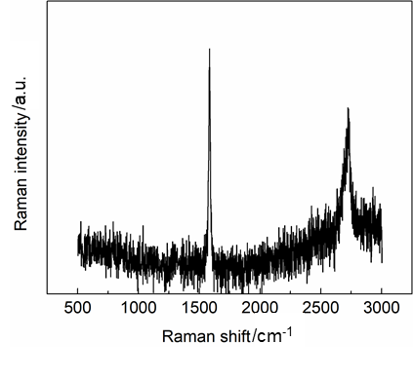
Fig. S4. Raman spectra of pristine PG.
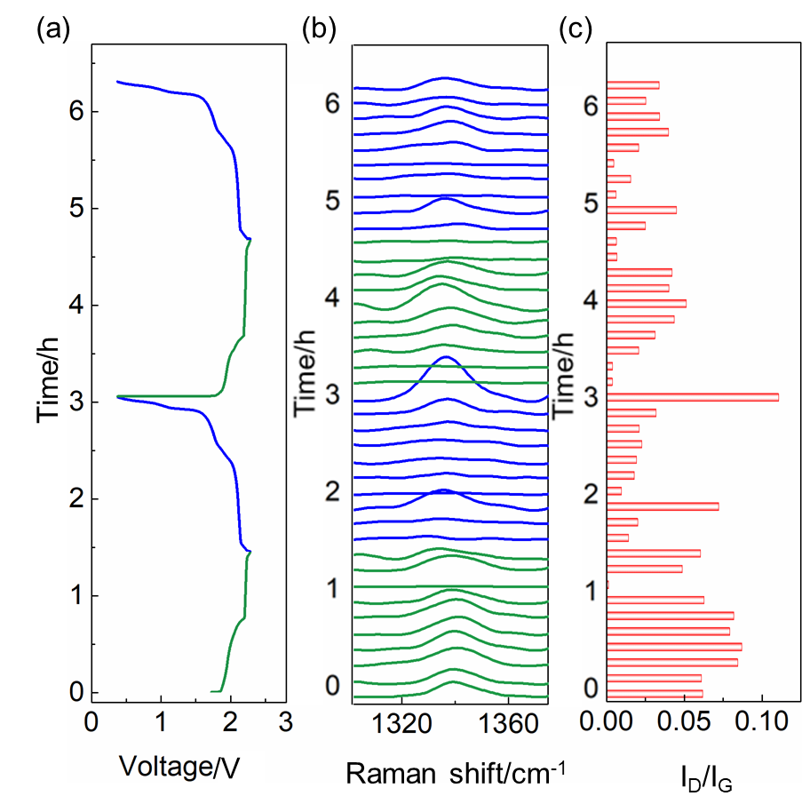

Fig. S5. (a) Galvanostatic charge and discharge profiles at a current density of 50 mA·g⁻¹ for in-situ Raman tests; (b) D band; (c) relative intensity of D band to G band.

Table S1. Simulated 2θ degree, the graphite bonding layer, the graphite interior layer, the intercalant layer and the periodic repeat distance for all stages based on DFT theory

Stage | 2θ_{00l}/(º) | 2θ_{00l+1}/(º) | l^{a)} | d_{gb}^{b)} /nm | d_{gi}^{c)}  /nm | d_{i}^{d)}  /nm | d_{GIC}^{e)}  /nm
6 | 24.21 | 27.77 | 7 | 0.342 | 0.334 | 0.868 | 1.879
5 | 23.96 | 28.05 | 6 | 0.337 | 0.335 | 0.865 | 2.211
4 | 23.39 | 28.20 | 5 | 0.338 | 0.333 | 0.864 | 2.540

Notes: a)--Miller index; b)--Graphite bonding layer thickness; c)--Graphite interior layer thickness; d)--Intercalant layer thickness; e)--Periodic repeat distance

References
[1] S. C. Jung, Y. Kang, D. Yoo, J. W. Choi, and Y. Han, Flexible few-layered graphene for the ultrafast rechargeable aluminum-ion battery, J. Phys. Chem. C., 120 (2016), No. 13, p. 13384.
[2] S. Takahashi, N. Koura, S. Kohara, M. Saboungi, and L. A. Curtiss, Technological and scientific issues of room-temperature molten salts. Plasmas Ions, 2 (1999), No. 3, p. 91.
[3] M. S. Dresselhaus, and G. Dresselhaus, Intercalation compounds of graphite, Adv. Phys., 30(1981), No. 2, p. 139.
[4] G. A. Elia, G. Greco, P. H. Kamm, F. M. García, S. Raoux, and R. Hahn, Simultaneous X-Ray diffraction and tomography operando investigation of aluminum/graphite batteries, Adv. Funct. Mater., 30 (2020), No. 43, No. 2003913.
[5] B. Özmen-Monkul, and M. M. Lerner, The first graphite intercalation compounds containing tris(pentafluoroethyl) trifluorophosphate, Carbon, 48 (2010), No. 11, p. 3205.
[6] H. Kim, J. Hong, G. Yoon, H. Kim, K. Park, M. Park, W. Yoon, and K. Kang, Sodium intercalation chemistry in graphite, Energy Environ. Sci., 8 (2015), No. 10, p. 2963.
[7] A. L. Patterson, The scherrer formula for X-ray particle size determination, Phys. Rev., 56 (1939), No. 10, p. 978.
[8] T. Placke, O. Fromm, S. F. Lux, P. Bieker, S. Rothermel, H. W. Meyer, S. Passerini, and M. Winter, Reversible intercalation of bis(trifluoromethanesulfonyl)imide anions from an ionic liquid electrolyte into graphite for high performance dual-ion cells, J. Electrochem. Soc., 159 (2012), No. 11, p. A1755.
[9] S. C. Jung, Y. Kang, D. Yoo, J. W. Choi, and Y. Han, Flexible few-layered graphene for the ultrafast rechargeable aluminum-ion battery, J. Phys. Chem. C., 120 (2016), No. 13, p. 13384.

