Supplementary information
Construction of BiVO₄/BiOCl@C Z-scheme heterojunction for enhanced photoelectrochemical performance
Jiaxin Li, Hao Yuan, Wenjie Zhang, Ruijie Zhu, and Zhengbo Jiao
Institute of Materials for Energy and Environment, College of Material Science and Engineering, Qingdao University, Qingdao 266071, China
Corresponding author: Zhengbo Jiao E-mail: jiaozhb@qdu.edu.cn, jiaozhb@163.com

1. Experimental
1.1. Chemicals
Bi(NO₃)₃·5H₂O, (NH₄)₆Mo₇O₂₄, (NH₄)₁₀H₂(W₂O₇)₆, NH₄VO₃, ammonium hydroxide, ethanol, formaldehyde (37wt%), PEG-600 and ethylene glycol were obtained from Sinopharm Chemical Reagent Co., Ltd (Shanghai, China). Tetrapropyl orthosilicate (TPOS), resorcinol and methyl imidazole (MI) were purchased from Shanghai Macklin Biochemical Co., Ltd. SnO₂ transparent conductive glass doped with fluorine (FTO) was provided by Baisite Co., Ltd. Deionized water was used to prepare all the solutions. All chemicals are of analytical grade and no further purification is required when used. All instruments and samples are cleaned with deionized water.
1.2. Preparation of nanoporous BiVO₄ and Mo,W:BVO photoanodes
In brief, the nanoporous BiVO₄ photoelectrode was prepared by instilling the precursor solution on the FTO substrate. The precursor solution was prepared by the following three steps: (I) Bi(NO₃)₃·5H₂O and NH₄VO₃ were respectively dissolved in ethylene glycol solution, the concentration of which was 75 mM. Then, 0.68 g PEG-600 was dissolved in another 20 mL ethylene glycol solution. (II) Slowly mix the three solutions in the following proportions: 5 mL Bi(NO₃)₃·5H₂O solution, 5 mL NH₄VO₃ solution and 2.5 mL PEG-600 solution. (III) Drop 0.2 mL of precursor solution on the FTO substrate. Finally, the FTO glass slide covered with the precursor solution was dried in an oven at 150°C for 1 h, and then annealed in a muffle furnace at 500°C for 2.5 h. The synthesis method of Mo and W ions co-doped BiVO₄ is basically the same as above, but the first step is different, as follows: Bi(NO₃)₃·5H₂O is dissolved in ethylene glycol solution (75 mM). Similarly, NH₄VO₃, (NH₄)₆Mo₇O₂₄, and (NH₄)₁₀H₂(W₂O₇)₆ were dissolved in another glycol solution at the percentages of 3at% Mo and 3at% W with respect to the amount of Bi. Then, 0.68 g PEG-600 was dissolved in another 20 mL ethylene glycol solution. The subsequent steps are the same as the synthesis steps of pure BiVO₄ photoanode.
1.3. Preparation of BiOCl@C
Mix ethanol, deionized water, and ammonium hydroxide at a ratio of 14:2:1 at room temperature and stir evenly. Add 3.5 mL of TPOS and stir for 15 min, then add 0.56 mL of formaldehyde and 0.4 g of resorcinol and stir for 24 h. Finally, it was washed and dried with ethanol to obtain precursor. Separately, 1 g of precursor, 5 mmol of MI and 2.5 mmol of Bi(NO₃)₃·5H₂O were uniformly dispersed in 100 mL of ethanol, and then evaporated to dryness at 70°C. The samples prepared above were calcined at 800°C under N₂ atmosphere, and etched with 5wt% hydrofluoric acid for 24 h. Then the above product is filtered by suction to obtain BiF₃/C. Finally, BiOCl/C was prepared by using FeCl₃ to oxidize BiF₃ to obtain BiOCl.
1.4. Preparation of Mo,W:BVO/BiOCl@C
The fabrication method of Mo,W:BVO/BiOCl@C was similar to that of Mo, W co-doped BiVO₄. The BiOCl@C was dissolved in ethylene glycol solution, then disperse it into the Mo,W:BVO precursor solution uniformly. Take 0.2 mL of the above mixed solution and evenly drop it on FTO, and then dry it at 130°C for 1 h in oven. After that, the FTO coated with the solution was calcined and annealed in a muffle furnace at 500°C for 2.5 h to obtain Mo,W:BVO/BiOCl@C photoanodes.
1.5. Preparation of Mo,W:BVO/BiOCl@C-S
The Mo,W:BVO/BiOCl@C-S was prepared by spin-coating BiOCl@C ethylene glycol solution on the surface of FTO coated with Mo,W:BVO solution at 2000 rpm for 20 s. After that, drying it in an oven at 60℃ to obtain Mo,W:BVO/BiOCl@C-S.
1.6. Characterization
X-ray diffraction (XRD) measurements were performed on a Rigaku Ultima IV instrument (Tokyo, Japan) utilizing Cu K_{α} radiation (40 kW), and recorded from 10° to 90° with a scanning rate of 20°/min. Scanning electron microscopy (SEM) measurements were carried out using a field-emission scanning electron microscope (JSM-7800F, JEOL, Tokyo, Japan) operated at an accelerating voltage of 5 kW. Transmission electron microscopy (TEM) measurements were carried out using a JEOL JEM-2100 Plus transmission electron microscope (Tokyo, Japan). X-ray photoelectron spectroscopy (XPS) measurements were performed on a PHI 5000 Versa Probe III (Ulvac-Phi, Japan). Raman spectra were recorded on a Renishaw inVia Plus Micro-Raman spectroscopy system (Wottonunder-Edge, UK). The light source was supplied by a 300 W Xe lamp, and air mass (AM) 1.5 was used to simulate sunlight. Photoelectrochemical tests were performed with a standard threeelectrode system on an electrochemical workstation (CHI660E, Austin, TX, USA).
1.7. Photoelectrochemical performances examination
The BiVO₄-based film is used as a photoanode in the PEC cell with 3 electrodes. A CHI-660D potentiotrometer was used to record the photocurrent response under simulated sunlight in a sandwich configuration using Pt wire as counter electrode, saturated calomel electrode (SCE) as reference electrode, and 0.1 M Na₂SO₄ solution as electrolyte. The 300 W xenon arc lamp is equipped with an analog sun light filter (HSX-F300, Beijing NBeT Technology Co., Ltd.) calibrated to 100 mW/cm⁻² and measured with a radiometer (CEL-NP 2000, Beijing Aogang Technology Co., Ltd.) as the light source. EIS Nyquist plots were obtained in the range of 0.6 V and 5 mV AC amplitudes, 0.1–10⁵ Hz frequencies. All experiments were carried out under environmental conditions.

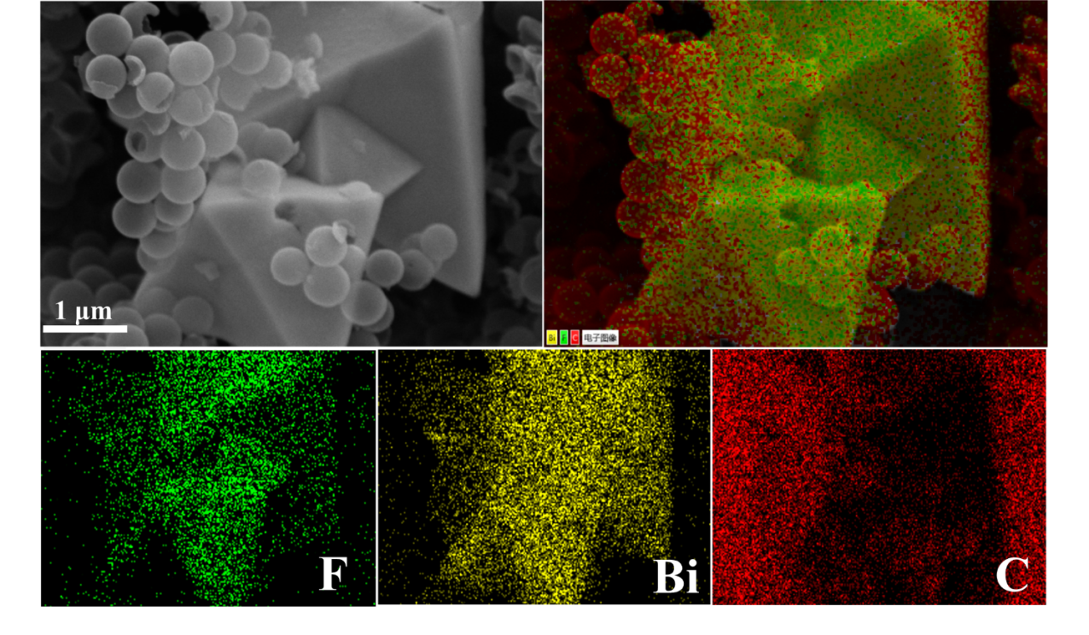
Fig. S1. SEM and EDS elemental mappings of BiF₃@C.

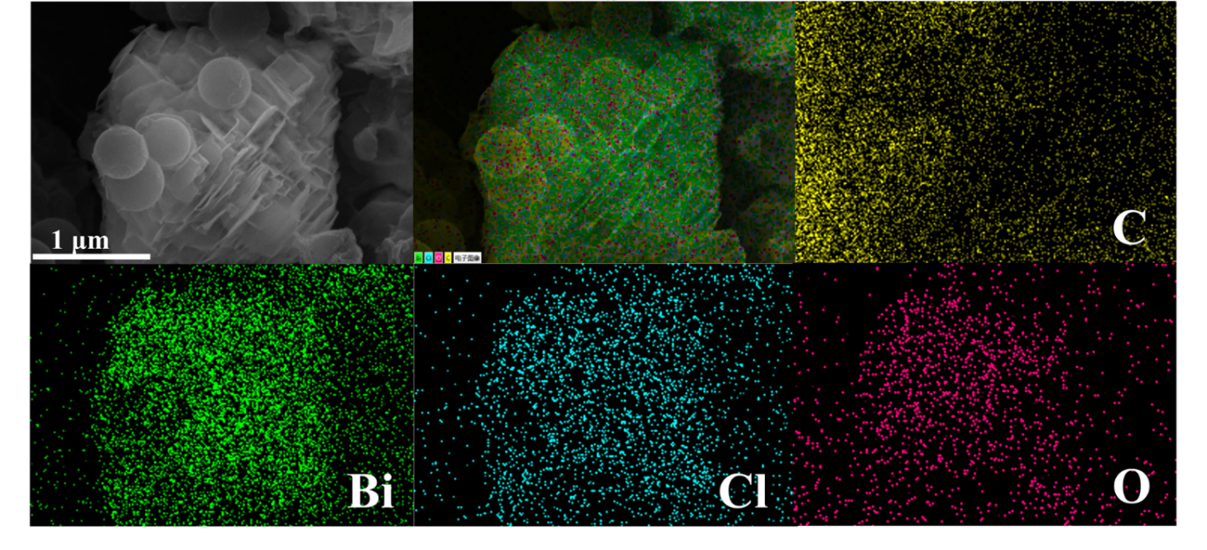
Fig. S2. SEM and EDS elemental mappings of BiOCl@C.

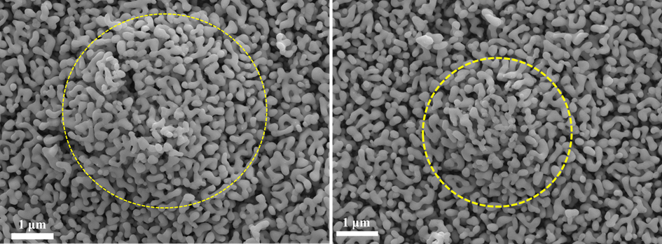
Fig. S3. SEM images of Mo,W:BVO/BiOCl@C heterostructure.

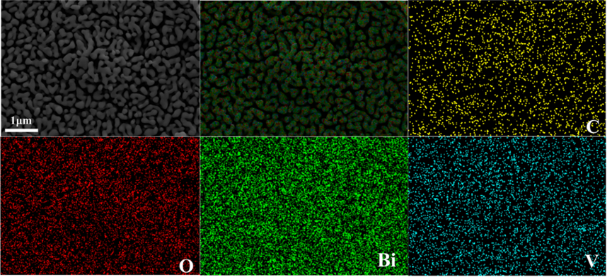
Fig. S4. SEM and EDS elemental mappings of Mo,W:BVO/C.

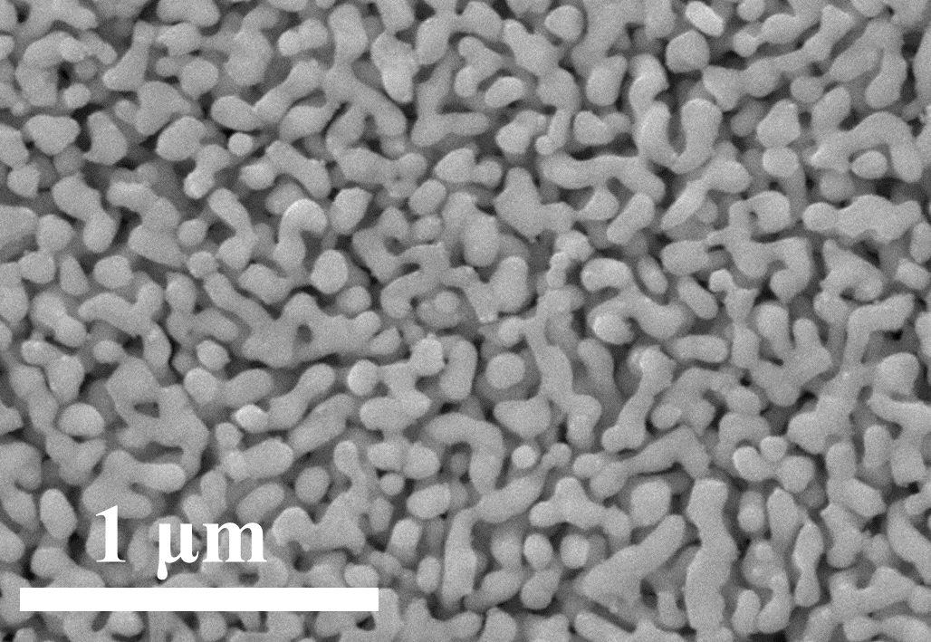
Fig. S5. SEM of pure BiVO₄ film.

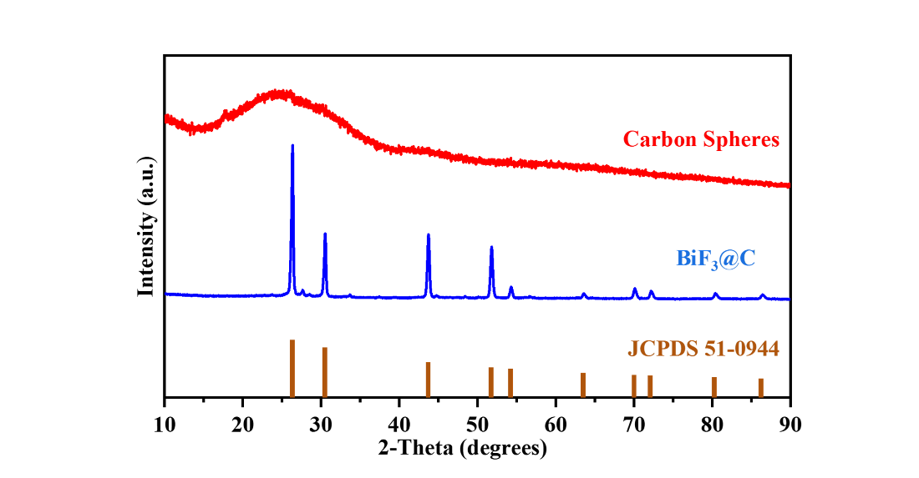
Fig. S6. XRD of carbon spheres and BiF₃@C.

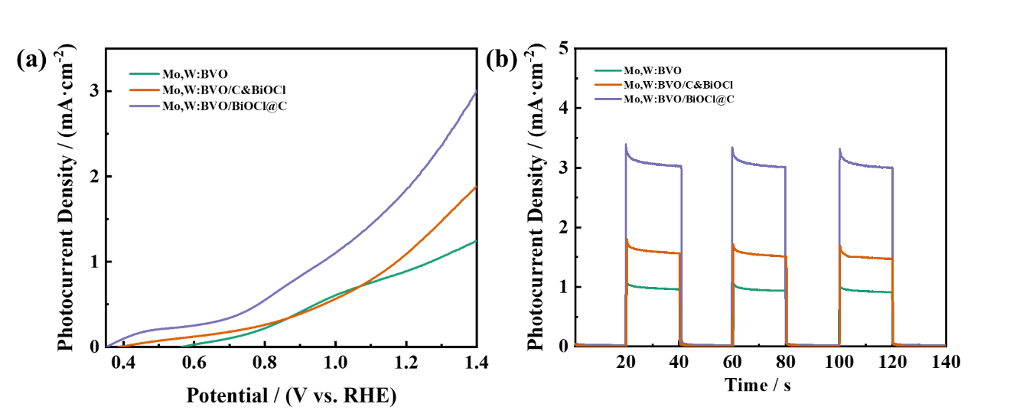
Fig. S7. (a) LSV curves and (b) amperometric i–t curve of Mo,W:BVO, Mo,W:BVO/C&BiOCl (obtained through mechanical mixing) and Mo,W:BVO/BiOCl@C.

