Supplementary Information

Theoretical study on the morphology of cobalt nanoparticles modulated by alkali metal promoters
Xiaobin Geng¹⁾, Hui Yang^{1,2,3)}, Wenping Guo¹⁾, Xiaotong Liu^{4,5)}, Tao Yang^{4,5),}, and Jinjia Liu^{1,6),}
1) National Energy Center for Coal to Liquids, Synfuels China Co., Ltd, Beijing 101400, China
2) State Key Laboratory of Coal Conversion, Institute of Coal Chemistry, Chinese Academy of Sciences, Taiyuan 030001, China
3) University of Chinese Academy of Sciences, Beijing 100049, China
4) Beijing Advanced Innovation Center for Materials Genome Engineering, Beijing Information Science and Technology University, Beijing 100101, China
5) School of Computer, Beijing Information Science and Technology University, Beijing 100101, China
6) College of Chemistry and Environmental Science, Inner Mongolia Key Laboratory of Green Catalysis, Inner Mongolia Normal University, Hohhot 010022, China
Corresponding authors: Tao Yang E-mail: ytyangmei@bistu.edu.cn; Jinjia Liu E-mail: liujj6636@163.com

Table S1. The adsorption energy (E_{ads}), the distance of Co and Na₂O (d_{Co-Na2O}), the surface energy (E_{sur}) and the proportion of surface area (S_{s}) under lowest Na₂O coverage
Phase | Facets | E_{ads} (eV) | d_{Co-Na2O} (Å) | E_{sur} (eV/Å²) | S_{s} (%)
FCC | (111) | −4.55 | 1.41 | 0.141 | 13
 | (110) | −3.71 | 1.39 | 0.143 | 0
 | (100) | −4.71 | 1.29 | 0.110 | 87
 | (311) | −5.43 | 1.42 | 0.145 | 0
HCP | (0001) | −4.83 | 1.32 | 0.114 | 22
 | ($10\overline{1}0$) | −4.46 | 1.70 | 0.129 | 26
 | ($10\overline{1}1$) | −5.15 | 1.24 | 0.132 | 51
 | ($10\overline{1}2$) | −5.13 | 1.35 | 0.144 | 0
 | ($11\overline{2}0$) | −4.90 | 1.48 | 0.147 | 1
 | ($11\overline{2}1$) | −4.59 | 1.24 | 0.158 | 0

Table S2. The adsorption energy (E_{ads}), the distance of Co and K₂O (d_{Co-K2O}), the surface energy (E_{sur}) and the proportion of surface area (S_{s}) under lowest K₂O coverage
Phase | Facets | E_{ads} (eV) | d_{Co-K2O} (Å) | E_{sur} (eV/Å²) | S_{s} (%)
FCC-Co | (111) | −4.88 | 1.40 | 0.140 | 12
 | (110) | −3.95 | 1.43 | 0.143 | 0
 | (100) | −5.14 | 1.33 | 0.108 | 88
 | (311) | −5.73 | 1.34 | 0.144 | 0
HCP-Co | (0001) | −5.28 | 1.27 | 0.112 | 22
 | ($10\overline{1}0$) | −4.99 | 1.40 | 0.128 | 26
 | ($10\overline{1}1$) | −5.60 | 1.15 | 0.131 | 51
 | ($10\overline{1}2$) | −5.78 | 1.32 | 0.143 | 0
 | ($11\overline{2}0$) | −5.15 | 1.40 | 0.146 | 1
 | ($11\overline{2}1$) | −4.93 | 0.87 | 0.158 | 0

Table S3. The adsorption energy (E_{ads}), the surface energy (E_{sur}) and the proportion of surface area (S_{s}) under different Na₂O coverages on FCC-Co. (N is number of Na₂O adsorbed on the surface)
N | Facets | E_{ads} (eV) | E_{sur} (eV/A²) | S_{s} (%)
1 | (111) | −4.55 | 0.141 | 13
 | (110) | −3.71 | 0.143 | 0
 | (100) | −4.71 | 0.110 | 87
 | (311) | −5.43 | 0.145 | 0
2 | (111) | −8.97 | 0.127 | 8
 | (110) | −8.55 | 0.132 | 0
 | (100) | −9.19 | 0.093 | 92
 | (311) | −10.85 | 0.137 | 0
3 | (111) | −13.19 | 0.113 | 4
 | (110) | −13.25 | 0.121 | 0
 | (100) | −13.56 | 0.076 | 96
 | (311) | −16.16 | 0.129 | 0
4 | (111) | −17.25 | 0.099 | 0
 | (110) | −17.86 | 0.110 | 0
 | (100) | −17.68 | 0.060 | 100
 | (311) | −21.49 | 0.121 | 0

Table S4. The adsorption energy (E_{ads}), the surface energy (E_{sur}) and the proportion of surface area (S_{s}) under different K₂O coverages on FCC-Co. (N is number of K₂O adsorbed on the surface)
N | Facets | E_{ads} (eV) | E_{sur} (eV/A²) | S_{s} (%)
1 | (111) | −4.88 | 0.140 | 12
 | (110) | −3.95 | 0.143 | 0
 | (100) | −5.14 | 0.108 | 88
 | (311) | −5.73 | 0.144 | 0
2 | (111) | −9.41 | 0.125 | 7
 | (110) | −8.45 | 0.132 | 0
 | (100) | −9.99 | 0.090 | 93
 | (311) | −11.44 | 0.136 | 0
3 | (111) | −13.94 | 0.110 | 4
 | (110) | −14.04 | 0.119 | 0
 | (100) | −14.15 | 0.074 | 96
 | (311) | −17.02 | 0.127 | 0
4 | (111) | −17.85 | 0.097 | 0
 | (110) | −18.59 | 0.108 | 0
 | (100) | −18.21 | 0.058 | 100
 | (311) | −22.59 | 0.119 | 0

Table S5. The adsorption energy (E_{ads}), the surface energy (E_{sur}) and the proportion of surface area (S_{s}) under different Na₂O coverages on HCP-Co. (N is number of Na₂O adsorbed on the surface)
N | Facets | E_{ads} (eV) | E_{sur} (eV/A²) | S_{s} (%)
1 | (0001) | −4.83 | 0.114 | 22
 | ($10\overline{1}0$) | −4.46 | 0.129 | 26
 | ($10\overline{1}1$) | −5.15 | 0.132 | 51
 | ($10\overline{1}2$) | −5.13 | 0.144 | 0
 | ($11\overline{2}0$) | −4.90 | 0.147 | 1
 | ($11\overline{2}1$) | −4.59 | 0.158 | 0
2 | (0001) | −9.43 | 0.096 | 22
 | ($10\overline{1}0$) | −8.89 | 0.117 | 19
 | ($10\overline{1}1$) | −0.20 | 0.114 | 59
 | ($10\overline{1}2$) | −10.30 | 0.131 | 0
 | ($11\overline{2}0$) | −9.66 | 0.137 | 0
 | ($11\overline{2}1$) | −10.14 | 0.149 | 0
3 | (0001) | −13.82 | 0.080 | 23
 | ($10\overline{1}0$) | −13.32 | 0.105 | 10
 | ($10\overline{1}1$) | −14.61 | 0.098 | 67
 | ($10\overline{1}2$) | −16.08 | 0.115 | 0
 | ($11\overline{2}0$) | −14.43 | 0.127 | 0
 | ($11\overline{2}1$) | −14.27 | 0.141 | 0
4 | (0001) | −18.04 | 0.064 | 23
 | ($10\overline{1}0$) | −17.71 | 0.092 | 0
 | ($10\overline{1}1$) | −19.66 | 0.079 | 77
 | ($10\overline{1}2$) | −21.34 | 0.101 | 0
 | ($11\overline{2}0$) | −18.66 | 0.118 | 0
 | ($11\overline{2}1$) | −18.75 | 0.134 | 0
Table S6. The adsorption energy (E_{ads}), the surface energy (E_{sur}) and the proportion of surface area (S_{s}) under different K₂O coverages on HCP-Co. (N is number of K₂O adsorbed on the surface)
N | Facets | E_{ads} (eV) | E_{sur} (eV/A²) | S_{s} (%)
1 | (0001) | −5.28 | 0.112 | 22
 | ($10\overline{1}0$) | −4.99 | 0.128 | 26
 | ($10\overline{1}1$) | −5.60 | 0.131 | 51
 | ($10\overline{1}2$) | −5.78 | 0.143 | 0
 | ($11\overline{2}0$) | −5.15 | 0.146 | 1
 | ($11\overline{2}1$) | −4.93 | 0.158 | 0
2 | (0001) | −10.19 | 0.093 | 22
 | ($10\overline{1}0$) | −9.98 | 0.114 | 20
 | ($10\overline{1}1$) | −11.04 | 0.111 | 58
 | ($10\overline{1}2$) | −11.48 | 0.127 | 0
 | ($11\overline{2}0$) | −10.06 | 0.136 | 0
 | ($11\overline{2}1$) | −9.82 | 0.149 | 0
3 | (0001) | −14.72 | 0.076 | 24
 | ($10\overline{1}0$) | −14.88 | 0.100 | 15
 | ($10\overline{1}1$) | −15.30 | 0.095 | 61
 | ($10\overline{1}2$) | −16.99 | 0.113 | 0
 | ($11\overline{2}0$) | −14.82 | 0.126 | 0
 | ($11\overline{2}1$) | −13.93 | 0.142 | 0
4 | (0001) | −18.59 | 0.062 | 23
 | ($10\overline{1}0$) | −19.42 | 0.087 | 4
 | ($10\overline{1}1$) | −19.95 | 0.078 | 73
 | ($10\overline{1}2$) | −21.79 | 0.100 | 0
 | ($11\overline{2}0$) | −19.63 | 0.116 | 0
 | ($11\overline{2}1$) | −18.05 | 0.135 | 0

Fig. S1. The stable adsorption structure of one Na₂O adsorbed on FCC-Co. (Purple is sodium, red is oxygen, blue is cobalt).

Fig. S2. The stable adsorption structure of one K₂O adsorbed on FCC-Co. (Purple is potassium, red is oxygen, blue is cobalt).

Fig. S3. The stable adsorption structure of one Na₂O adsorbed on HCP-Co. (Purple is sodium, red is oxygen, blue is cobalt).

Fig. S4. The stable adsorption structure of one K₂O adsorbed on HCP-Co. (Purple is potassium, red is oxygen, blue is cobalt).

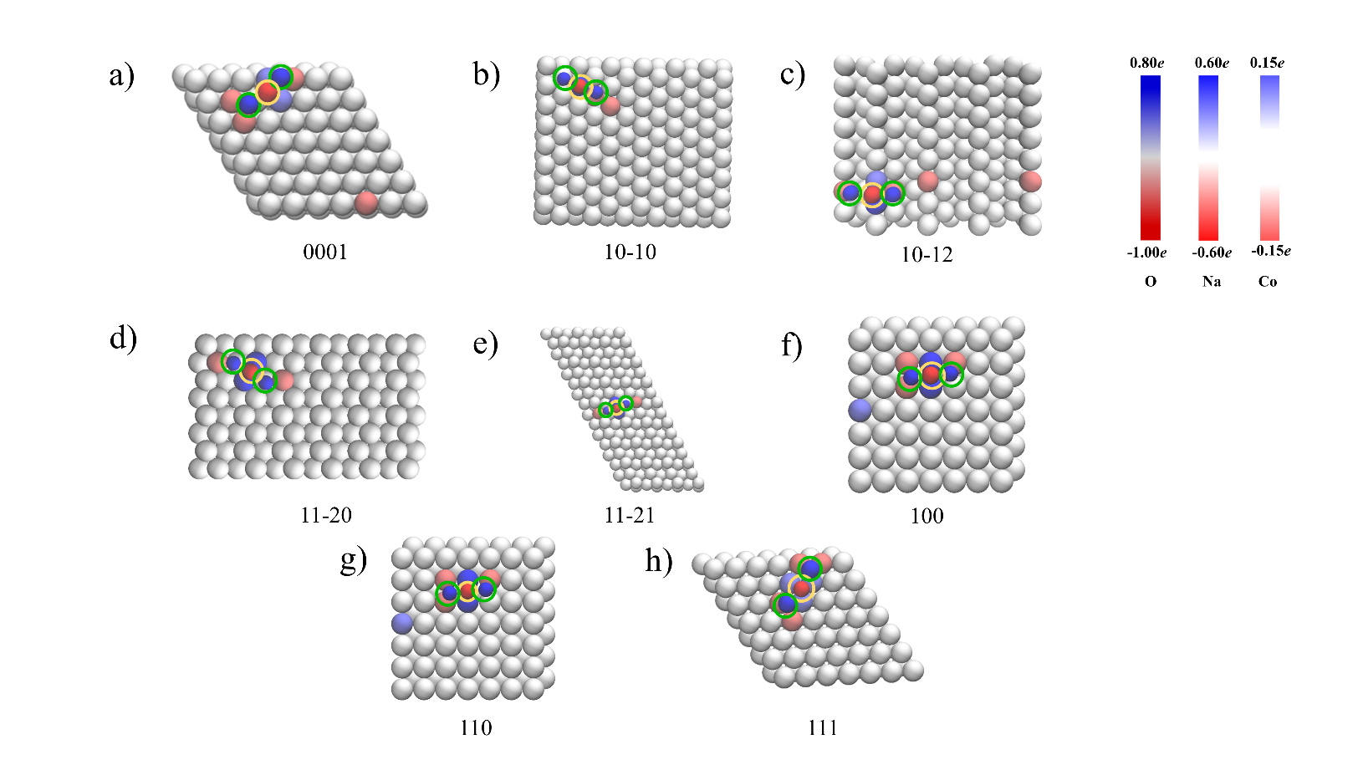
Fig. S5. Charge transfer analysis of (a) Na₂O/Co(0001), (b) Na₂O/Co(10-10), (c) Na₂O/Co(10-12), (d) Na₂O/Co(11-20), (e) Na₂O/Co(11-21), (f) Na₂O/Co(100), (g) Na₂O/Co(110) and (h) Na₂O/Co(111), the positive and negative values represents lost and gained electrons, respectively. (The yellow circle is O, the green circle is Na, the others are Co) (The positive and negative values represent lost and gained electrons).

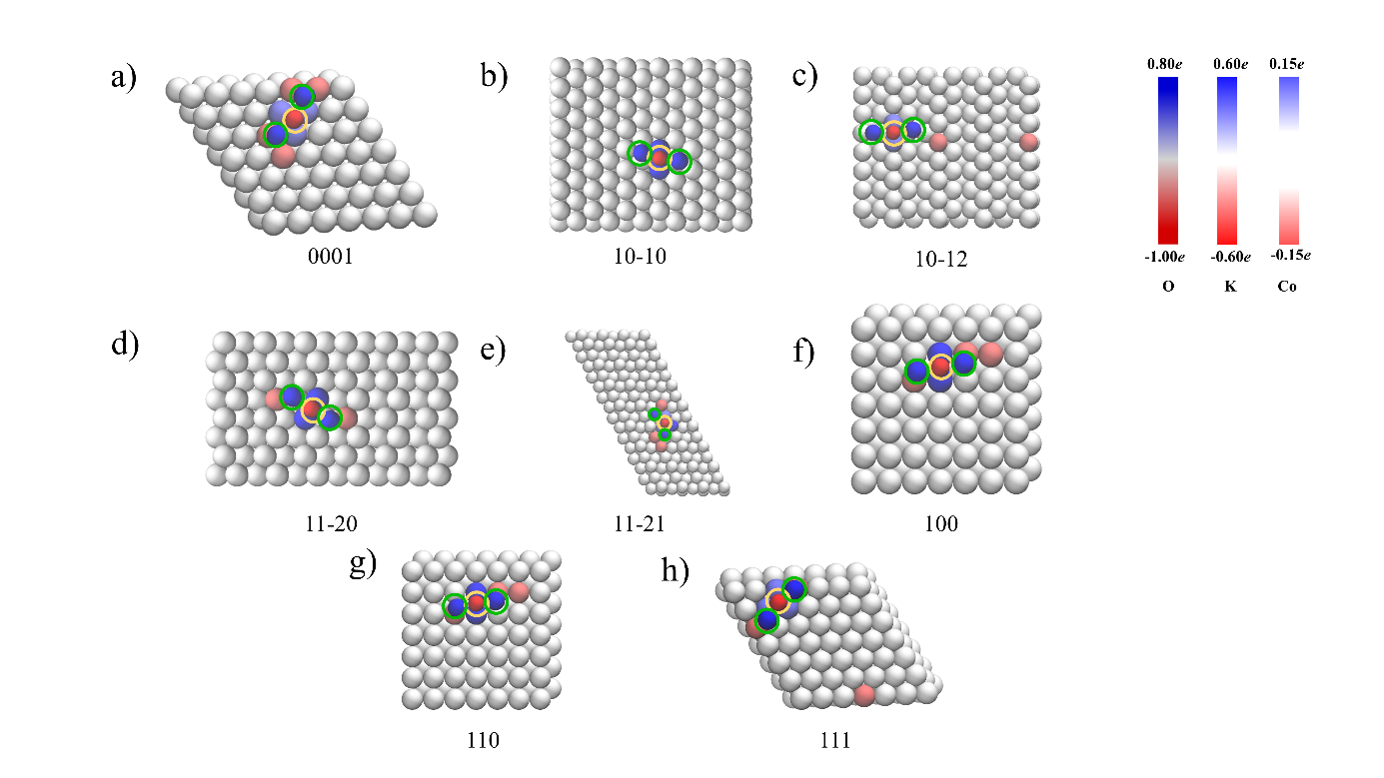
Fig. S6. Charge transfer analysis of (a) K₂O/Co(0001), (b) K₂O/Co(10-10), (c) K₂O/Co(10-12), (d) K₂O/Co(11-20), (e) K₂O/Co(11-21), (f) K₂O/Co(100), (g) K₂O/Co(110) and (h) K₂O/Co(111), the positive and negative values represents lost and gained electrons, respectively. (The yellow circle is O, the green circle is K, the others are Co) (The positive and negative values represent lost and gained electrons).

Fig. S7. The stable adsorption structure of two Na₂O adsorbed on FCC-Co. (Purple is sodium, red is oxygen, blue is cobalt).

Fig. S8. The stable adsorption structure of two K₂O adsorbed on FCC-Co. (Purple is potassium, red is oxygen, blue is cobalt).

Fig. S9. The stable adsorption structure of two Na₂O adsorbed on HCP-Co. (Purple is sodium, red is oxygen, blue is cobalt).

Fig. S10. The stable adsorption structure of two K₂O adsorbed on HCP-Co. (Purple is potassium, red is oxygen, blue is cobalt).

Fig. S11. The stable adsorption structure of three Na₂O adsorbed on FCC-Co. (Purple is sodium, red is oxygen, blue is cobalt).

Fig. S12. The stable adsorption structure of three K₂O adsorbed on FCC-Co. (Purple is potassium, red is oxygen, blue is cobalt).

Fig. S13. The stable adsorption structure of three Na₂O adsorbed on HCP-Co. (Purple is sodium, red is oxygen, blue is cobalt).

Fig. S14. The stable adsorption structure of three K₂O adsorbed on HCP-Co. (Purple is potassium, red is oxygen, blue is cobalt).

Fig. S15. The stable adsorption structure of four Na₂O adsorbed on FCC-Co. (Purple is sodium, red is oxygen, blue is cobalt).

Fig. S16. The stable adsorption structure of four K₂O adsorbed on FCC-Co. (Purple is potassium, red is oxygen, blue is cobalt).

Fig. S17. The stable adsorption structure of four Na₂O adsorbed on HCP-Co. (Purple is sodium, red is oxygen, blue is cobalt).

Fig. S18. The stable adsorption structure of four K₂O adsorbed on HCP-Co. (Purple is potassium, red is oxygen, blue is cobalt).

