Supplementary Material

Synergistically coupling of graphene quantum dots with Zn-intercalated MnO₂ cathode for high-performance aqueous Zn-ion batteries
Minjie Shi^{1),} , Hangtian Zhu¹⁾, Cong Chen¹⁾, Jintian Jiang³⁾, Liping Zhao²⁾, and Chao Yan^{1),}
1) School of Materials Science and Engineering, Jiangsu University of Science and Technology, Zhenjiang, 212003, China
2) State Key Laboratory for Metallic Matrix Composite Materials, School of Materials Science and Engineering, Shanghai Jiao Tong University, Shanghai 200240, China
3) Zhejiang Research Institute of Chemical Industry Co., Ltd, Hangzhou, 310012, China

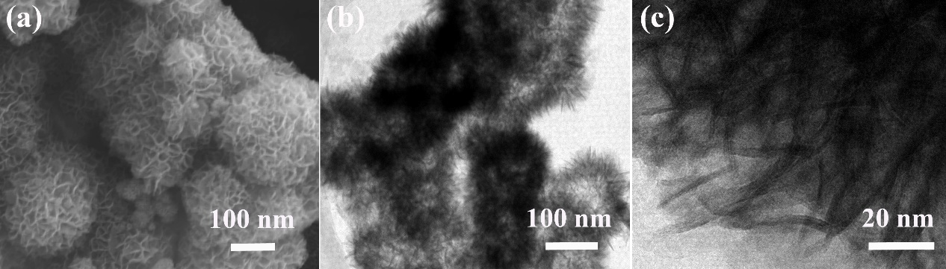
Fig. S1. (a) SEM image, (b) low-resolution and (c) high-resolution TEM images of pristine MnO₂.
As shown in Fig. S1a and S1b, the pristine MnO₂ consists of many monodispersed and uniform nanoflowers with the size of 200 nm, wherein the surface of MnO₂ nanosheets is smooth and no GQDs can be observed on the surface of MnO₂ nanosheets (Fig. S1c).

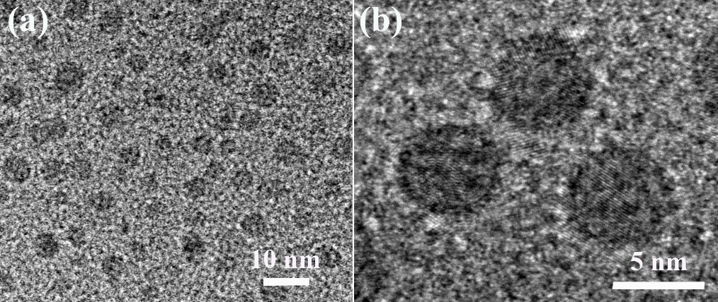
Fig. S2. (a) Low-resolution and (b) high-resolution TEM images of GQDs.
As shown in Fig. S2, the GQDs are effectively synthesized from GO via a facile solvothermal approach. The resultant GQDs are nanometer-sized graphene sheets with excellent electron mobility.

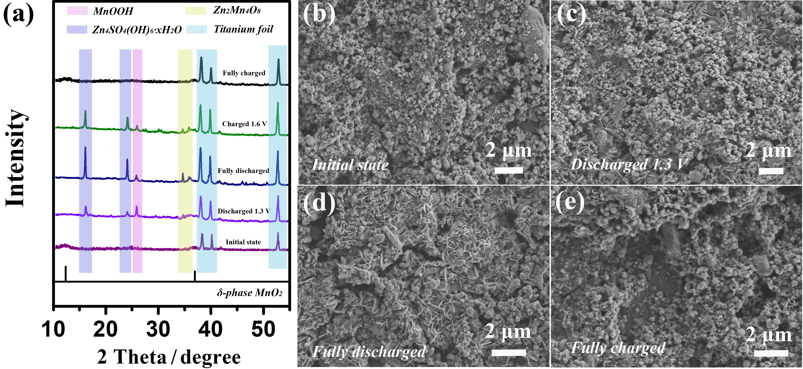
Fig. S3. (a) Ex-situ XRD pattern and (b-e) SEM images of the cathode collected at various charging and discharging states.

For better understanding the reaction mechanism, ex-situ XRD (Fig. S3a) and SEM measurements (Fig. S3b-e) have been carried out to analyze the phase and structural evolutions upon charging and discharging. As seen from Fig. S3a, a new phase with obvious diffraction peaks at around 16.1° and 24.2° appear during the discharging process, which could be assigned to the zinc sulfate hydroxide hydrate (Zn₄SO₄(OH)₆·xH₂O, JPCDS #39-0688). The Zn₄SO₄(OH)₆·xH₂O phase exhibits a two-dimensional layered architecture (Fig. S3c), which is constructed by the stacking of Zn(OH)₂ layers with ZnSO₄ and filling of water molecules in the interlayer tunnels. After fully discharge, the peak intensity of Zn₄SO₄(OH)₆·xH₂O increases obviously, suggesting the growth of Zn₄SO₄(OH)₆·xH₂O phase with the large-size sheets (Fig. S3d). In the reverse charging process, both the diffraction peaks of the Zn₄SO₄(OH)₆·xH₂O phase and the large-size sheets disappear (Fig. S3e), revealing the reversible dissolution/precipitation of the Zn₄SO₄(OH)₆·xH₂O phase. Apart from the Zn₄SO₄(OH)₆·xH₂O phase in the discharged cathode, the diffraction peak at 26° corresponds to MnOOH (JPCDS#41-1379), while those in the range of 34°–36° are attributed to Zn₂Mn₄O₈ (JPCDS #09-0459). These characteristic peaks cannot be observed in the fully charged cathode, indicating that the energy storage mechanism is related to the co-insertion/extraction process of H⁺ and Zn²⁺ accompanied by the dissolution/precipitation of the Zn₄SO₄(OH)₆·xH₂O phase. The electrochemical reaction process can be listed as follows:
The cathode reaction:
MnO₂ + H⁺ + e⁻ → MnOOH
4MnO₂ + 2Zn²⁺ + 4e⁻ + H₂O → Zn₂Mn₄O₈·H₂O
2MnOOH + SO₄²⁻ + 4Zn²⁺ + 7H₂O + 2e⁻ → Zn₄SO₄(OH)₆·5H₂O + 2Mn²⁺
3Zn₂Mn₄O₈·H₂O + 8SO₄²⁻ + 61H₂O + 26Zn²⁺ + 12e⁻ → 8Zn₄SO₄(OH)₆·5H₂O + 12Mn²⁺
The anode reaction: Zn - 2e⁻ → Zn²⁺
Different from the one-electron redox process of Mn⁴⁺/Mn³⁺ limited by its theoretical capacity of 308 mAh g⁻¹ and voltage of 1.2–1.4 V [S1, S2], the two-electron Mn⁴⁺/Mn²⁺ reaction shows a high theoretical capacity of ∼616 mAh g⁻¹ and high voltage [S2]. Based on the Mn⁴⁺/Mn²⁺ two-electron energy storage mechanism, the GQDs@Zn_{x}MnO₂ cathode can deliver a large discharge capacity of 403.6 mAh g⁻¹ in aqueous ZIBs.
The reason why two-electron reaction is easy to occur could be attributed to the layered δ-phase MnO₂ with Zn-intercalation in the electrode material. Compared to α-, β-, γ-, and λ-MnO₂, the layered δ-MnO₂ with lower crystallinity contains higher energy and possesses the ability to carry out a deeper reaction via the Mn⁴⁺/Mn²⁺ two-electron reaction pathway [S3]. For instance, Xia et al. [S4] demonstrated the two-electron reaction mechanism of layered δ-MnO₂ cathode with the H⁺/Zn²⁺ co-insertion/extraction, accompanied by the formation and disappearance of zinc sulfate hydroxide hydrate on the surface of the δ-MnO₂ cathode. Apart from the intrinsical characteristics of δ-MnO₂ structure, the Zn-intercalation is also beneficial for the occurrence of two-electron reaction. The Zn-intercalation could not only decrease the electrostatic repulsion between carrier ions and host framework of δ-MnO₂, but also enlarge the interlayer spacing of δ-MnO₂ to accommodate with water molecules and carrier ions [S5, S6], thereby allowing for the abundant co-insertion/extraction of H⁺ and Zn²⁺ ions accompanied with efficient two-electron reaction during the charging-dicharging process.

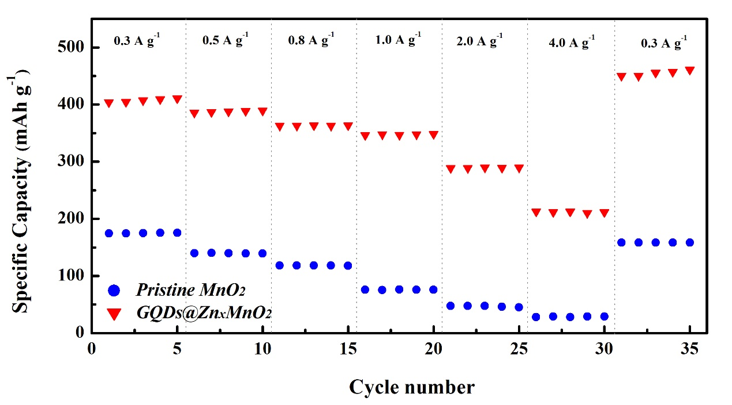
Fig. S4. The comparison of rate capabilities of pristine MnO₂ and GQDs@Zn_{x}MnO₂ cathodes in aqueous ZIBs.

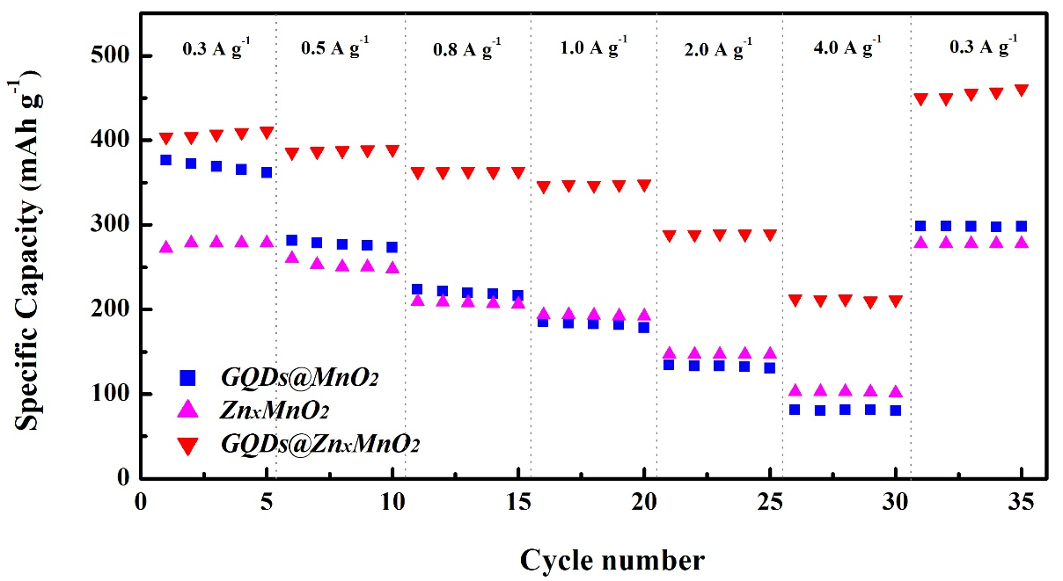
Fig. S5. The comparison of rate capabilities of GQDs@MnO₂, Zn_{x}MnO₂ and GQDs@Zn_{x}MnO₂ cathodes in aqueous ZIBs.
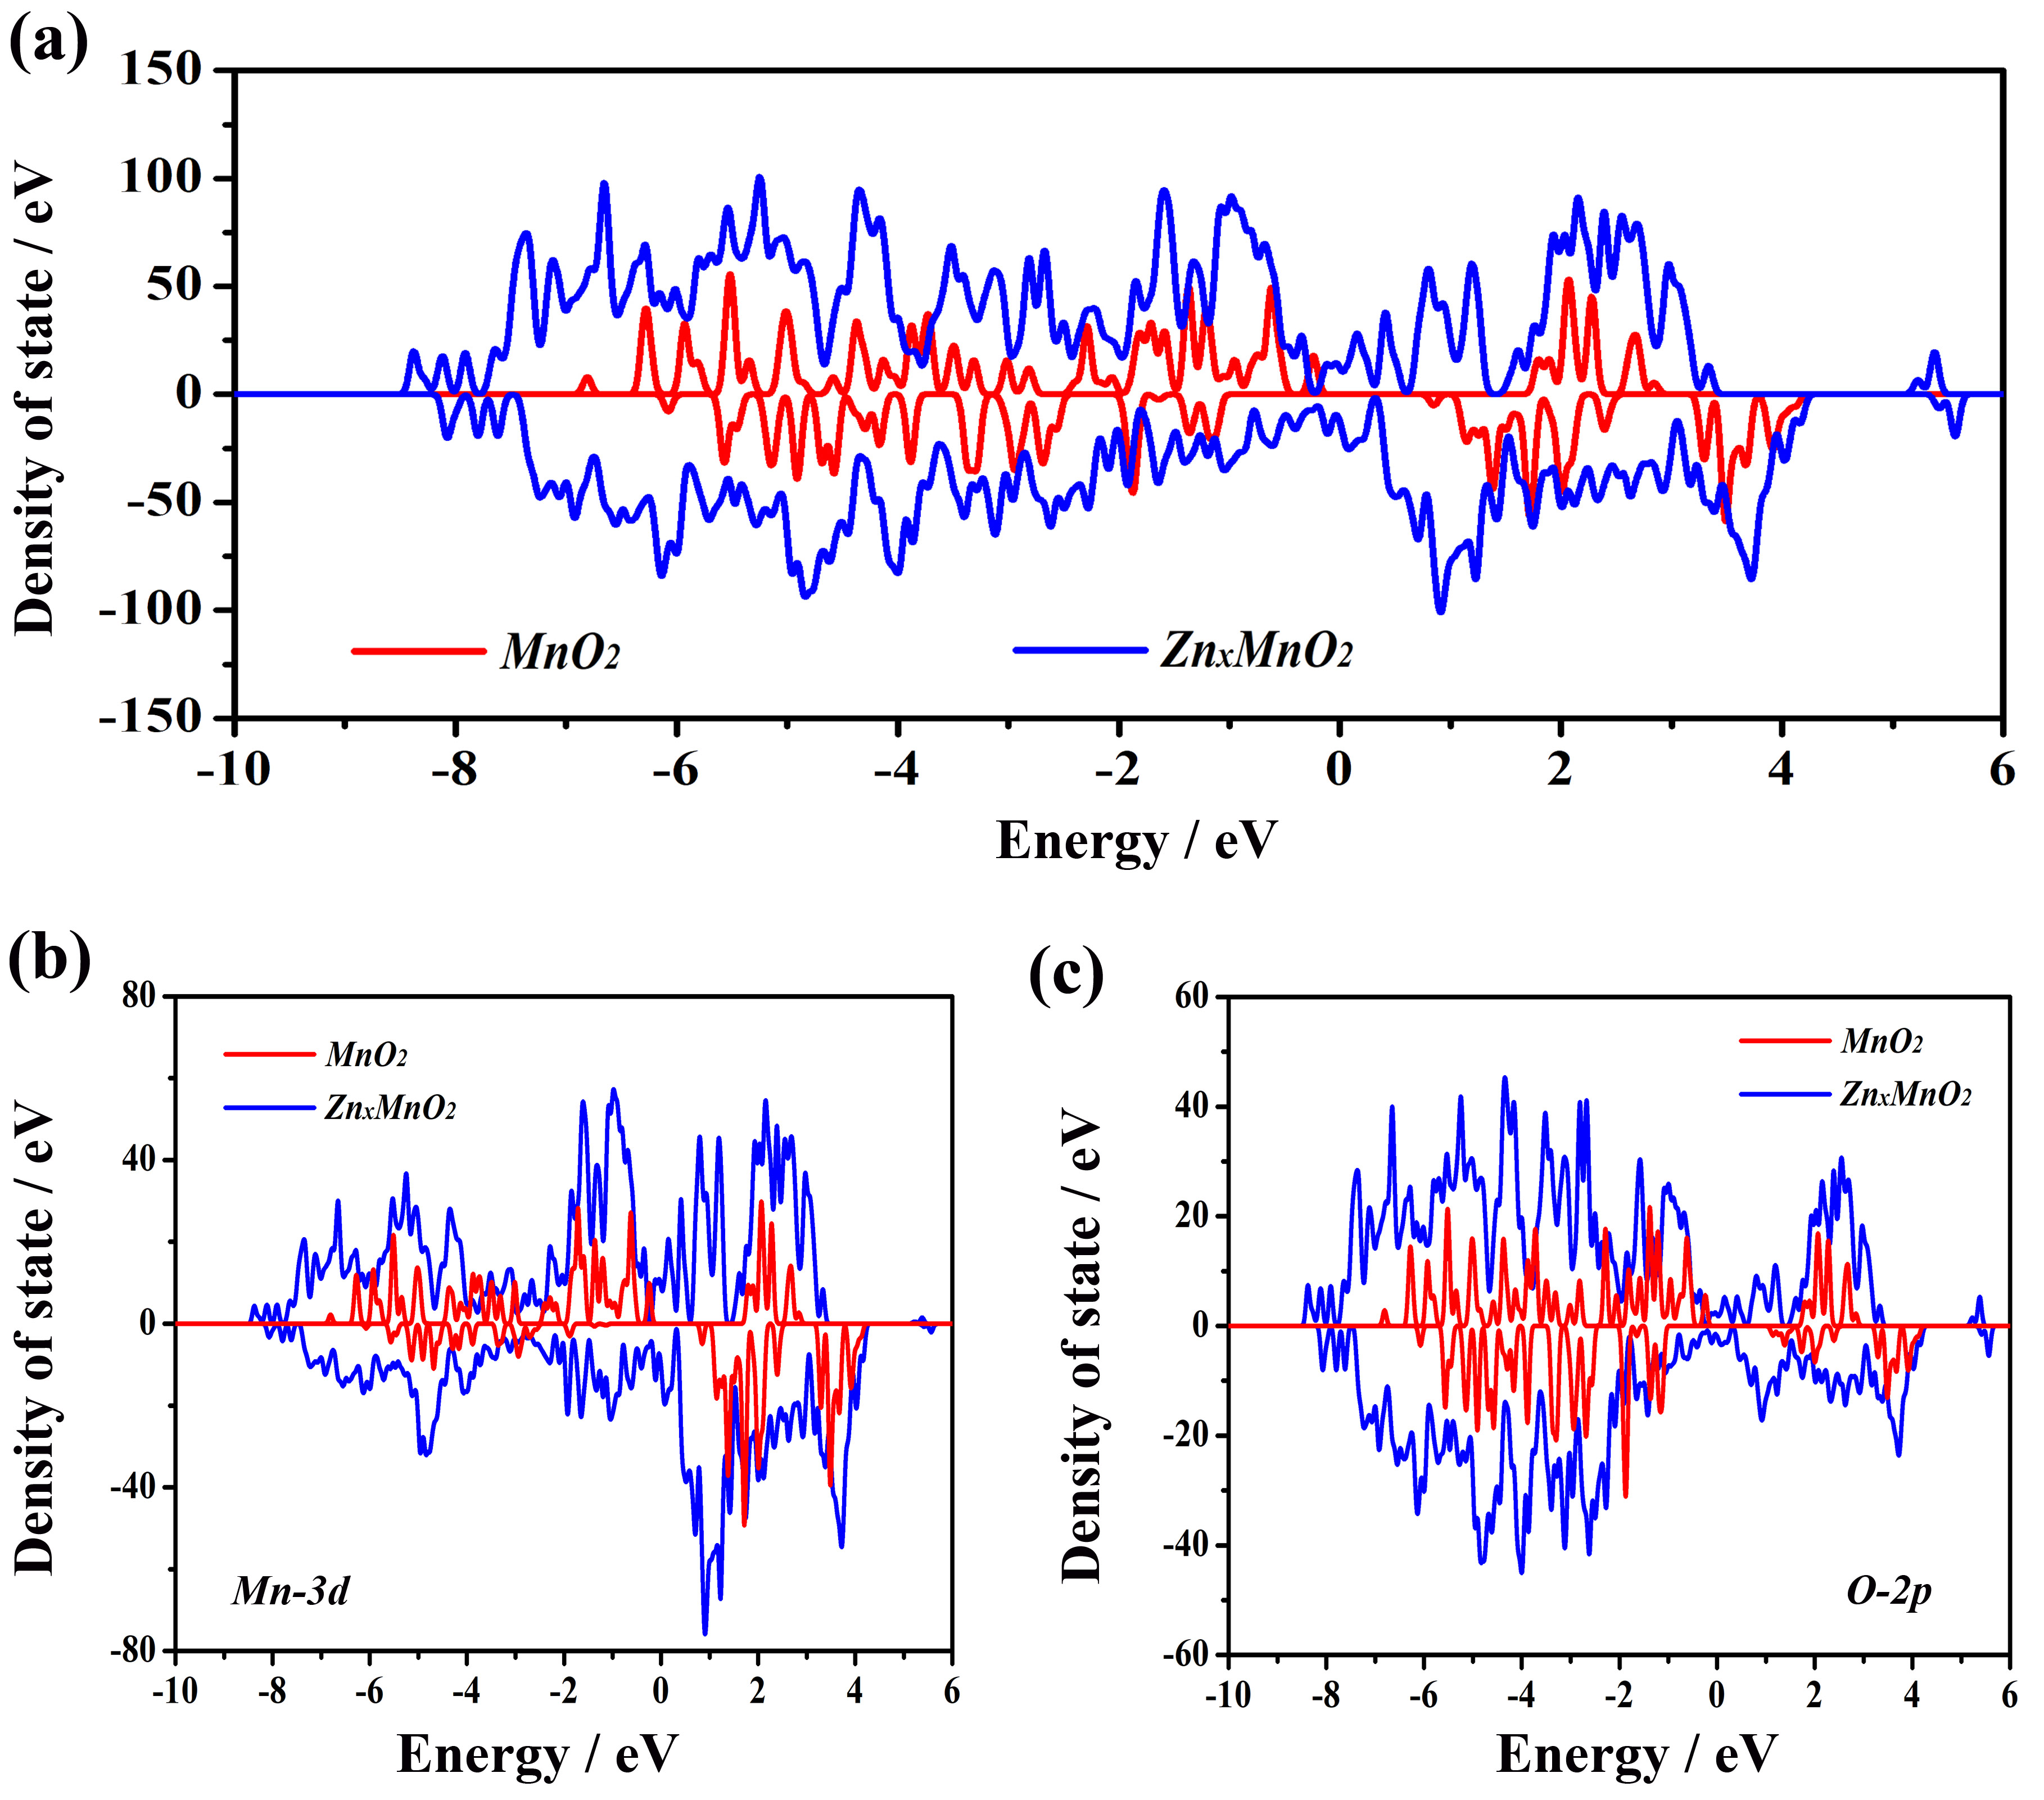
Fig. S6. DFT calculations about the (a) TDOS patterns for pristine MnO₂ and Zn_{x}MnO₂. The corresponding (b) Mn 3d and (c) O 2p PDOS patterns of pristine MnO₂ and Zn_{x}MnO₂.
DFT calculations have been performed to explore the density of states and electronic properties of pristine MnO₂ and Zn_{x}MnO₂. According to the total density of state (TDOS) as shown in Fig. S6a, the pristine MnO₂ possesses a distinct separation between the conduction and valence bands at the Fermi level with a bandgap of ~1.59 eV. By contrast, the bandgap of Zn_{x}MnO₂ is drastically narrowed because of the increased TDOS in the vicinity of Fermi level, suggesting that more charge carriers could be introduced into the Zn_{x}MnO₂ owing to the Zn intercalation, thereby providing the higher carrier and enhanced electronic conductivity for the Zn_{x}MnO₂. Fig. S6b and S6c illustrate the partial density of state (PDOS) for pristine MnO₂ and Zn_{x}MnO₂, respectively. Stronger Mn 3d and O 2p electron states can be observed in the Zn_{x}MnO₂, further indicating the enhanced Mn and O electrochemical activities in the Zn_{x}MnO₂ after the Zn intercalation [S7, S8].

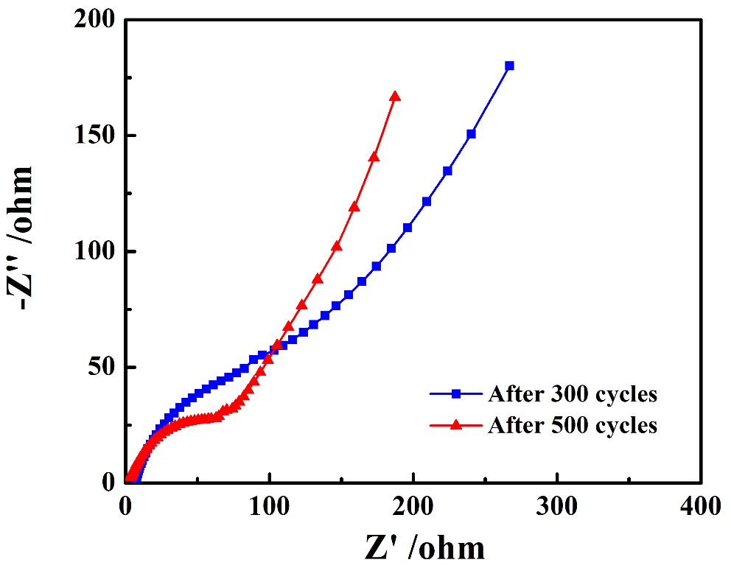
Fig. S7. EIS plots of the aqueous ZIBs based on GQDs@Zn_{x}MnO₂ cathode after 300 and 500 cycles.

References
[S1] D.L. Chao, C. Ye, F.X. Xie, W.H. Zhou, Q.H. Zhang, Q.F. Gu, K. Davey, L. Gu, and S.Z. Qiao, Atomic engineering catalyzed MnO₂ electrolysis kinetics for a hybrid aqueous battery with high power and energy density, Adv. Mater., 32(2020), No. 25, p. 2001894.
[S2] D.L. Chao, W.H. Zhou, C. Ye, Q.H. Zhang, Y.G. Chen, L. Gu, K. Davey, and S.Z. Qiao, An electrolytic Zn–MnO₂ battery for high-voltage and scalable energy storage, Angew. Chem. Int. Ed., 58(2019), No. 23, p. 7823-7828.
[S3] G.Z. Li, Z.X. Huang, J.B. Chen, F. Yao, J.P. Liu, O.L. Li, S.H. Sun, and Z.C. Shi, Rechargeable Zn-ion batteries with high power and energy densities: a two-electron reaction pathway in birnessite MnO₂ cathode materials, J. Mater. Chem. A, 8(2020), No. 4, p. 1975-1985.
[S4] J.H. Huang, Z. Wang, M.Y. Hou, X.L. Dong, Y. Liu, Y.G. Wang, and Y.Y. Xia, Polyaniline-intercalated manganese dioxide nanolayers as a high-performance cathode material for an aqueous zinc-ion battery, Nat. Commun., 9(2018), No. 1, p. 2906.
[S5] Q.H. Zhao, A.Y. Song, S.X. Ding, R.Z. Qin, Y.H. Cui, S.N. Li, and F. Pan, Preintercalation strategy in manganese oxides for electrochemical energy storage: review and prospects, Adv. Mater., 32(2020), No. 50, p. 2002450.
[S6] Y. Zhang, S.J. Deng, G.X. Pan, H.Z. Zhang, B. Liu, X.L. Wang, X.S. Zheng, Q. Liu, X.L. Wang, X.H. Xia, and J.P. Tu, Introducing oxygen defects into phosphate ions intercalated manganese dioxide/vertical multilayer graphene arrays to boost flexible zinc ion storage, Small Methods, 4(2020), p. 1900828.
[S7] Y. Xu, J. Wan, L. Huang, M. Ou, C. Fan, P. Wei, J. Peng, Y. Liu, Y. Qiu, X. Sun, C. Fang, Q. Li, J. Han, Y. Huang, J.A. Alonso, and Y. Zhao, Structure distortion induced monoclinic nickel hexacyanoferrate as high-performance cathode for Na-ion batteries, Adv. Energy Mater., 9(2019), No. 4, p. 1803158.
[S8] C. Chen, M.J. Shi, Y. Zhao, C. Yang, L.P. Zhao, and C. Yan, Al-intercalated MnO₂ cathode with reversible phase transition for aqueous Zn-ion batteries, Chem. Eng. J., 422(2021), p. 130375.
[S9] B.K. Wu, G.B. Zhang, M.Y. Yan, T.F. Xiong, P. He, L. He, X. Xu, and L.Q. Mai, Graphene scroll-coated α-MnO₂ nanowires as high-performance cathode materials for aqueous Zn-ion battery, Small, 14(2018), No. 13, p. 1703850.
[S10] H.L. Pan, Y.Y. Shao, P.F. Yan, Y.W. Cheng, K.S. Han, Z. Nie, C.M. Wang, J.H. Yang, X.L. Li, P. Bhattacharya, K.T. Mueller, and J. Liu, Reversible aqueous zinc/manganese oxide energy storage from conversion reactions, Nat. Energy, 1(2016), No. 5, p. 16039.
[S11] S.-D. Han, S. Kim, D.G. Li, V. Petkov, H.D. Yoo, P.J. Phillips, H. Wang, J.J. Kim, K.L. More, B. Key, R.F. Klie, J. Cabana, V.R. Stamenkovic, T.T. Fister, N.M. Markovic, A.K. Burrell, S. Tepavcevic, and J.T. Vaughey, Mechanism of Zn insertion into nanostructured δ-MnO₂: A nonaqueous rechargeable Zn metal battery, Chem. Mater., 29(2017), No. 7, p. 4874-4884.
[S12] D.H. Wang, L.F. Wang, G.J. Liang, H.F. Li, Z.X. Liu, Z.J. Tang, J.B. Liang, and C.Y. Zhi, A superior δ-MnO₂ cathode and a self-healing Zn-δ-MnO₂ battery, ACS Nano, 13(2019), No. 9, p. 10643-10652.
[S13] L.L. Wang, X. Cao, L.H. Xu, J.T. Chen, and J.R. Zheng, Transformed akhtenskite MnO₂ from Mn₃O₄ as cathode for a rechargeable aqueous zinc ion battery, ACS Sustain. Chem. Eng., 6(2018), p. 16055-16063.
[S14] M.Q. Liu, Q.H. Zhao, H. Liu, J.L. Yang, X. Chen, L.Y. Yang, Y.H. Cui, W.Y. Huang, W.G. Zhao, A.Y. Song, Y.T. Wang, S.X. Ding, Y.L. Song, G.Y. Qian, H.B. Chen, and F. Pan, Tuning phase evolution of β-MnO₂ during microwave hydrothermal synthesis for high-performance aqueous Zn ion battery, Nano Energy, 64(2019), p. 103942.
[S15] I. Stoševski, A. Bonakdarpour, B. Fang, S.T. Voon, and D.P. Wilkinson, Hausmannite Mn₃O₄ as a positive active electrode material for rechargeable aqueous Mn-oxide/Zn batteries, Int. J. Energy Res., 45(2021), No. 1, p. 220-230.
[S16] Y.Z. Liu, X.W. Chi, Q. Han, Y.X. Du, J.Q. Huang, Y. Liu, and J.H. Yang, α-MnO₂ nanofibers/carbon nanotubes hierarchically assembled microspheres: Approaching practical applications of high-performance aqueous Zn-ion batteries, J. Power Sources, 443(2019), p. 227244.
[S17] C. Wang, Y.X. Zeng, X. Xiao, S.J. Wu, G.B. Zhong, K.Q. Xu, Z.F. Wei, W. Su, and X.H. Lu, γ-MnO₂ nanorods/graphene composite as efficient cathode for advanced rechargeable aqueous zinc-ion battery, J. Energy. Chem., 43(2020), p. 182-187.
[S18] K. Sada, B. Senthilkumar, and P. Barpanda, Cryptomelane K_{1.33}Mn₈O₁₆ as a cathode for rechargeable aqueous zinc-ion batteries, J. Mater. Chem. A, 7(2019), No. 41, p. 23981-23988.
[S19] J. Mao, F.F. Wu, W.H. Shi, W.X. Liu, X.L. Xu, G.F. Cai, Y.W. Li, and X.H. Cao, Preparation of polyaniline-coated composite aerogel of MnO₂ and reduced graphene oxide for high-performance zinc-ion battery, Chin. J. Polym. Sci., 38(2020), p. 514-521.
[S20] J.H. Huang, Z. Wang, M.Y. Hou, X.L. Dong, Y. Liu, Y.G. Wang, and Y.Y. Xia, Polyaniline-intercalated manganese dioxide nanolayers as a high-performance cathode material for an aqueous zinc-ion battery, Nat. Commun., 9(2018), No. 1, p. 2906.
[S21] H.J. Peng, H.Q. Fan, C.H. Yang, Y.P. Tian, C. Wang, and J.N. Sui, Ultrathin δ-MnO₂ nanoflakes with Na⁺ intercalation as a high-capacity cathode for aqueous zinc-ion batteries, RSC Adv., 10(2020), No. 30, p. 17702-17712.

