Alkyl dimethyl betaine activates the low-temperature collection capacity of sodium oleate for scheelite
Xu Wang^{1,2,4)}, Zhengquan Zhang ^{1,2)}, Yanfang Cui ^{1,2)}, Wei Li^{1,2)}, Congren Yang^{1,2)}, Hao Song^{3,4)}, Wenqing Qin ^{1,2), ✉}, Fen Jiao^{1,2), ✉}
1) School of Minerals Processing and Bioengineering, Central South University, Changsha 410083, China
2) Key Laboratory of Hunan Province for Clean and Efficient Utilization of Strategic Calcium-containing Mineral Resources, Central South University, Changsha 410083, China
3) College of Engineering, Drexel University, Philadelphia, PA 19102, USA
4) Luoyang Zhenbei Industry and Trade Co., Ltd, Luoyang 47100, China
✉Corresponding authors: Wenqing Qin E-mail:qinwenqing369@126.com;
Fen Jiao: E-mail: jfen0601@126.com

Table S1. XRF analysis results of a scheelite single mineral wt%
WO₃ | CaO | SiO₂ | Fe
77.56 | 20.92 | 0.43 | 0.57

Table S2. XRF characterization of the actual ore wt%
F | Na | Mg | Al | Si | P | S | K
0.386 | 0.727 | 1.108 | 2.52 | 19.243 | 0.185 | 0.185 | 0.983
Ca | Ti | Mn | Fe | Cu | Zn | Rb | Sr
21.054 | 0.224 | 1.027 | 6.619 | 0.013 | 0.051 | 0.009 | 0.005
Y | Zr | Mo | W | Hg | Pb | O
0.002 | 0.014 | 0.135 | 0.052 | 0.007 | 0.012 | 31.135

Table S3. Mineral liberation analysis of the actual ore wt%
Scheelite | Wolframite | Molybdenite | Powethite | Pyrite | Pyrrhotite
0.12 | Occasional | 0.24 | 0.03 | 0.41 | 0.41
Blende | Hematite/  lignite | Garnet | Wollastonite | Pyroxene | Hornblende
Trace | 0.19 | 21.03 | 35.32 | 13.78 | 1.21
Quartz | Feldspar | Mica | Calcite/  dolomite | Fluorite | Chlorite
8.50 | 4.21 | 2.40 | 5.21 | 2.74 | 0.35
Montmorillonite | Talc | Serpentine | Titanite | Apatite | Others
2.70 | 0.34 | 0.12 | 0.10 | 0.43 | 0.28

Fig. S1. Structural formula of ADB.
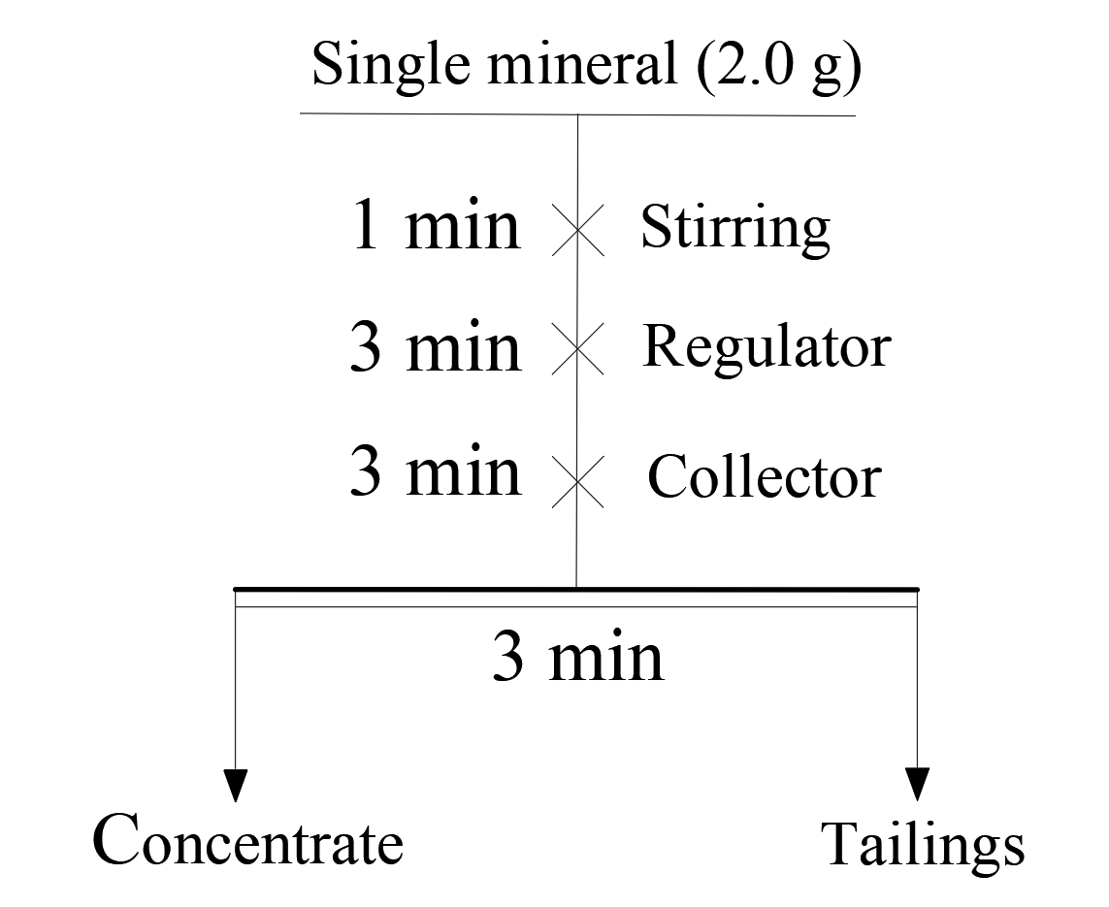
Fig. S2. Flowsheet of the micro-flotation test.
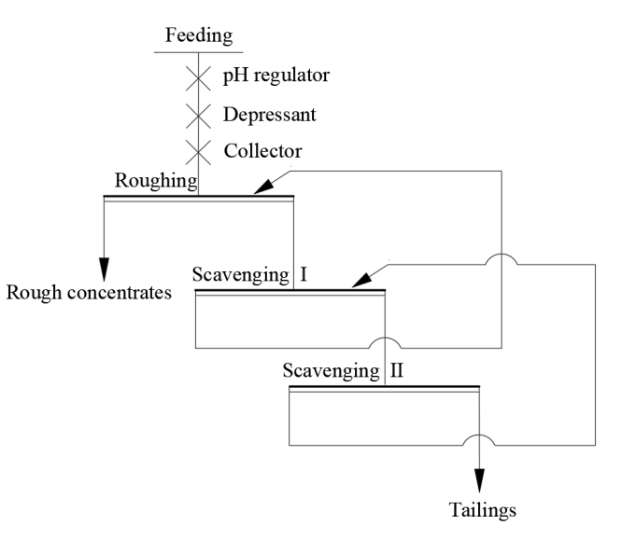
Fig. S3. Scheelite roughing process.
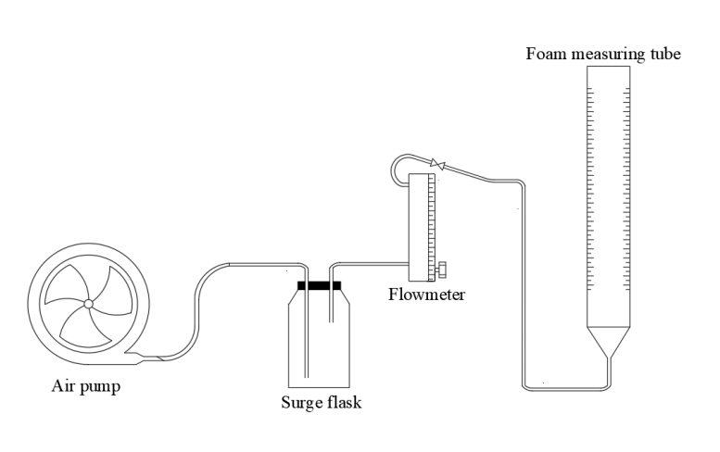
Fig. S4. Device used in testing the foaming performance.

