Supplementary Information
Molecular mechanism of fly ash affecting the performance of cemented backfill material
Shuo Yang¹⁾, Jiangyu Wu^{1,3,4),}, Hongwen Jing¹⁾, Xinguo Zhang^{2),}, Weiqiang Chen⁵⁾, Yiming Wang¹⁾, Qian Yin¹⁾, and Dan Ma⁶⁾
1) State Key Laboratory for Geomechanics and Deep Underground Engineering, China University of Mining and Technology, Xuzhou 221116, China
2) Shandong Key Laboratory of Mining Disaster Prevention and Control, Shandong University of Science and Technology, Qingdao 266590, China
3) State Key Laboratory of High Performance Civil Engineering Materials, Jiangsu Research Institute of Building Science Co., Ltd., Nanjing 210008, China
4) Department of Materials, University of Oxford, Parks Rd, Oxford, OX1 3PH, United Kingdom
5) Department of Mechanical, Aerospace and Civil Engineering, School of Engineering, The University of Manchester, Manchester M13 9PL, United Kingdom
6) School of Mines, China University of Mining and Technology, Xuzhou 221116, Jiangsu, China
Corresponding authors: Jiangyu Wu E-mail: wujiangyu@cumt.edu.cn; Xinguo Zhang E-mail: zhangxg1229@163.com

Fig. S1. XRD spectrum of experimental materials: (a) XRD spectrum of CPC32.5; (b) XRD spectrum of FA.
Fig. S2. PSD of experimental materials: (a) PSD of CPC32.5; (b) PSD of FA; (c) PSD of tailings.

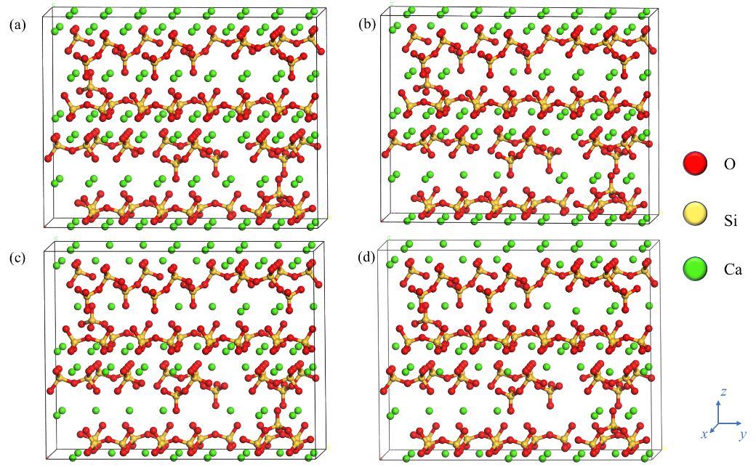
Fig. S3. C–S–H model of four Ca/Si ratios: (a) 1.62; (b) 1.42; (c) 1.22; (d) 1.02.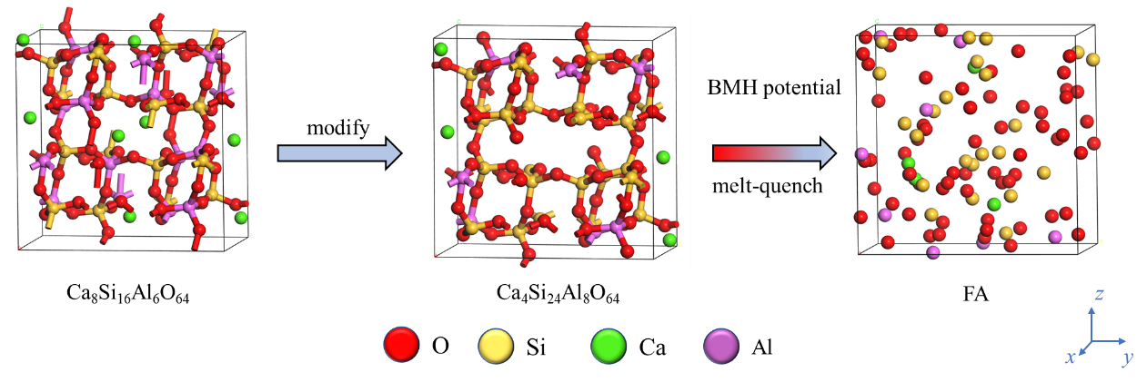
Fig. S4. Process of constructing the initial cell model of FA.
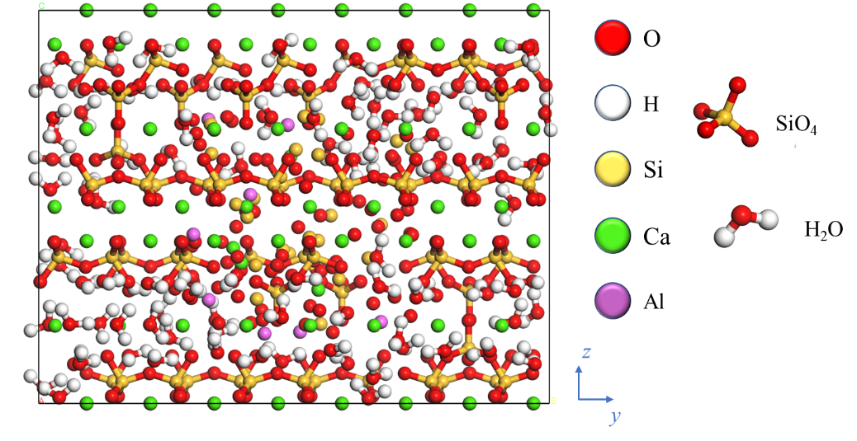
Fig. S5. 22wt% dosage of FA, Ca/Si ratio of 1.62 initial combination model.
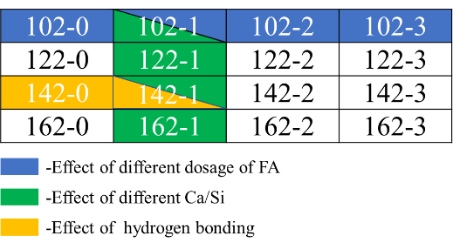
Fig. S6. Models mainly discussed in molecular dynamics simulations. (162 means Ca/Si ratio of 1.62 and the number after it refers to the number of parts of fly ash, one part of fly ash is 22wt% of CSH mass fraction)

