Supplementary Information

Effects of conductive agent type on lithium extraction from salt lake brine with LiFePO₄ electrodes
Zhen Zhang^{1,2)*}, Pan Luo^{1,2)*}, Yan Zhang^{1,2)}, Yuhan Wang^{1,2)}, Li Liao^{1,2)}, Bo Yu^{1,2)}, Mingshan Wang^{1,2)}, Junchen Chen^{1,2)}, Bingshu Guo^{1,2)}, and Xing Li^{1,2),}
1) School of New Energy and Materials, Southwest Petroleum University, Chengdu 610500, China
2) Energy Storage Research Institute, Southwest Petroleum University, Chengdu 610500, China

Fig. S1. The SEM of the raw materials (a)LiFePO₄, (b)AB, (c)MWCNTs; XRD patterns of (d)LiFePO₄, (e)AB, (f)MWCNTs.
Fig. S2. (a) Electrochemical continuous lithium extraction device and (b) Schematic diagram of continuous lithium extraction device.
In this paper, an electrochemical continuous lithium extraction device is designed as shown in Fig.S2(a), and Fig.S2(b) is the schematic diagram of the continuous lithium extraction process of the device. Redox reversible lithium-lean iron phosphate is used as the negative electrode and lithium-rich lithium iron phosphate as the positive electrode to form an electrochemical lithium extraction system. Only lithium ions in the solution are extracted, and no polluting waste is generated. The main body of the unit consists of 4 chambers, each 20×20×10 cm³, and the entire unit can process 8L of salt lake brine at the same time. Each chamber includes a lithium-rich lithium iron phosphate cathode working electrode in a solution of 0.5 mol L⁻¹ sodium chloride to be enriched with lithium ions. It also includes a lithium-lean lithium iron phosphate electrode in a simulated solution of salt lake brine to be extracted from lithium ions. The two electrodes and solution are separated by an anionic diaphragm in the middle. On the side wall of the cavity, there are salt lake brine simulation solution inlet, sodium chloride solution inlet, salt lake brine simulation solution wastewater outlet, enrichment solution outlet. The positive and negative working electrodes are put in from above the cavity, and the liquid pump controls the inflow and outflow of various solutions, the inlet and outlet pipelines are switched according to the lithium insertion situation, and the positive and negative electrode exchange is also exchanged according to the lithium ion embedding of the electrode. The working method of this continuous operation of the electrochemical lithium extraction device includes the following steps: firstly, the simulated solution of salt lake brine to be extracted in the salt lake brine solution storage tank to be extracted lithium ions is filled with a lithium-poor lithium iron phosphate electrode electrochemical reaction chamber, and the 0.5mol L⁻¹ sodium chloride solution to be enriched with lithium ions in the sodium chloride storage tank is filled with a lithium-rich lithium iron phosphate electrode electrochemical reaction chamber, and after the above process, all four chambers are filled with working solutions. The lithium ions in the salt lake brine simulation solution are captured by the lithium iron phosphate electrode (Li_{1-x}FePO₄+ x Li⁺+x e⁻→ LiFePO₄) through the power supply to the electrochemical reaction chamber, and the Li⁺ in the lithium-rich lithium iron phosphate is removed into the sodium chloride solution (LiFePO_{4−x} Li⁺−x e⁻→ Li_{1−x}FePO₄), and the chloride ions in the salt lake brine simulation solution enter the sodium chloride solution through the anion separator to form lithium chloride with lithium ions. Achieve the purpose of enriching lithium ions in salt lake brine. After the completion of one extraction, the wastewater of the salt lake brine simulation solution after the reaction in the negative electrode chamber of the electrochemical reaction was discharged to the waste tank, and the salt lake brine simulation solution was continuously introduced into the chamber, and the sodium chloride solution to be enriched continued unchanged. Until the enriched solution reaches the working saturation state or the lithium ions of the lithium-rich lithium iron phosphate electrode are removed, the enriched solution is discharged to exchange the positive and negative electrodes to continue the lithium extraction reaction. The above process is repeated all the time to achieve continuous lithium extraction. The lithium extraction process adopts constant current or constant pressure mode.
The continuous lithium extraction system provided by this unit can be applied to the recovery of lithium in lithium-containing solutions including salt lake brine, seawater, high magnesium-lithium ratio solutions and any lithium-ion containing waste liquid.
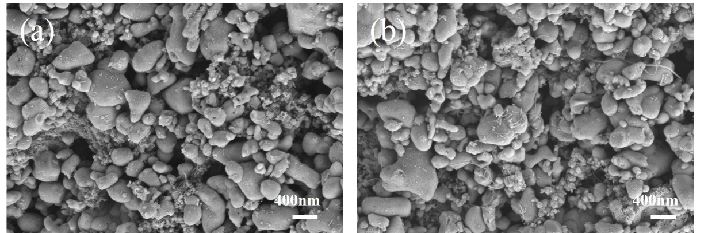
Fig. S3. Microscopic morphology SEM images of LFP-AB/MWCNTs electrode surface after 5 and 30 cycle, a) 5 cycles, b) 30 cycles.
As shown in Fig. S3, there is no significant change of the electrode surface morphology and conductive network after 5 and 30 cycles, this indicated that the hybrid conductive agent electrode can effectively maintain the electrode conductive network during electrode cycling.

