Supplementary Information

Process–Structure–Property Relationship for Plasma-Sprayed Iron-Based Amorphous-Crystalline Composite Coatings
Abhishek Pathak¹⁾, Biswajyoti Mukherjee²⁾, Krishna Kant Pandey²⁾, Aminul Islam²⁾, Pavan Bijalwan¹⁾, Monojit Dutta¹⁾, Atanu Banerjee¹⁾ Anup Kumar Keshri²⁾

- R&D, Tata Steel, Jamshedpur 831001, Jharkhand, India.
- Plasma Spray Coating Laboratory, Metallurgical and Materials Engineering, Indian Institute of Technology Patna, Bihta 801106, India

Corresponding author: Anup Kumar Keshri; E-mail: anup@iitp.ac.in

Table S1. Average temperature and velocity of the Fe based powder particle measured at several different parameters during the Accuraspray experiment
No. | Accuraspray parameter | Average temp. / °C | Average velocity / (m⋅s⁻¹)
1 | P1G1F1S1 | 2248 | 128.5
2 | P1G2F1S1 | 2170 | 129
3 | P1G3F1S1 | 2162 | 128
4 | P2G1F1S1 | 2281 | 141
5 | P2G2F1S1 | 2218 | 147.5
6 | P2G3F1S1 | 2219 | 141.5
7 | P3G1F1S1 | 2298 | 153
8 | P3G2F1S1 | 2271 | 164
9 | P3G3F1S1 | 2259 | 171
10 | P1G1F2S1 | 2207 | 130
11 | P1G2F2S1 | 2161 | 130
12 | P1G3F2S1 | 2150 | 132.5
13 | P2G1F2S1 | 2243 | 146
14 | P2G2F2S1 | 2219 | 148
15 | P2G3F2S1 | 2173 | 149.5
16 | P3G1F2S1 | 2327 | 159
17 | P3G2F2S1 | 2281 | 167
18 | P3G3F2S1 | 2250 | 172
19 | P1G1F1S2 | 2172 | 124
20 | P1G2F1S2 | 2158 | 112
21 | P1G3F1S2 | 2146 | 92.5
22 | P2G1F1S2 | 2219 | 136
23 | P2G2F1S2 | 2238 | 145.5
24 | P2G3F1S2 | 2196 | 142.5
25 | P3G1F1S2 | 2298 | 158
26 | P3G2F1S2 | 2253 | 164
27 | P3G3F1S2 | 2210 | 170
28 | P1G1F2S2 | 2170 | 125.5
29 | P1G2F2S2 | 2136 | 126
30 | P1G3F2S2 | 2120 | 128
31 | P2G1F2S2 | 2221 | 139
32 | P2G2F2S2 | 2190 | 147
33 | P2G3F2S2 | 2160 | 147
34 | P3G1F2S2 | 2246 | 157
35 | P3G2F2S2 | 2230 | 166.5
36 | P3G3F2S2 | 2180 | 168

Section S1. Test of the powder flowability

Flowability of the powder was characterized by keeping the theoretical feed rate 4 g/min. carrier gas pressure 414 kPa and carrier gas flow as 0.28 m³/h and vibrator air pressure as 138 kPa using the Metco powder feeder. Three reading were recorded for the feed rate and tabulated in Table S2. All the three readings are very consistent and the average flowability of the power was found to be 98.6 %.

Table S2. Flowability of the Alloy-1 powder by keeping the theoretical feed rate as 4 g/min, carrier gas pressure 414 kPa and carrier gas flow as 0.28 m³/h and vibrator air pressure as 138 kPa

S. No. | Exp. feed rate (g/min) | Flowability  / %
1 | 3.96 | 99
2 | 3.98 | 99.5
3 | 3.90 | 97.5
Avg. | 3.94 | 98.6

Fig. S1

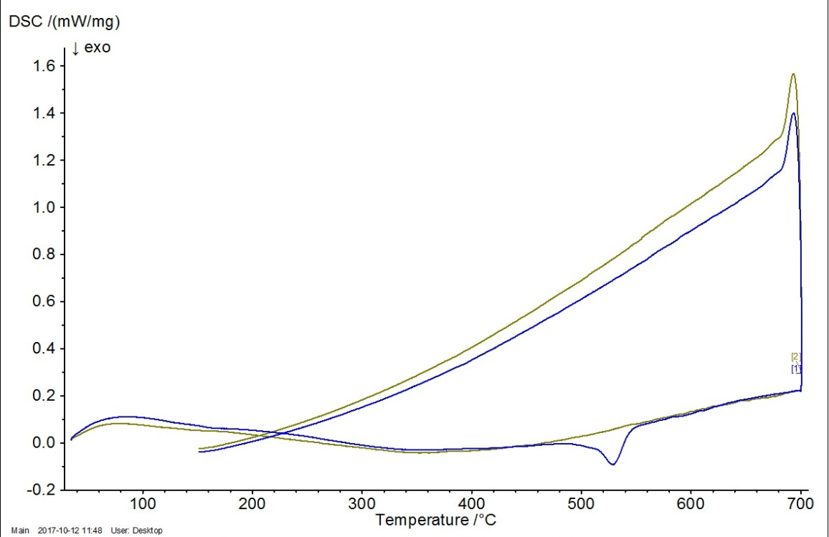

Fig. S1: DSC isotherm of the Fe based powder

Fig. S2

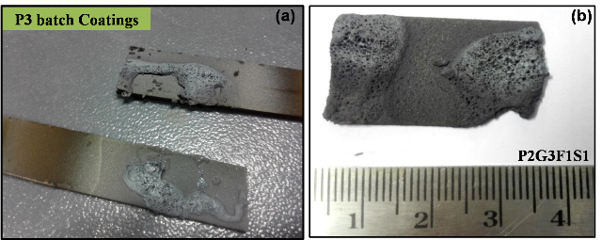

Fig. S2. Digital image of the coatings fabricated using (a) P3 = 35 kW showing melted coatings and (b) P2G3F1S1 also showing sign of melting.

Fig. S3:
Fig. S3. DSC isotherm for the Fe based coatings synthesized at parameters set (a) P1G3F2S2; (b) P1G2F1S1; (c) P2G1F2S1; (d) P1G3F1S2 and (e) P1G2F2S1.

Table S3. DSC of Fe based alloys free standing coatings depicting the enthalpy of crystallization (ΔH) of all the five coatings.
S. No. | Sample codes | ΔH (kJ/g)  from DSC
1 | P1G2F1S1 | 10.52
2 | P1G2F2S1 | 11.00
3 | P1G3F1S2 | 12.12
4 | P1G3F2S2 | 8.60
5 | P2G1F2S1 | 8.81

