High-performance triboelectric nanogenerator based on ZrB₂/ polydimethylsiloxane for metal corrosion protection
Xiucai Wang^{1,2),}, Naijian Hu²⁾, Jia Yang²⁾, Jianwen Chen²⁾, Xinmei Yu²⁾, Wenbo Zhu³⁾, Chaochao Zhao⁴⁾, Ting Wang⁵⁾, and Min Chen^{1),}

1) School of Materials Science and Hydrogen Energy, Guangdong Key Laboratory for Hydrogen Energy Technologies, Foshan University, Foshan 528000, China
2) School of Electronic and Information Engineering, Foshan University, Foshan 528000, China
3) Mechatronics Engineering and Automation College, Foshan University, Foshan 528200, China
4) Department of Biomedical Engineering, School of Medicine, Foshan University, Foshan 528225, China
5) Guangdong Provincial Key Laboratory of Electronic Functional Materials and Devices, Huizhou University, Huizhou 516001, China
(Received: 25 December 2022; revised: 11 February 2023; accepted: 6 March 2023)

Corresponding authors: Xiucai Wang E-mail: wxc5168@163.com; Min Chen E-mail: minchen1981@126.com
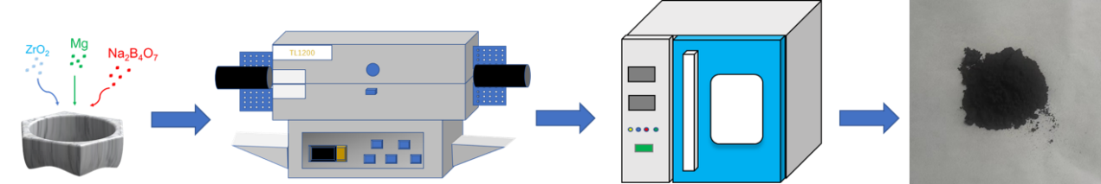
Fig. S1. Preparation process of ZrB₂ nanoparticles.
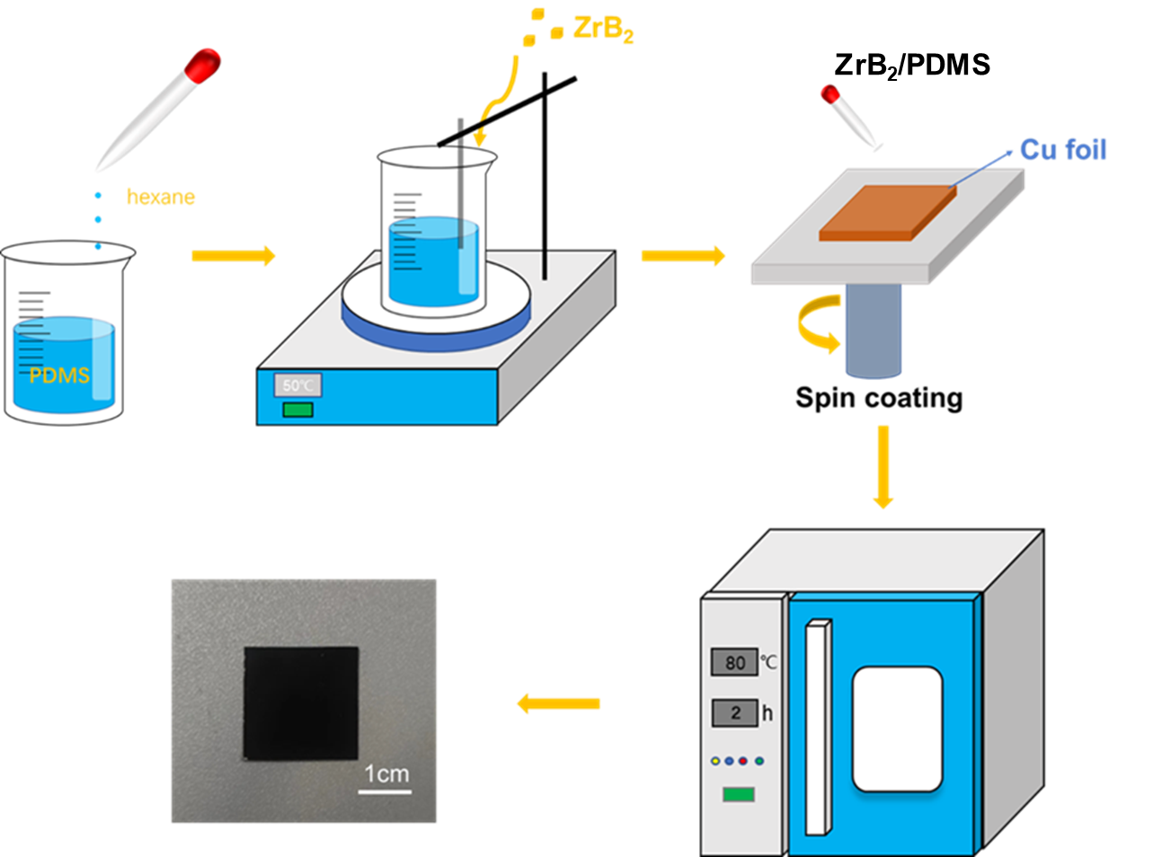
Fig. S2. Preparation process of ZrB₂/PDMS films.
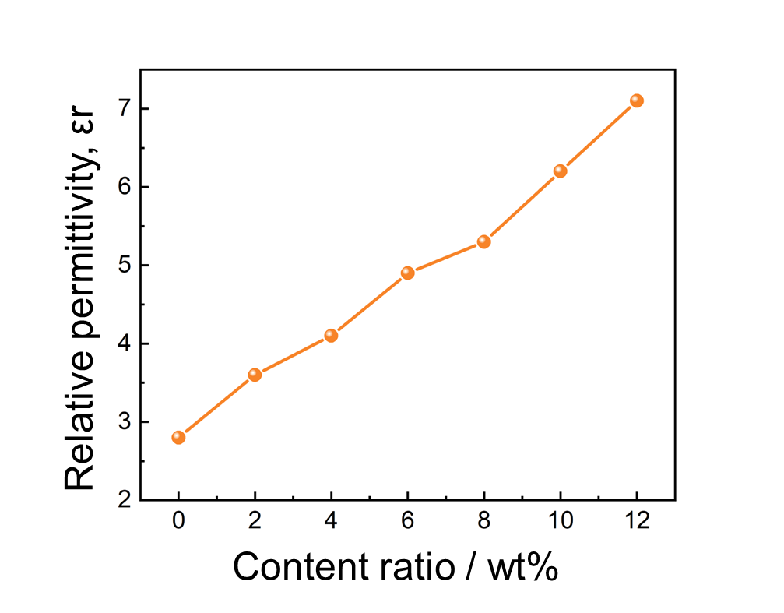
Fig. S3. Dielectric constant of PDMS films at different concentrations.

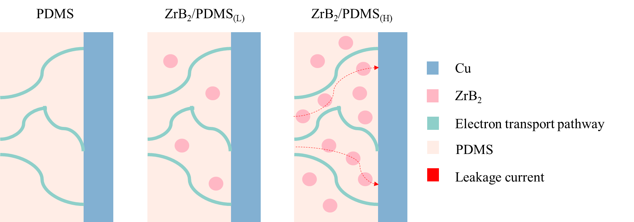
Fig. S4. Modeling of electronic pathways in films of different concentrations.
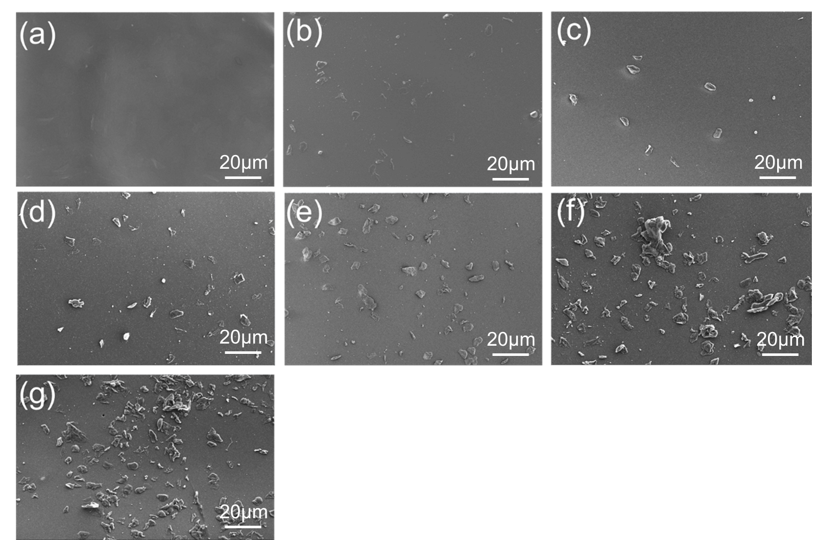
Fig. S5. SEM images of different concentrations of ZrB₂/PDMS thin films: (a) 0wt%; (b) 2wt%; (c)4wt%; (d)6wt%; (e) 8wt%; (f) 10wt%; (g) 12wt%.
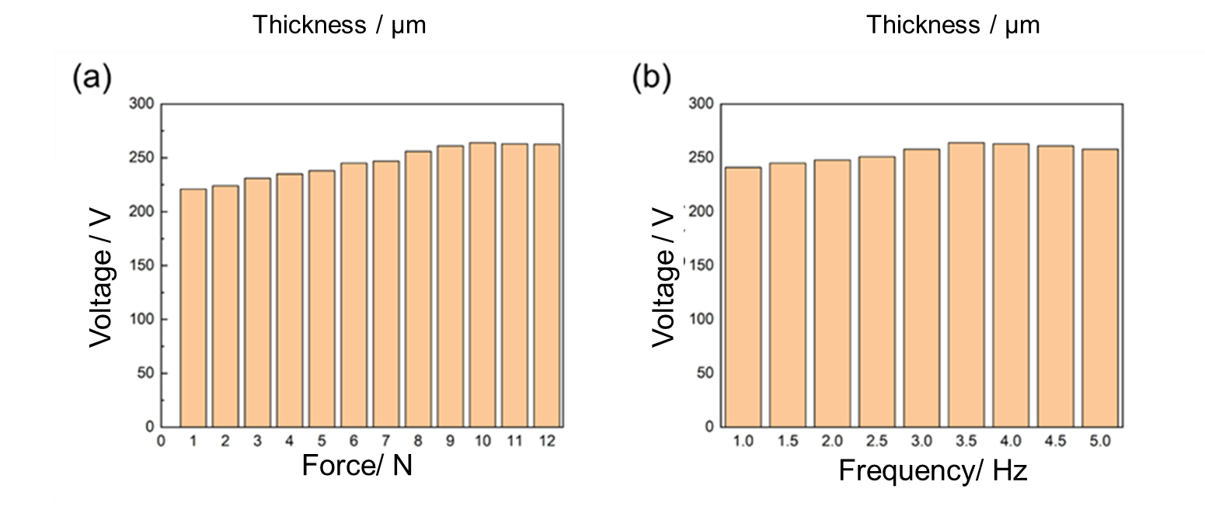
Fig. S6. (a) Output various with force and voltage; (b) output various with frequency and voltage.
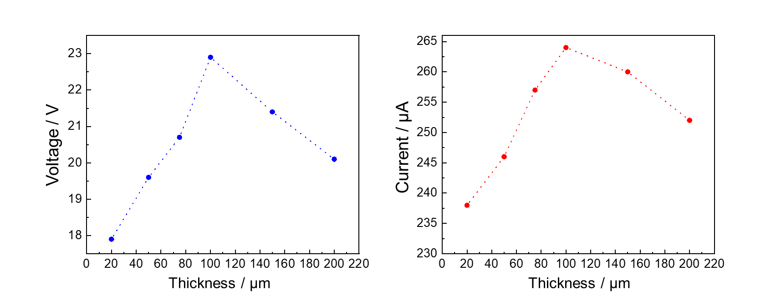
Fig. S7. ZrB₂ films thickness as a function of (a) voltage and (b) current.
Table S1. Comparison of the output performance of TENGs
Positive  triboelectric layer | Negative  triboelectric layer | Voltage / V | Current / μA | Ref.
Al | PDMS/TiN | 51.8 | 36.8 | [1]
Al | PDMS/ZnFe₂O₄ | 60 | 7.4 | [2]
Chitosan/Albumin | PTFE | 77 | 13 | [3]
Al | PDMS/BT-MWCNT | 150 | 6.5 | [4]
PVA/Rice | FEP | 96 | 0.6 | [5]
Rice paper | PVC | 224 | 6 | [6]
Nylon | silica gel/Ag | 102.8 | 4.42 | [7]
Nylon-11 | PVC/KN | 208 | 24 | [8]
Al | PDMS/ ZrB₂ | 264 | 22.9 | This work
[1]Y. Xiao, X. Lv, L. Yang, M. Niu, and J. Liu, A High‐Performance Flexible Triboelectric Nanogenerator Based on Double‐Sided Patterned TiN/PDMS Composite Film for Human Energy Harvesting, Energy Technology, 9(2021), No.12, p.2100665.
[2] A. Nawaz, M.Kumar, N.Sarwar, D. i.Jeong, and D. H.Yoon, ZnFe₂O₄@PDMS composite film for mechanical energy harvesting and tactile sensing application. Materials Technology 37(2022), p.2659-2667.
[3]T. Charoonsuk, S. Pongampai, P. Pakawanit, and N. Vittayakorn, Achieving a highly efficient chitosan-based triboelectric nanogenerator via adding organic proteins: Influence of morphology and molecular structure, Nano Energy, 89(2021), p.106430.
[4]S. Feng, H. Zhang, D. He, Y. Xu, A. Zhang, Y. Liu, and J. Bai, Synergistic Effects of BaTiO₃/Multiwall Carbon Nanotube as Fillers on the Electrical Performance of Triboelectric Nanogenerator Based on Polydimethylsiloxane Composite Films, Energy Technology, 7(2019), No. 6, p.1900101.
[5]A. P. Sathya Prasanna, V. Vivekananthan, G. Khandelwal, N. R. Alluri, N. P. Maria Joseph Raj, M. Anithkumar, and S.-J. Kim, Green Energy from Edible Materials: Triboelectrification-Enabled Sustainable Self-Powered Human Joint Movement Monitoring, ACS Sustainable Chemistry & Engineering, 10(2022), No. 20, p.6549.
[6]Y. Chi, K. Xia, Z. Zhu, J. Fu, H. Zhang, C. Du, and Z. Xu, Rice paper-based biodegradable triboelectric nanogenerator, Microelectronic Engineering, 216(2019), p.111059.
[7]P. Zhang, P. F. Li, H. H. Zhang, and L. Deng, Effect of Ag nanoparticle size on triboelectric nanogenerator for mechanical energy harvesting, Nanotechnology, 33(2022), No.47.
[8]H. Zhang, Y. Guo, J. Cui, J. Guo, G. Zhao, and B. Yang, Lead‐Free KNbO₃ Nanoblocks Improved Triboelectric Nanogenerator with High Output Performance and Self‐Powered Anticorrosion System, ChemistrySelect, 6(2021), No.13, p.3169.

