Support Information
Synthesis of crystal-phase and color tunable mixed anion co-doped titanium oxides and their controllable photocatalytic activity
Jingdi Cao¹⁾, Takuya Hhasegawa¹⁾, Yusuke Asakura²⁾, Akira Yamakata³⁾, Peng Sun^{1,4)}, Wenbin Cao⁴⁾, and Shu Yin^{1,5),}
1) Institute of Multidisciplinary Research for Advanced Materials, Tohoku University 2-1-1, Katahira, Aoba-ku, Senda 980-8577, Japan
2) Kagami Memorial Research Institute for Materials Science and Technology, Waseda University 2-8-26, Nishi-waseda, Shinju-ku 169-0051, Japan
3) Graduate School of Natural Science and Technology, Okayama University, 3-1-1, Tsushima-naka, Kita-ku, Okayama 700-8530, Japan
4) University of Science and Technology Beijing, 30 Xueyuanlu, Haidian District, Beijing 100083, China
5) Advanced Institute for Materials Research (WPI-AIMR), Tohoku University 2-1-1, Katahira, Aoba-ku, Sendai 980-8577, Japan

Scheme S1. Synthesis flow chart for B and N co-doped TiO₂.
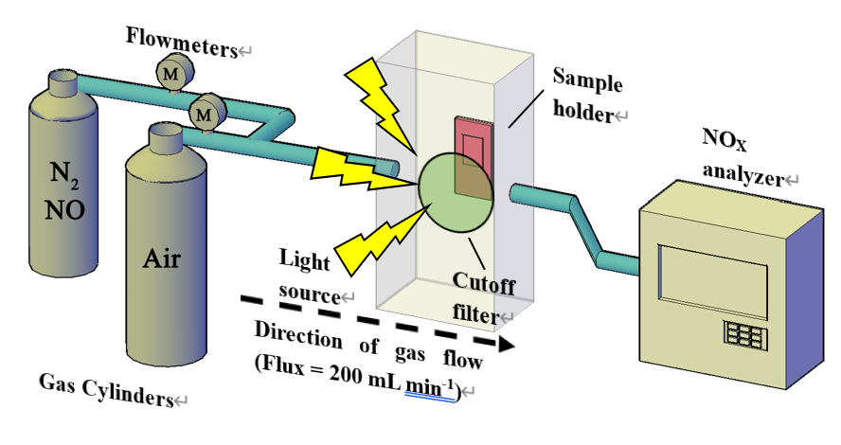
Scheme S2. The schematic light-driven NO decomposition system.

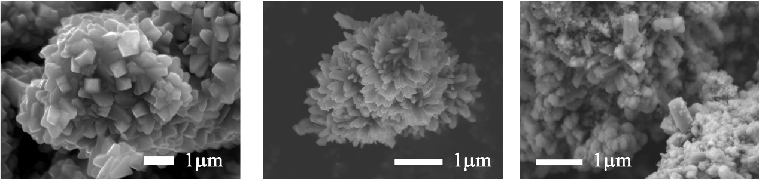
- (b) (c)
Fig. S1. SEM images of the as-prepared (a) BN-Ana, (b) BN-Rut, (c) BN-Bro particles.

Table S1. Color parameters of samples with different nitridation time at 600ºC in terms of CIELAB system
Phase | Nitridation time / min | Sample name | L* | a* | b* | h˚ | C
Anatase | 30 | BNA_30 | 39.15 | 10.01 | 6.29 | 32 | 12
 | 60 | BNA _60 | 39.61 | 9.01 | 6.17 | 34 | 11
 | 120 | BNA _120 | 37.36 | 7.75 | 4.51 | 30 | 9
Rutile | 30 | BNR_30 | 53.44 | -4.12 | 4.03 | 316 | 6
 | 60 | BNR _60 | 60.52 | -3.83 | 4.54 | 310 | 6
 | 120 | BNR _120 | 47.70 | -3.32 | 2.69 | 321 | 4
Brookite | 30 | BNB _30 | 56.63 | -3.28 | 7.12 | 295 | 8
 | 60 | BNB _60 | 60.41 | -2.92 | 6.61 | 294 | 7
 | 120 | BNB _120 | 54.60 | -3.35 | 6.99 | 296 | 8
Fig. S2. The dynamic changes in L* a* b* parameters were drawn as the function of nitridation time.

Table S2. Color parameters of pre-oxidized samples with different nitridation time at 600ºC in terms of CIE L*a*b* coordinate
Phase | Nitridation time / h | Sample name | L* | a* | b* | h˚ | C
Anatase | 1 | BNAO_1 | 76.05 | 4.45 | 17.40 | 76 | 18
 | 2 | BNAO_2 | 59.08 | 11.59 | 16.62 | 55 | 20
 | 3 | BNAO_3 | 39.20 | 6.52 | 4.48 | 34 | 8
Rutile | 1 | BNRO_1 | 62.30 | -3.35 | 1.86 | 331 | 4
 | 2 | BNRO_2 | 59.30 | -4.61 | 4.14 | 318 | 6
 | 3 | BNRO_3 | 52.25 | -4.26 | 3.07 | 324 | 5
Brookite | 1 | BNBO_1 | 81.21 | -1.91 | 6.51 | 286 | 7
 | 2 | BNBO_2 | 76.30 | -2.46 | 6.20 | 292 | 7
 | 3 | BNBO_3 | 69.93 | -3.94 | 8.02 | 296 | 9

Fig. S3. Variations of L* a* b* parameters of pre-oxidated samples as the function of nitridation time.
Fig. S4. The deNO_{x} capacity of pre-oxidated B and N co-doped TiO₂ prepared by different nitridation time (1, 2, and 3 h). The columns are grouped by crystal phases. Red is for anatase, blue is for rutile and green is for brookite. Three kinds of irradiation lights (λ > 510, 400, and 290 nm) are utilized to investigate the specific photocatalytic activity under different light wavelengths.

Fig. S5. The NO photodegradation capacity under λ > 510 nm, λ > 400 nm, and λ > 290m nm light irradiation for (a) various photocatalysts, together with Degussa P25 as a reference and (b) The results of five times cycling experiments under successive visible light irradiation (λ ≥ 400 nm). N is cycling times.

Table S3. Comparisons of different photocatalysts for photocatalytic
NO removal under visible light irradiation (λ ˃ 400 nm)
Photocatalyst | Activity (%) | Reference
GaON | 10 | [S-1]
GaN:ZnO  BiVO₄ | 12  15 | [S-2]  [S-3]
Ca-siloxene | 20 | [S-4]
P25 (TiO₂) | 20.9
C-TiO₂ | 29 | [S-5, S-6]
N-TiO₂ | 30 | [S-6, S-7]
BiOX (X = Cl, Br, I) | 25, 30, 2 | [S-6]
NaTaO₃ | 30 | [S-8]
Bi₂WO₆  (Zn_{1+x}Ge) (N₂O_{x}) | 30  35 | [S-3]  [S-9]
OVs-TiO₂ | 45 | [S-10]
BN-Ana  BN-Rut  BN-Bro | 0.4  3.7  32 | This work  This work  This work

References
[S-1] Y. Asakura, Y. Inaguma, K. Ueda, Y. Masubuchi, S. Yin, Nanoscale 10 (2018) 1837-1844.
[S-2] Y. Asakura, Y. Nishimura, Y. Masubuchi, S. Yin, European Journal of Inorganic Chemistry 2019 (2019) 1999-2005.
[S-3] Z. Gu, B. Zhang, Y. Asakura, S. Tsukuda, H. Kato, M. Kakihana, S. Yin, Applied Surface Science (2020) 146213.
[S-4] H. Imagawa, X. Wu, H. Itahara, S. Yin, K. Kojima, S.F. Chichibu, T. Sato, Dalton Transactions 47 (2018) 7070-7076.
[S-5] X. Wu, S. Yin, Q. Dong, T. Sato, Applied Catalysis B: Environmental 156 (2014) 257-264.
[S-6] X. Wu, K. Zhang, G. Zhang, S. Yin, Chemical Engineering Journal 325 (2017) 59-70.
[S-7] S. Yin, B. Liu, P. Zhang, T. Morikawa, K.-i. Yamanaka, T. Sato, The Journal of Physical Chemistry C 112 (2008) 12425-12431.
[S-8] X. Wu, S. Yin, B. Liu, M. Kobayashi, M. Kakihana, T. Sato, Journal of Materials Chemistry A 2 (2014) 20832-20840.
[S-9] J. Wang, Y. Asakura, S. Yin, Nanoscale 11 (2019) 20151-20160.
[S-10] Z.Gu, Z. Cui, Z. Wang, K. S. Qin, Y. Asakura; T. Hasegawa, K. Hongo, R. Maezono, S. Yin, J.Catal., 393(2021), 179-189
.

