**Supplementary Information**

**Promoting the microwave absorption performance of** **hierarchical CF@NiO/Ni composites** **via phase and morphology evolution**

Shipeng Wang1), Ziyan Liu1), Qiangchun Liu4), Baojun Wang1), Wei Wei1), Hao Wu1), Zijie Xu1), Shikuo Li1,2),🖂, Fangzhi Huang2,3),🖂, and Hui Zhang1,2),🖂

1) School of Materials Science and Engineering, Anhui University, Hefei 230601, China

2)Key Laboratory of Structure and Functional Regulation of Hybrid Materials, Ministry of Education, Anhui University, Hefei 230601, China

3) School of Chemistry and Chemical Engineering, Anhui University, Hefei 230601, China

4) School of Physics and Electronic Information, Huaibei Normal University, Huaibei 235000, China

🖂 Corresponding authors:Shikuo Li E-mail: lishikuo@ahu.edu.cn;

Fangzhi Huang E-mail: huangfangzhi@163.com;

Hui Zhang E-mail: zhhui@ahu.edu.cn

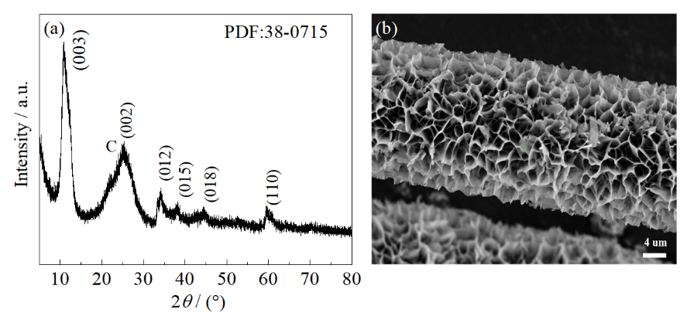

**Fig. S1. (a) XRD pattern and (b) SEM image of CF@Ni(OH)2 precursors.**

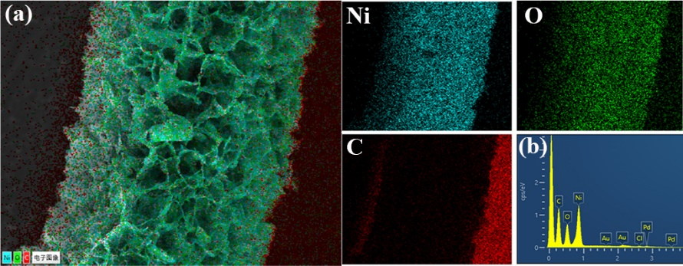

**Fig. S2. (a) Elemental mapping and (b) EDX spectrum of CF@NiO/Ni-500 composite.**



**Fig. S3. Frequency-dependent relative complex permittivity of CF.**



**Fig. S4. Typical Cole−Cole semicircles for the as-prepared composites.**



**Fig. S5. Frequency dependence of eddy current loss for the as-prepared composites.**



**Fig. S6. Frequency dependence of RL of CF.**

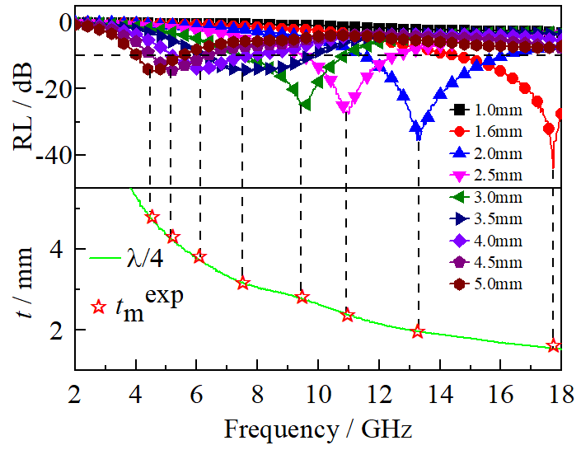

**Fig. S7. Frequency dependence of RL and simulations of the thickness of absorber (*t*m) versus peak frequency (*f*m) of CF@NiO/Ni-500 composites under the *nλ*/4 model (*n* = 1).**

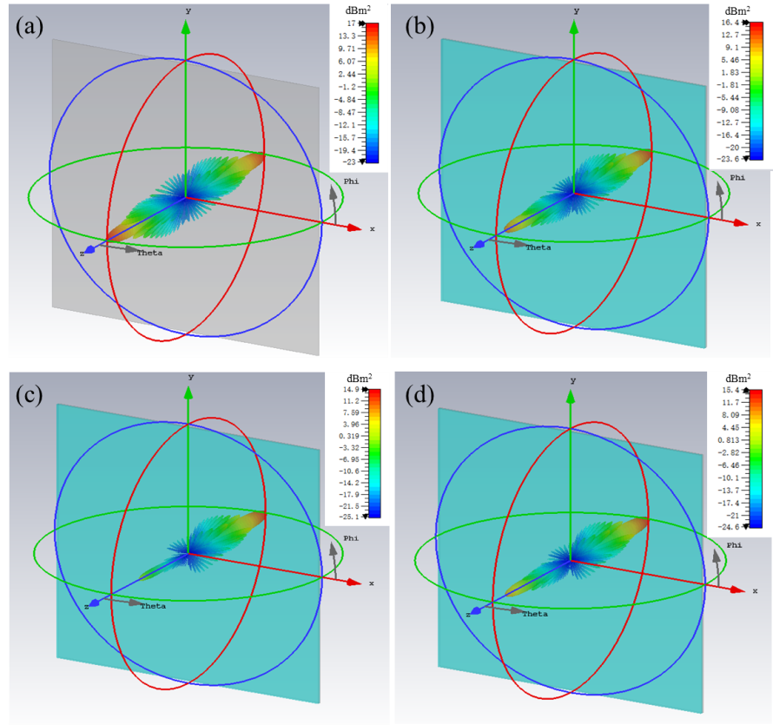

**Fig. S8. 3D RCS simulation maps of (a) PEC, (b) CF, (c) CF@NiO/Ni-400, and (d) CF@NiO/Ni-500.**

Table S1. Comparison of the absorption properties for CF@NiO/Ni composites with other CF-based MAMs in previous studies

|  |  |  |  |  |  |  |  |  |
| --- | --- | --- | --- | --- | --- | --- | --- | --- |
| Sample | RL / dB | Loading / wt% | EAB / GHz | Thickness / mm | |SRLt| | |SRLft| | |SRLBft| | Ref. |
| CF/SiC | ‒19.90 | 20 | 2.50 | 2 | 1.00 | 0.50 | 1.24 | [1] |
| CF/Fe3O4/FeO | ‒40.80 | 50 | 6.10 | 1.9 | 0.82 | 0.43 | 2.62 | [2] |
| CF/MoS2/Fe3O4 | ‒21.40 | 20 | 10.85 | 3.8 | 1.07 | 0.28 | 3.06 | [3] |
| CF/TiO2 | ‒58.63 | 50 | 3.40 | 1.1 | 1.17 | 1.07 | 3.62 | [4] |
| CF/Co3O4 | ‒29.00 | 20 | 5.44 | 2 | 1.45 | 0.73 | 3.94 | [5] |
| CF/NiF2O4 | ‒55.80 | 25 | 6.50 | 2.4 | 2.23 | 0.93 | 6.05 | [6] |
| CC/MnO2 | ‒53.20 | 25 | 5.84 | 2 | 2.13 | 1.06 | 6.21 | [7] |
| CC/CoS2 | ‒59.60 | 30 | 9.20 | 2.8 | 1.99 | 0.71 | 6.53 | [8] |
| CF/CO-LDH | ‒24.10 | 5 | 6.50 | 2.1 | 4.82 | 2.30 | 14.92 | [9] |
| CF/1T-2HMoS2 | ‒43.00 | 5 | 8.75 | 2.7 | 8.60 | 3.19 | 27.87 | [10] |
| CF@NiO/Ni-400 | ‒25.85 | 3 | 6.40 | 2.25 | 8.50 | 3.78 | 24.18 | This work |
| CF@NiO/Ni-500 | ‒43.92 | 3 | 5.64 | 1.80 | 14.64 | 8.13 | 45.87 | This work |

References

[1] W. Zhou, L. Long, P. Xiao, Y. Li, H. Luo, W.D. Hu, R.M. Yin, Silicon carbide nano-fibers *in-situ* grown on carbon fibers for enhanced microwave absorption properties, *Ceram. Int.*, 43(2017), No. 7, p. 5628.

[2] H. Liang, H. Xing, M. Qin, H. Wu, Bamboo-like short carbon fibers@Fe3O4@phenolic resin and honeycomb-like short carbon fibers@Fe3O4@FeO composites as high-performance electromagnetic wave absorbing materials, *Compos. Pt. A-Appl. Sci. Manuf.*, 135(2020), p. 105959.

[3] W.D. Zhang, X. Zhang, Q. Zhu, Y. Zheng, L.F. Liotta, H.J. Wu, High-efficiency and wide-bandwidth microwave absorbers based on MoS2-coated carbon fiber, *J. Colloid Interface Sci*. 586(2021), p. 457.

[4] H. Liang, J. Liu, Y. Zhang, L. Luo, H. Wu, Ultra-thin broccoli-like SCFs@TiO2 one-dimensional electromagnetic wave absorbing material, *Compos.Pt. B-Eng.*, 178(2019), p. 107507.

[5] Z. Zhao, K. Kou, H. Wu, 2-Methylimidazole-mediated hierarchical Co3O4/N-doped carbon/short-carbon-fiber composite as high-performance electromagnetic wave absorber, *J. Colloid Interface Sci*. 574(2020), No. 51, p. 1.

[6] W.X. Li, H.X. Qi, F. Guo, X.J. Niu, Y.E. Du, Y.Q. Chen, NiFe2O4 nanoparticles supported on cotton-based carbon fibers and their application as a novel broadband microwave absorbent, *Rsc Adv.*, 9(2019), No. 51, p. 29959.

[7] X. Li, L. Wang, W.B. You, L.S. Xing, L.T. Yang, X.F. Yu, J. Zhang, Y.S. Li, R.C. Che, Enhanced polarization from flexible hierarchical MnO2 arrays on cotton cloth with excellent microwave absorption, *Nanoscale*, 11(2019), No. 28, p. 13269.

[8] P.B. Liu, C.Y. Zhu, S. Gao, C. Guan, Y. Huang, W.J. He, N-doped porous carbon nanoplates embedded with CoS2 vertically anchored on carbon cloths for flexible and ultrahigh microwave absorption, *Carbon*, 163(2020), p. 348.

[9] Z. Zhao, X. Zhou, K. Kou, H. Wu, PVP-assisted transformation of ZIF-67 into cobalt layered double hydroxide/carbon fiber as electromagnetic wave absorber, *Carbon*, 173(2021), p. 80.

[10] J. Yan, Y. Huang, X. Zhang, X. Gong, C. Chen, G. Nie, X. Liu, P. Liu, MoS2-Decorated/Integrated Carbon Fiber: Phase Engineering Well-Regulated Microwave Absorber, *Nano-Micro Lett.*, 13(2021), No. 1, p. 114.