Supplementary Information

Environmental and economic assessment of structural repair technologies for spent lithium-ion battery cathode materials

Table S1. ICP test results and I₀₀₃/I₁₀₄ values for failing and repaired materials
Sample | Target Composition | Actual composition | I₀₀₃/I₁₀₄
BLCO | Li_{x}CoO₂ | Li_{0.491}CoO₂ | 8.03
RLCO1 | LiCoO₂ | Li_{0.906}CoO₂ | 1.59
RLCO1.05 | Li_{1.05}CoO₂ | Li_{0.934}CoO₂ | 1.20
RLCO1.1 | Li_{1.1}CoO₂ | Li_{0.921}CoO₂ | 1.86

Table S2. Resistance parameters of the equivalent circuit in EIS test with the fitting error rates in parentheses
 | R_{s} / Ω | R_{ct} / Ω
BLCO | 1.151 (9.59%) | 189.6 (1.68%)
RLCO1 | 1.419 (5.42%) | 102.1 (2.77%)
RLCO1.05 | 1.112 (7.93%) | 107.8 (1.56%)
RLCO1.1 | 1.034 (8.49%) | 144.3 (1.94%)

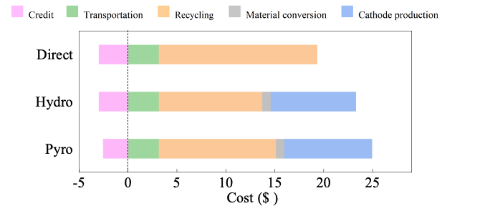
Fig. S1. Cost of each stage of regeneration of 1 kg of cathode material by different methods.

