Supporting Information

Intelligent method to experimentally identify the fracture mechanism of red sandstone
Zida Liu, Diyuan Li, Quanqi Zhu, Chenxi Zhang, Jinyin Ma, and Junjie Zhao
School of Resources and Safety Engineering, Central South University, Changsha 410083, China
Corresponding authors: Diyuan Li E-mail: diyuan.li@csu.edu.cn;

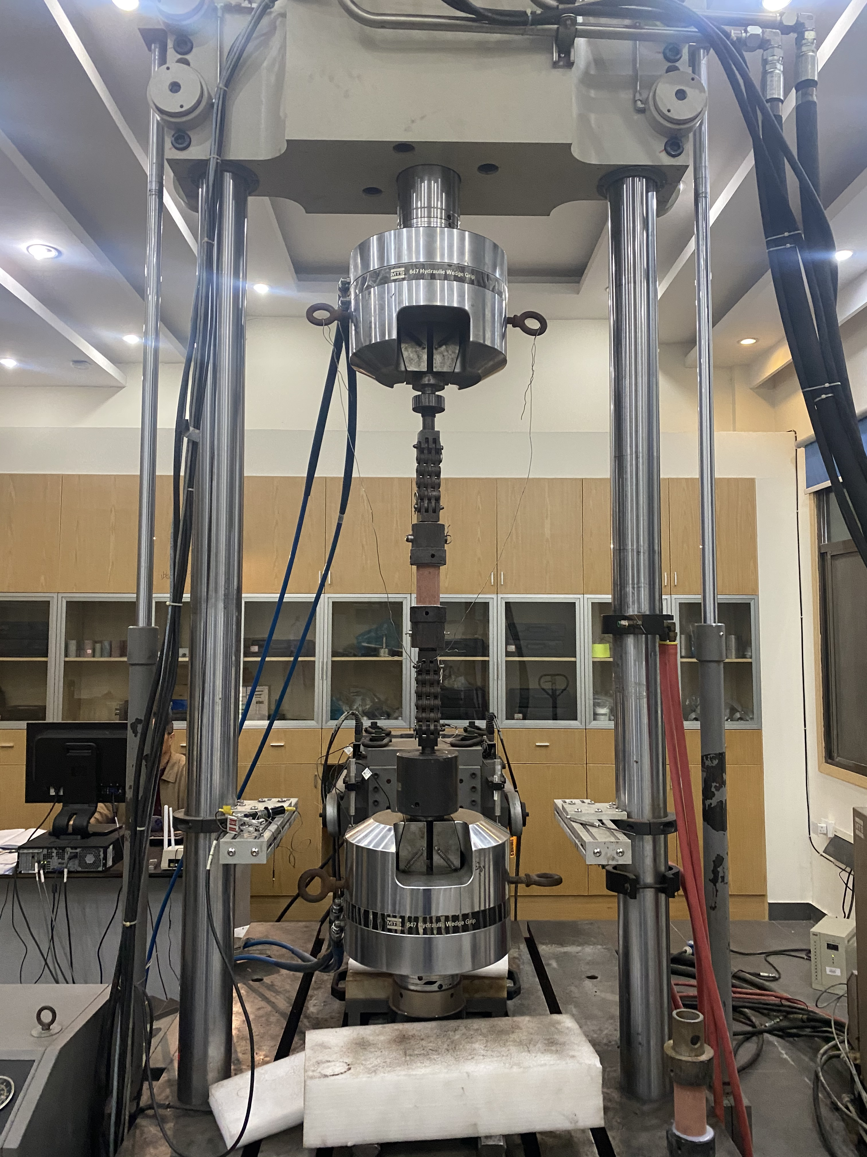 | 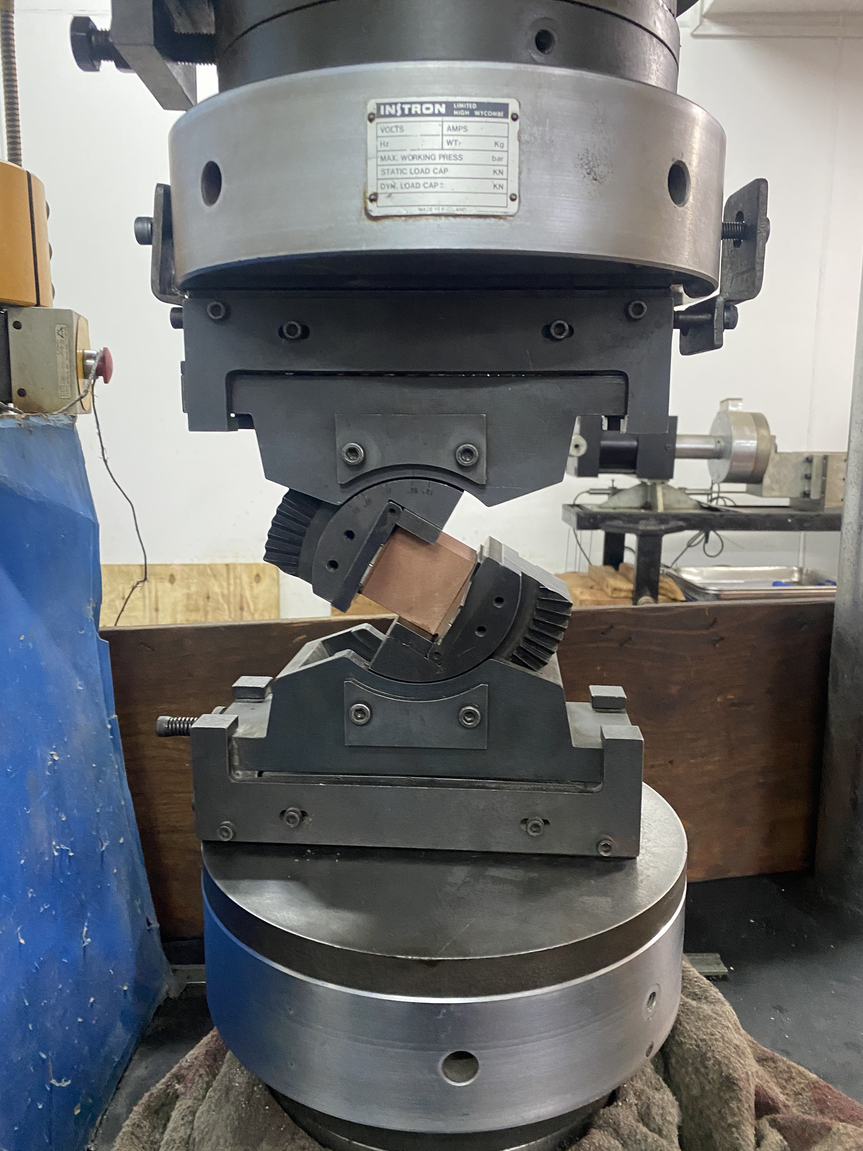
(a) | (b)
Fig. S1. Photographic view of (a) Direct tensile tests; (b) Preset angle shear tests.

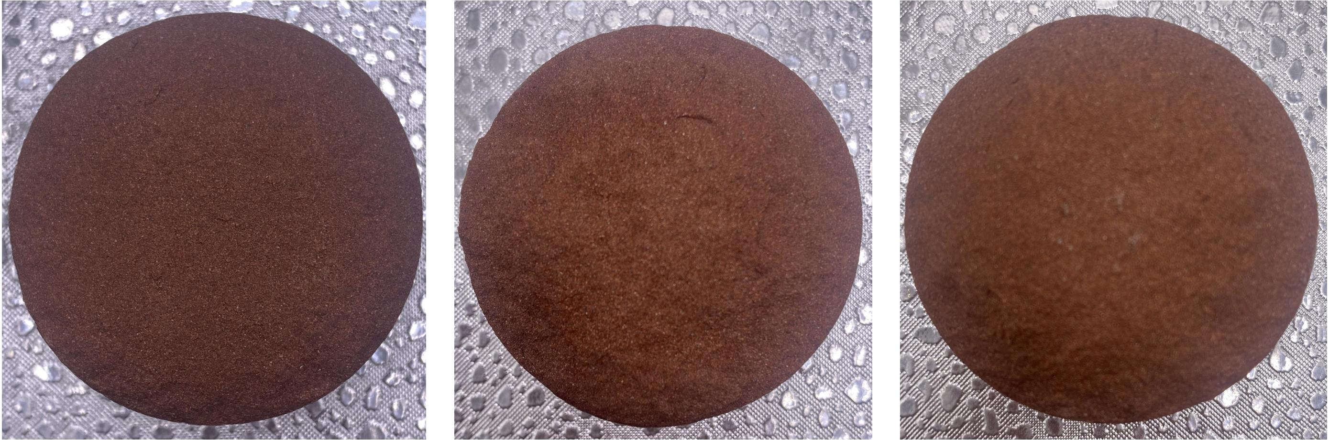
(a)
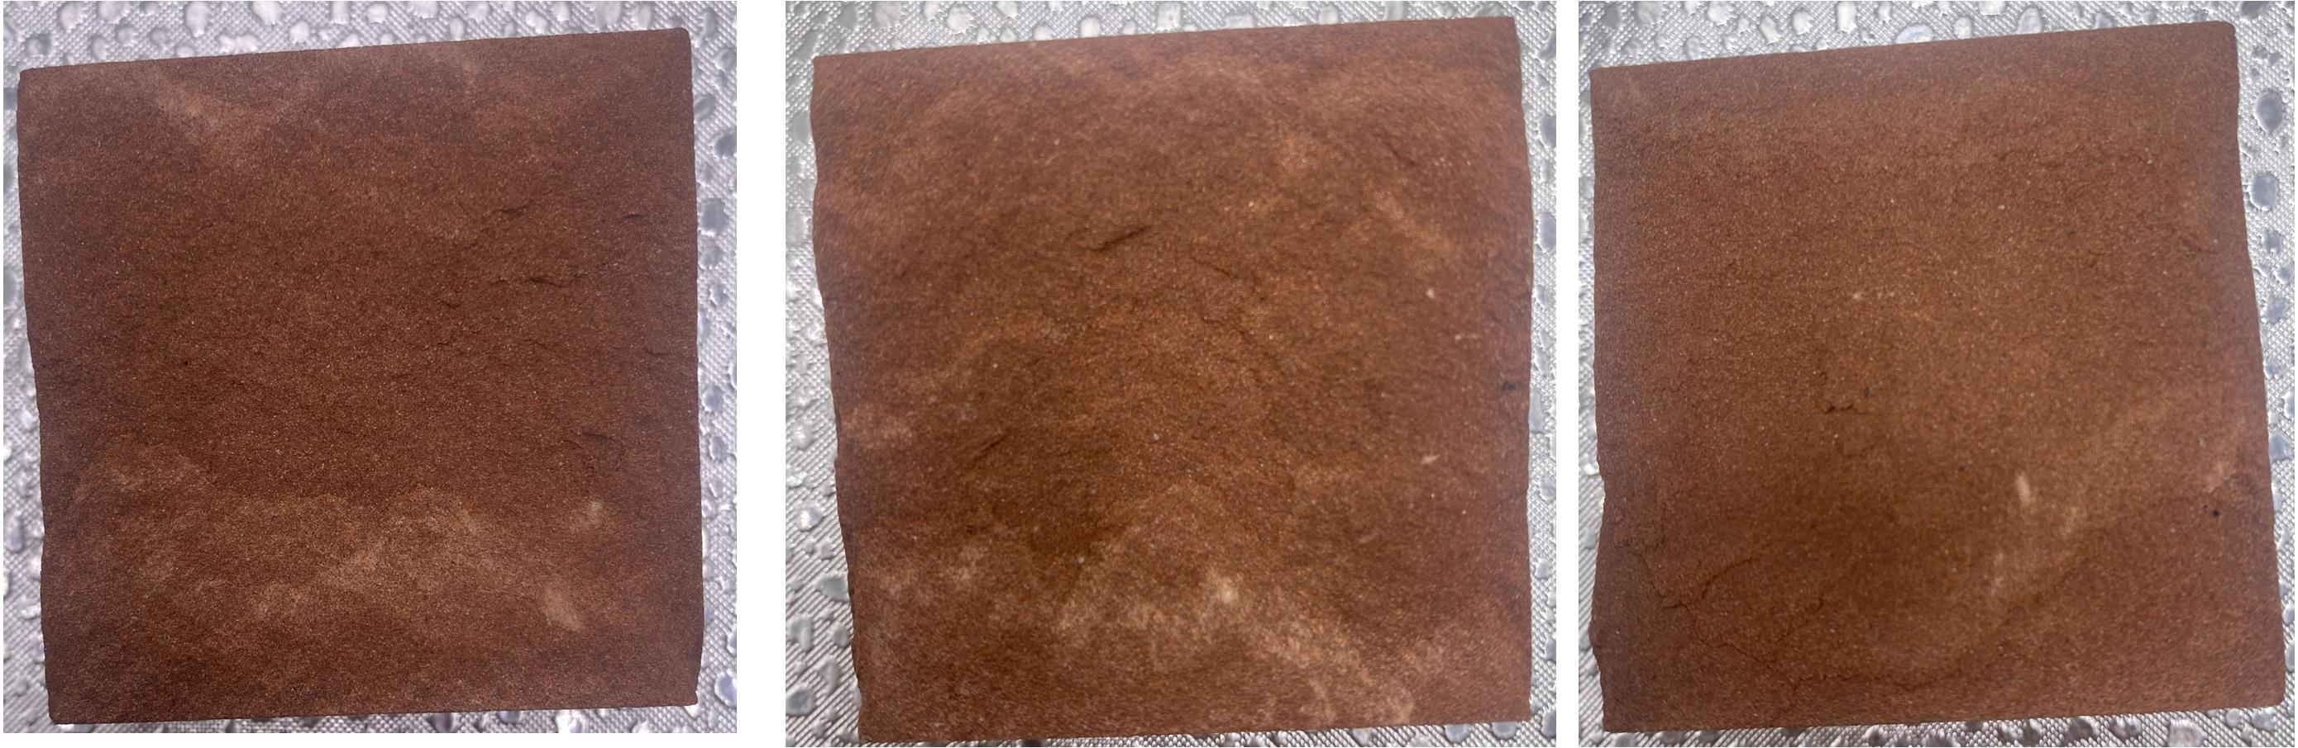
(b)
Fig. S2. (a) Tensile fracture surfaces; (b) shear fracture surfaces.

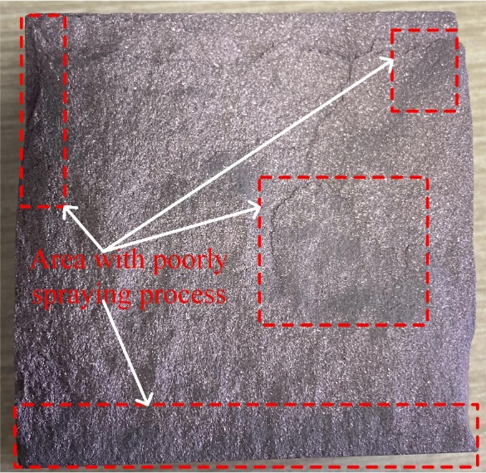
Fig. S3. Shear fracture surface with spraying gold powder

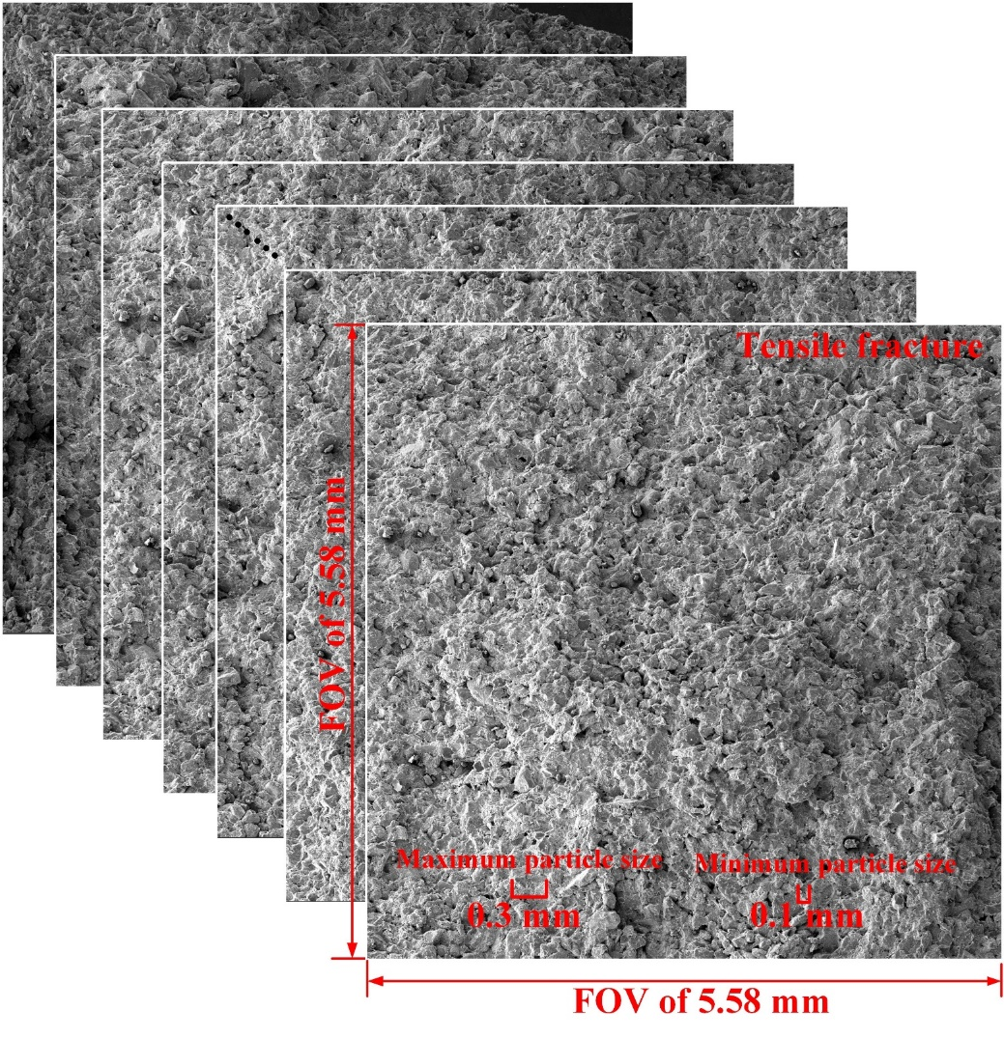
Fig. S4. Collected scanning electron microscopy images at a magnification of 50.

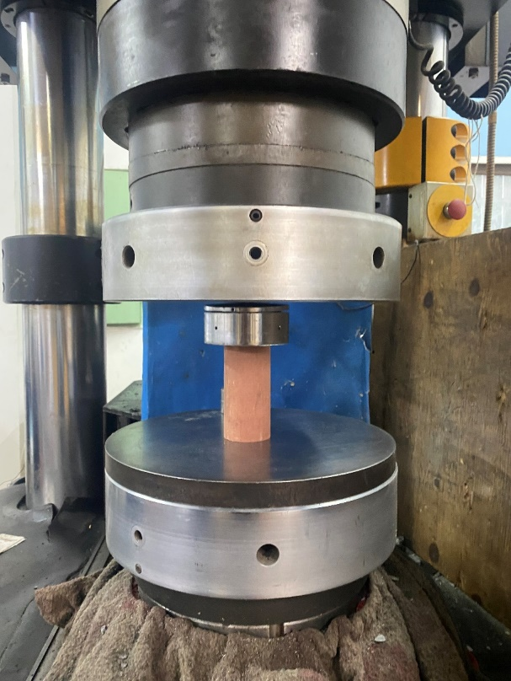 | 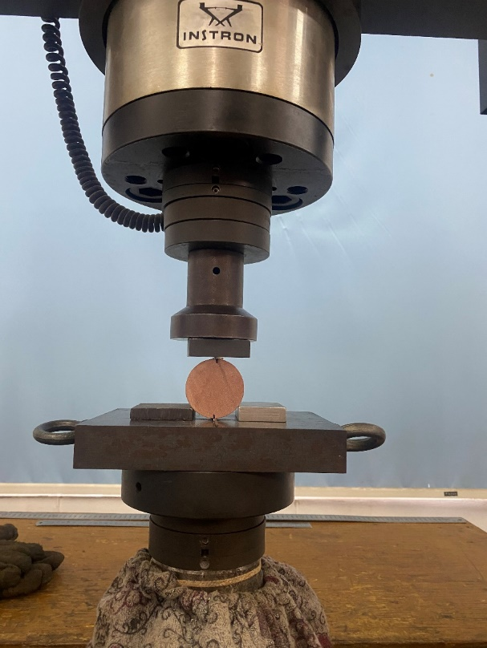
(a) | (b)
Fig. S5. (a) Uniaxial compression test and (b) Brazilian splitting test.

