Supplementary Information
Highly dispersed NiMo@rGO nanocomposite catalysts fabricated by a two-step hydrothermal method for hydrogen evolution

Duanhao Cao, Xiaofeng Ma, Yipeng Zhang, La Ta, Yakun Yang, Chao Xu, Feng Ye, and Jianguo Liu
School of Energy Power and Mechanical Engineering, North China Electric Power University, Beijing 102206, China
Corresponding author: Chao Xu E-mail: mechxu@ncepu.edu.cn

Table S1. EDS elemental data of NiMo@rGO-1
Element | Mass fraction / wt%
C | 37.97
O | 16.22
Ni | 42.49
Mo | 3.32

Table S2. EDS elemental data of nanoparticles on the surface of NiMo@rGO-1
Element | Mass fraction / wt%
C | 2.39
O | 4.37
Ni | 86.65
Mo | 6.59

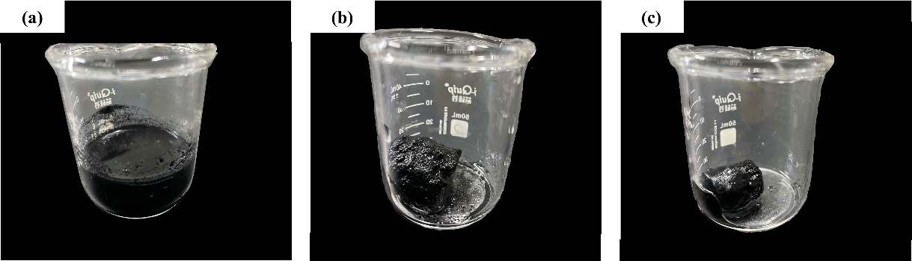
Fig. S1. Digital photographs of catalysts (a) NiMo@rGO-1, (b) NiMo@rGO-2, and (c) NiMo@rGO-3.
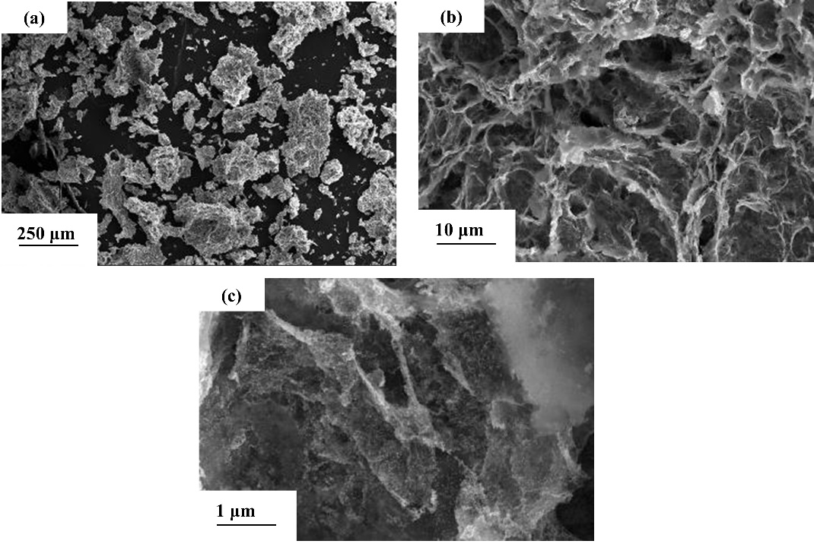
Fig. S2. SEM images of Ni@rGO: (a) 250× magnification; (b) 5000× magnification; (c) 50000× magnification.

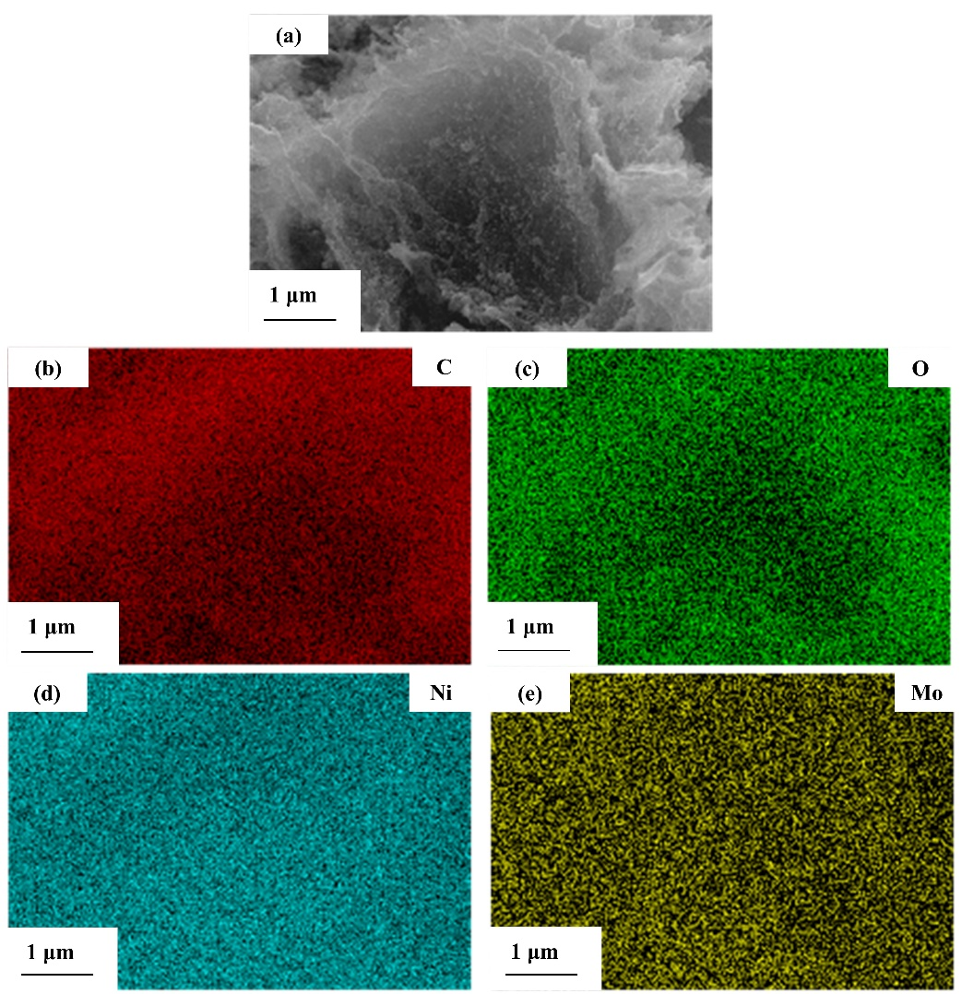
Fig. S3. EDS mappings of NiMo@rGO-1 at 50000× magnification.
Fig. S4. Raman spectrum of NiMo@rGO-1.
Fig. S5. CV curves of the catalysts at scan rates ranging from 10 to 50 mV·s⁻¹: (a) NiMo@rGO-1, (b) NiMo@rGO-2, (c) NiMo@rGO-3, and (d) Ni@rGO.
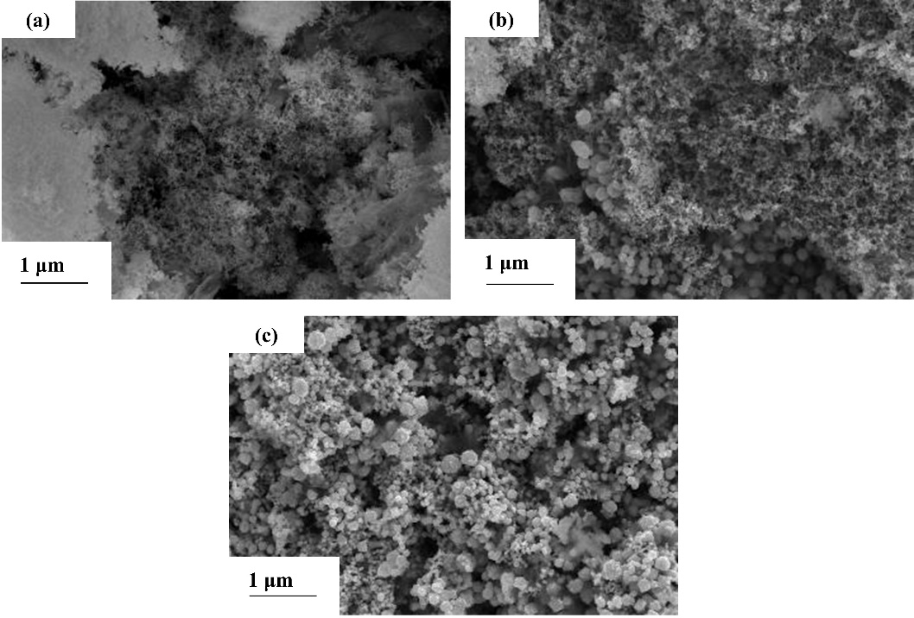
Fig. S6. SEM images of NiMo particles at 50000× magnification: (a) NiMo-1, (b) NiMo-2, and (c) NiMo-3.
Fig. S7. HER performance of NiMo@rGO-1, NiMo-1, and rGO aerogel: (a) LSV curves and (b) EIS of the materials; (c) CV curves of NiMo-1 and (d) rGO aerogel.

