Supplementary information

Sandwich-like structure C/SiO_{x}@graphene anode material with high electrochemical performance for lithium ion batteries
Zhaolin Li^{1),*}, Yaozong Yang^{1),*}, Jie Wang¹⁾, Zhao Yang¹⁾, and Hailei Zhao^{1,2),}
- School of Materials Science and Engineering, University of Science and Technology Beijing, Beijing 100083, China
- Beijing Municipal Key Laboratory of New Energy Materials and Technologies, Beijing 100083, China
*These authors contributed equally to this work.

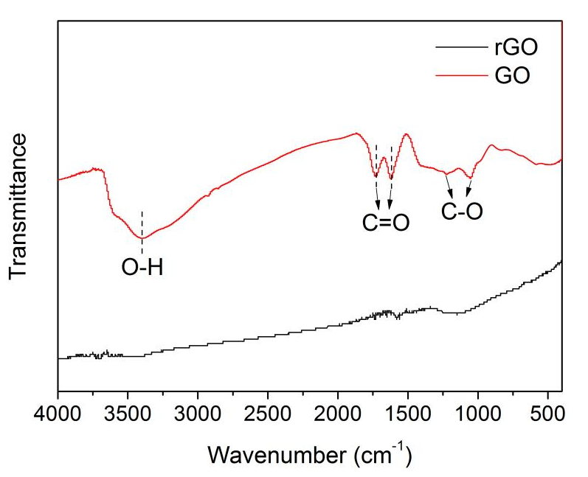
Fig. S1. FTIR spectra of rGO and GO.

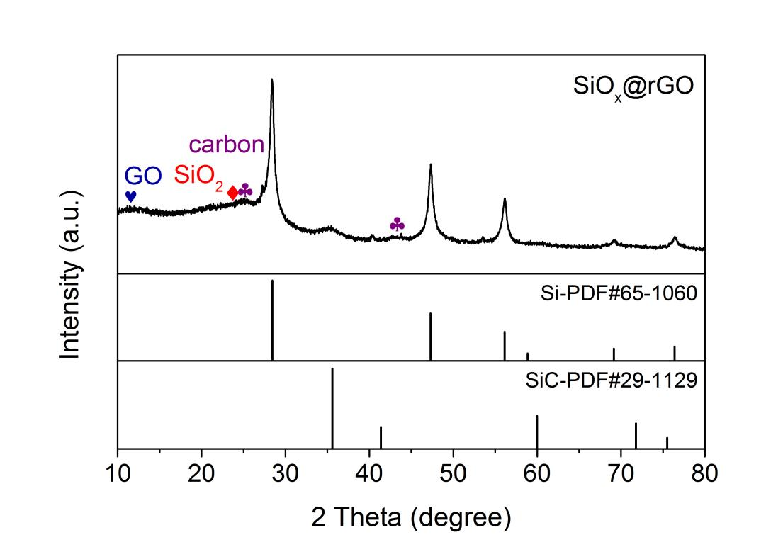
Fig. S2. XRD pattern of SiO_{x}@rGO material.

The lithium diffusion coefficient (D_{Li+}) of C/SiO_{x}@rGO electrode can be calculated based on the CV data at different scan rates (Fig. S3(c)) and the following equation (Eq. (S1)):
i_{p} = 2.69×10⁵·A·n^{3/2}·C₀·D^{1/2}·ν^{1/2} (S1)
where i_{p} is the peak current (A), n is the charge concentration in Li_{x}Si (as anodic peak Ⅱ is chosen in calculation, n = 2), A is the contact area between SiO_{x} and electrolyte (here the geometric area of electrode, 1.13 cm², is used for simplicity), C₀ is the bulk concentration of lithium in electrode (0.0549 mol/cm³, calculated from Li₂Si), and ν is the scan rate. A linear relationship between i_{p} and ν^{1/2} is obtained, and the diffusion coefficient of lithium ions in C/SiO_{x}@rGO is calculated according to the slope (Fig. S3(d)). The D_{Li+} of C/SiO_{x}@rGO electrode is calculated to be 1.4 × 10⁻¹² cm²/s.
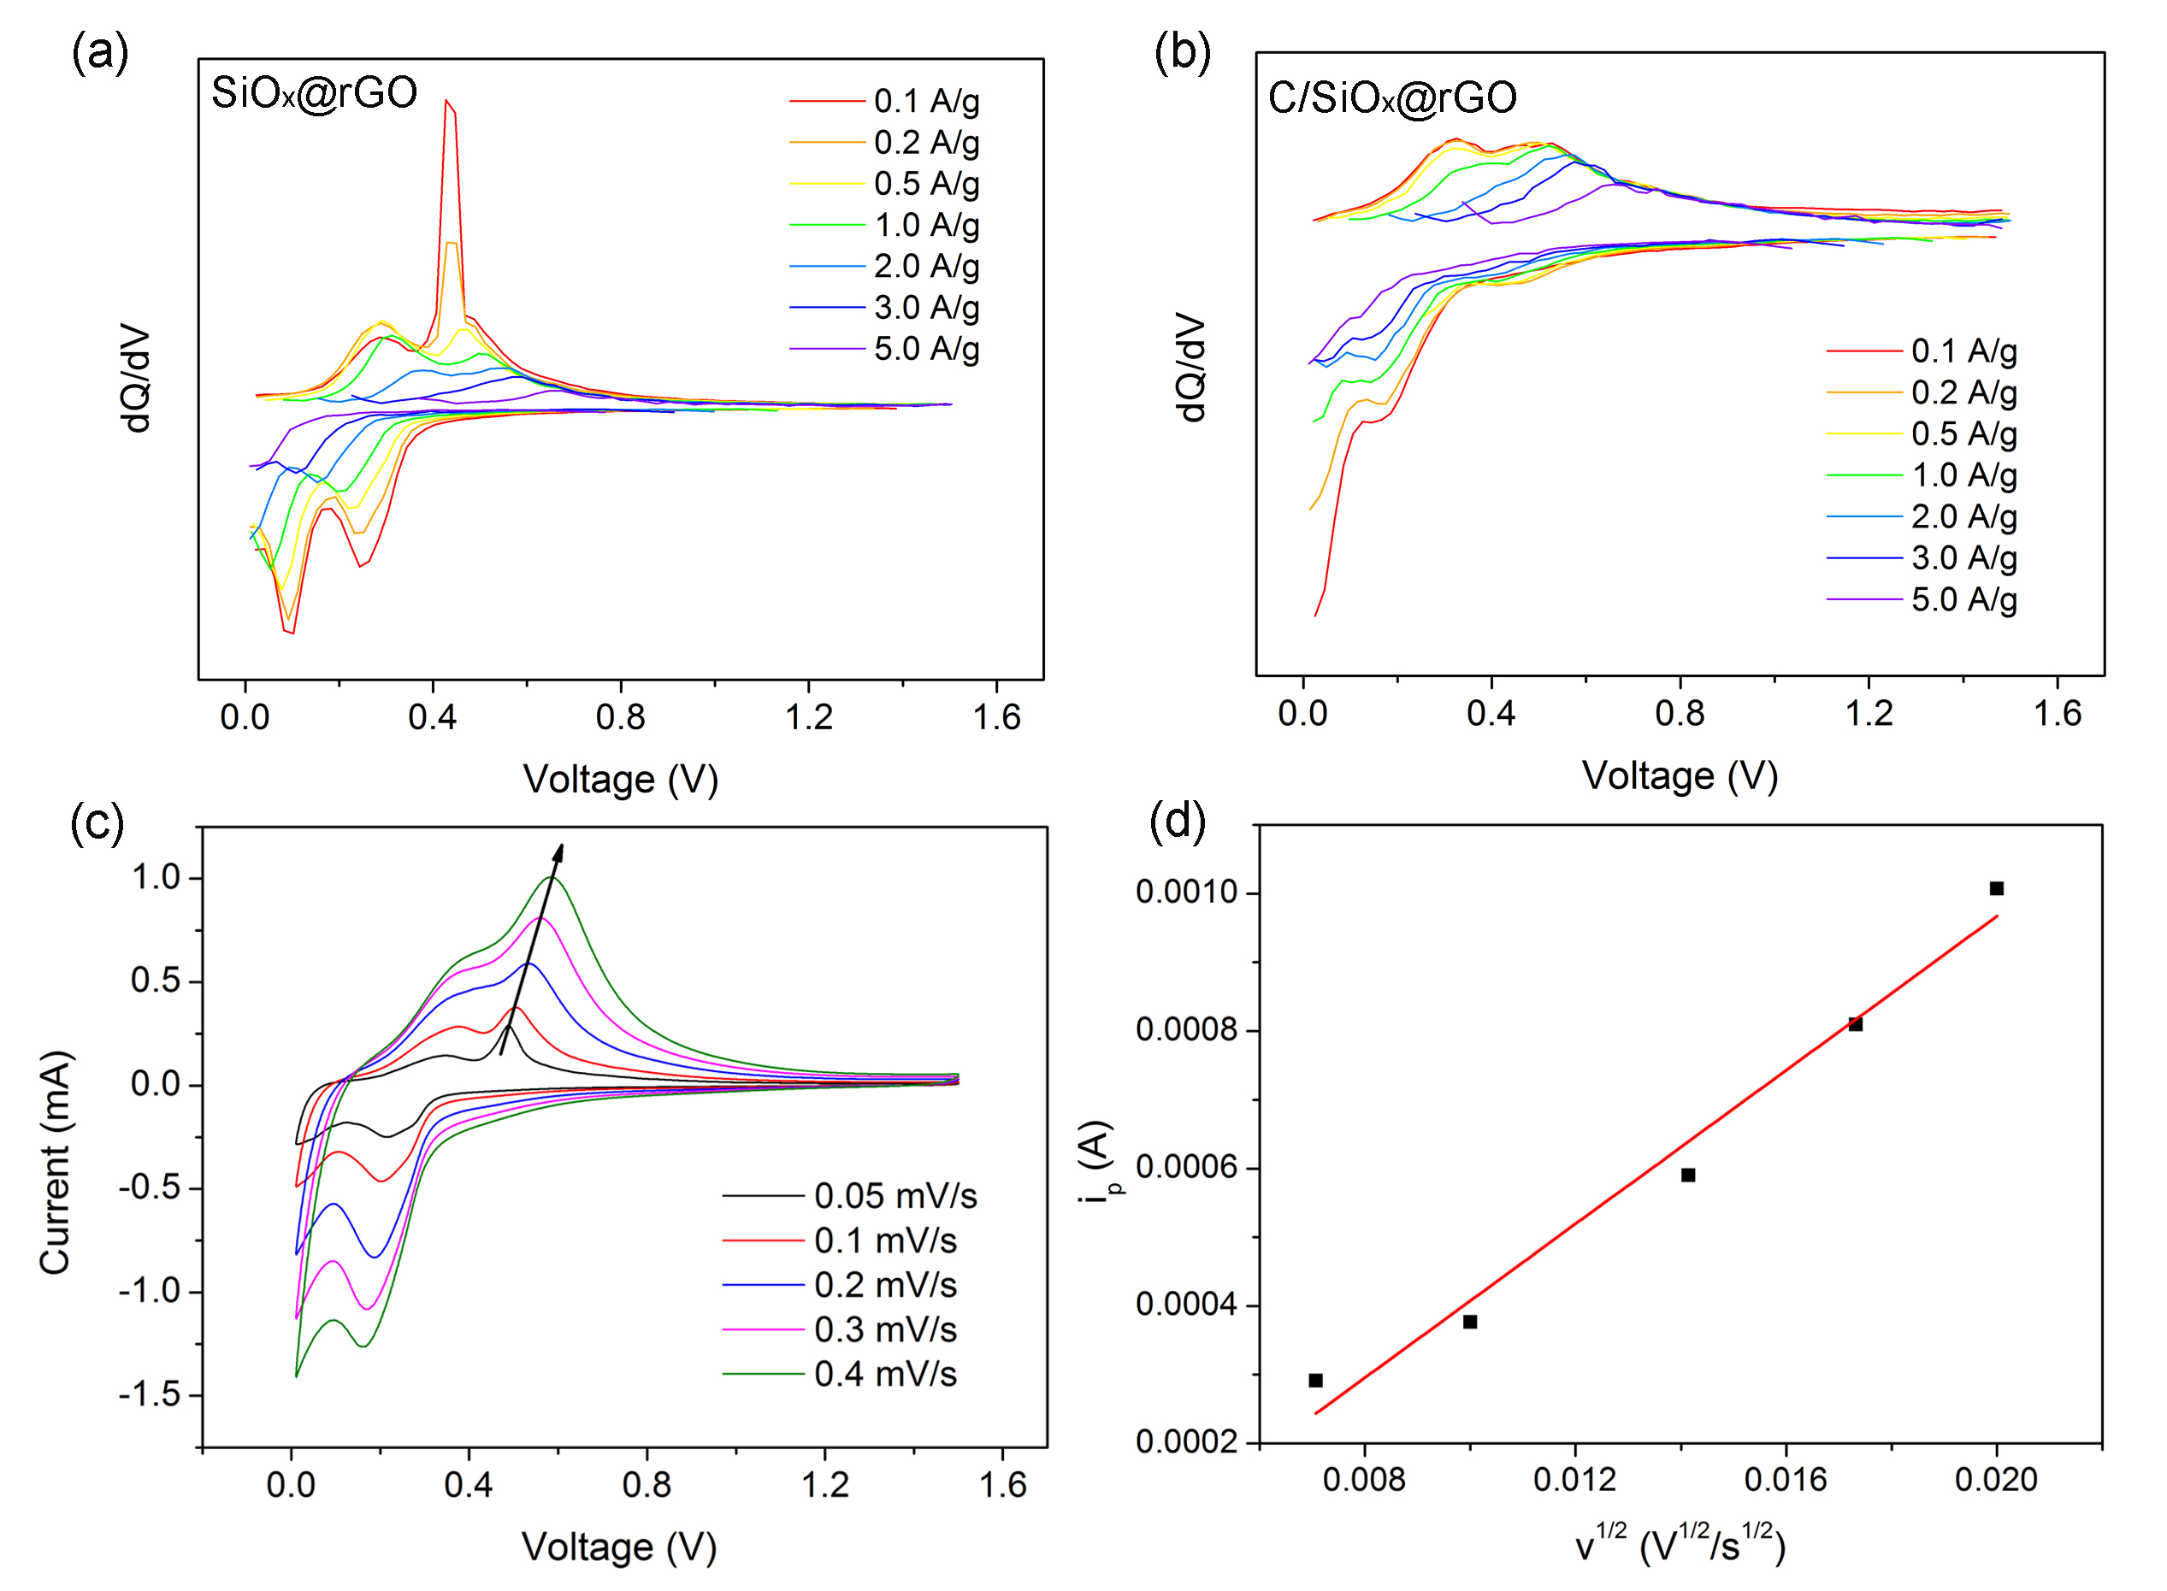
Fig. S3. Differentiate curves at different current densities of SiO_{x}@rGO (a) and C/SiO_{x}@rGO (b) electrodes. Cyclic voltammetry curves with different scan rates: 0.05, 0.1, 0.2, 0.3, and 0.4 mV/s (c); The relationship of the peak current (i_{p}) and the square root of scan rate (ν^{1/2}) (d).

Table S1. Comparison of electrochemical performance of recently reported SiO_{x}/graphene anode materials
Sample | Voltage range / V | ICE / % | Specific capacity / (mAh·g⁻¹) | Current density / (A·g⁻¹) | Cycles | Retention / % | Ref.
C/SiO_{x}@rGO | 0.01–1.5 | 47.0 | 886 | 0.1 | 100 | 73.7 | This work
 |  | — | 396 | 5.0 | — | 44.7
SiO_{x}/rGO composite | 0.01–1.5 | 13.8 | 103 | 0.1 | 120 | 60 | [1]
SiO_{x}/graphene | 0.01–3.0 | 51.7 | 1207 | 0.2 | 200 | 82.3 | [2]
 |  | — | 418 | 2.0 | — | 34.6
Gr-coated SiO_{x} | 0.01–1.5 | 71.2 | 1317 | 0.2 | 100 | 59.2 | [3]
Meso-porous SiO_{x}/rGO composite | 0.01–1.5 | 68.1 | 2563 | 0.2 | 200 | 22.6 | [4]
Si@SiO_{x}/graphene | 0.01–2.0 | 53.0 | 3000 | 0.1 | — | — | [5]
 |  | — | 1020 | 4.0 | — | 34.0
Si@SiO_{x}@C | 0.01–3.0 | 50.7 | 537 | 0.1 | 200 | >100 (capacity climb) | [6]
 |  | — | 56 | 5.0 | — | 10.4

References
- Mater. Lett., 299(2021), p. 130043.
- Electrochim. Acta, 422(2022), p. 140572.
- Chem. Eng. J., 442 (2022), p. 136166.
- Electrochim. Acta, 273(2018), p. 26.
- J. Power Sources, 306(2016), p. 42.
- Electrochim. Acta, 402(2022), p. 139556.

