Supplementary Information
Metal-organic framework derived NiFe₂O₄/FeNi₃@C composite for efficient electrocatalytic oxygen evolution reaction
Fangna Dai, Huakai Xu, Chuanhai Jiang, Zhifei Wang, Yuguo Ouyang, Chunyu Lu, Yuan Jing, Shiwei Yao, and Xiaofei Wei
School of Materials Science and Engineering, China University of Petroleum, Qingdao 266580, China
Corresponding author: Xiaofei Wei E-mail: b21140026@s.upc.edu.cn

Preparation of working electrode
The test sample in this work is powder sample. Weigh 5 mg of dried powder sample, measure 900 μL deionized water, 100 μL ethanol and 50 μL Nafion respectively, mix the four samples and ultrasonic until completely dispersed to form ink, then measure 5 μL ink drops with a pipetting gun and add them to a clean glassy carbon electrode with a diameter of 3 mm, and dry them at room temperature for use. The catalyst load on glassy carbon electrode was 0.35 mg·cm⁻². Glassy carbon electrode pretreatment method: the diameter of 3 mm glassy carbon electrode is slightly wiped clean, and then with 0.05 μm alumina polishing powder as polishing agent, the glassy carbon electrode is polished on the grinding disk. After the electrode surface was smooth, ultrasonic cleaning was carried out with ethanol for 30 s, and finally dry for reserve.

Fig. S1. Thermogravimetric analysis of FeNi₅-MOF.
The thermogravimetric curve of FeNi₅-MOF shows that at 200℃, MOF loses 21.6% of its mass, which is caused by the loss of physically adsorbed water molecules. When the temperature is between 200–500℃, the mass loss of the material is more, which is caused by the decomposition of the organic ligand of the MOF material. When the temperature reaches 400℃, only 58.5% of the mass of MOF remains, and when the temperature reaches 500℃, only 44.9% of the mass of MOF remains. When the temperature is 500–600℃, the pyrolysis of MOF is complete and the mass change is small, but the total mass is only 42.8%.

Fig. S2. Polarization curves of MOF catalysts with different contents of Ni.

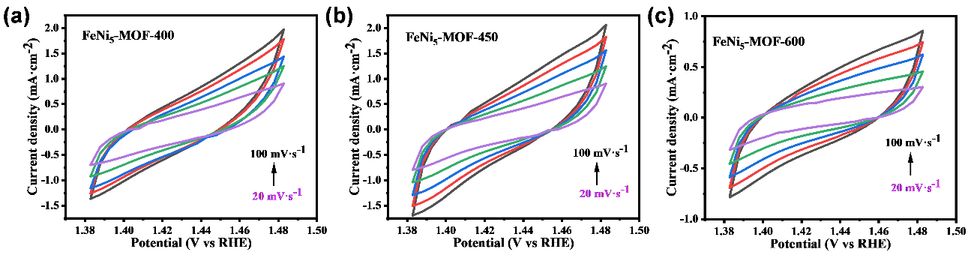
Fig. S3. CV cycle curve of (a) FeNi₅-MOF-400, (b) FeNi₅-MOF-450, (c) FeNi₅-MOF-600.

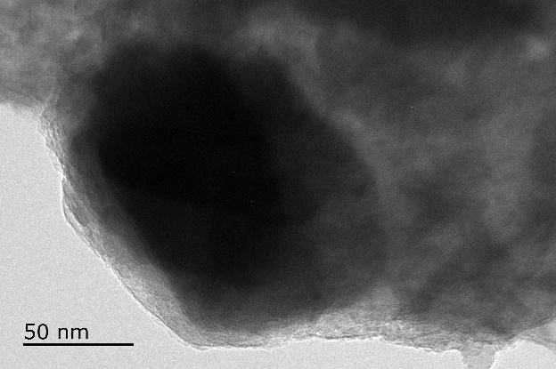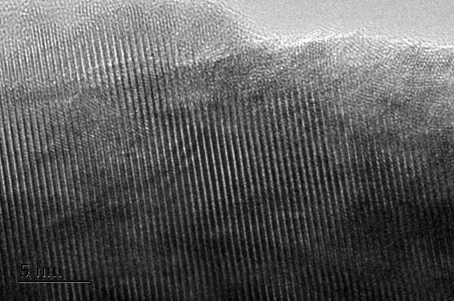
Fig. S4. TEM and HR-TEM images of FeNi₅-MOF-450 after working more than 40 h.

