Supplementary Information
Introducing oxygen vacancies in TiO₂ lattice through trivalent iron to enhance the photocatalytic removal of indoor NO
Peng Sun^{1,2)}, Sumei Han²⁾, Jinhua Liu¹⁾, Jingjing Zhang¹⁾, Shuo Yang²⁾, Faguo Wang²⁾, Wenxiu Liu³⁾, Shu Yin^{4,5),}, Zhanwu Ning^{1),}, and Wenbin Cao^{2,6),}
- Institute of Urban Safety and Environmental Science, Beijing Academy of Science and Technology, Beijing 100054, China
- School of Materials Science and Engineering, University of Science and Technology Beijing, Beijing 100083, China
- Zhongguancun Institute of Human Settlements Engineering and Materials, Beijing 100083, China
- Institute of Multidisciplinary Research for Advanced Materials (IMRAM), Tohoku University, Katahira 2-1-1, Aoba-ku, Sendai 980-8577, Japan
- Advanced Institute for Materials Research (WPI-AIMR), Tohoku University, Katahira 2-1-1, Aoba-ku, Sendai 980-8577, Japan
- Tianjin College, University of Science and Technology Beijing, Tianjin 301830, China
Corresponding authors: Shu Yin E-mail: yin.shu.b5@tohoku.ac.jp; Zhanwu Ning E-mail: nzwu@163.com; Wenbin Cao E-mail: wbcao@ustb.edu.cn

Table S1. The peak value and the crystal plane spacing of (101) peak for all samples
Sample | Peak value, 2θ / (°) | Crystal plane spacing / Å
TiO₂ | 25.362 | 3.5089
1%Fe–TiO₂ | 25.359 | 3.5093
2%Fe–TiO₂ | 25.344 | 3.5113
3%Fe–TiO₂ | 25.287 | 3.5191

Table S2. The specific surface area, pore volume and pore size of the samples
Sample | Specific surface area / (m²/g) | Pore volume / (cm³/g) | Pore diameter / nm
TiO₂ | 116.25 | 0.24 | 7.56
1%Fe-TiO₂ | 111.11 | 0.24 | 7.84
2%Fe-TiO₂ | 120.20 | 0.25 | 7.45
3%Fe-TiO₂ | 111.97 | 0.24 | 7.66

Table S3. The elemental composition of as-prepared samples (molar ratio)
 | Ti / % | O / % | Fe / % | Fe:Ti / % | O_{A}:O_{L} / %
TiO₂ | 31.51 | 68.49 | - | - | 12.5
1%Fe–TiO₂ | 28.98 | 70.80 | 0.22 | 0.76 | 24.4
2%Fe–TiO₂ | 29.09 | 70.34 | 0.57 | 1.96 | 31.8
3%Fe–TiO₂ | 29.11 | 70.10 | 0.78 | 2.68 | 24.8

Table S4. The comparison of NO removal ability for different photocatalysts under visible light irradiation
Photocatalysts | Photocatalytic experimental conditions | Photocatalytic activities
 |  | η₁ª | η₂^{b} | P^{c}
OVs-TiO₂[1] | Xe lamp of 300W, λ>400 nm  c₀=600 ppb  T=298 K  flow rate=1 L/min | 48% | 63% ^{d} | 131%
C-TiO₂[2] | Mercury lamp of 450 W, λ>400 nm  c₀=1 ppm  T=298 K  flow rate=100 mL/min | - | 29% | -
OVs-TiO₂[3] | Mercury lamp of 450 W, λ>400 nm  c₀=1 ppm  T=298 K  flow rate=100 mL/min | 22% | 45% | 204%
Ag/TiO₂[4] | Xe lamp of 300 W, λ>420 nm  c₀=600 ppb | 22% | 63% | 286%
C₃N₄/Ti³⁺-TiO₂[5] | Xe lamp of 300 W, λ>420 nm  c₀=400 ppb  flow rate=1.2 mL/min | 13.4% | 25% | 186%
Bi₄O₅Br₂/TiO₂[6] | Xe lamp of 300 W  c₀=430 ppb  RH=30±5% | 23.53% | 54.33% | 230%
C₃N₄[7] | Mercury lamp of 450 W, λ>400 nm  c₀=1 ppm  flow rate=100 mL/min | - | 32.5% | -
Bi₂WO₆/BiOCl[8] | Xe lamp of 300 W, λ>420 nm  c₀=100 ppm | - | 26% | -
This work | Mercury lamp of 450 W, λ>400 nm  c₀=1 ppm  T=298 K  flow rate=100 mL/min | 9% | 36% | 400%
ª Removal ratio of NO before modification
^{b} Removal ratio of NO before modification
^{c} (η₂-η₁)/ η₁×100%
Table S5. TPRL parameters of TiO₂ and Fe-TiO₂ photocatalysts
 | τ₁ / ns | Error of τ₁ / ns | f₁ / % | τ₂ / ns | Error of τ₂ / ns | f₂ / % | τ_{ave} / ns
TiO₂ | 1.125 | 1.202×10⁻² | 55.96 | 5.880 | 1.107×10⁻¹ | 44.04 | 3.22
1%Fe–TiO₂ | 1.125 | 1.445×10⁻² | 41.73 | 6.075 | 7.527×10⁻² | 58.27 | 4.00
2%Fe–TiO₂ | 1.099 | 1.455×10⁻² | 40.55 | 6.150 | 7.680×10⁻² | 59.45 | 4.10
3%Fe–TiO₂ | 1.176 | 1.237×10⁻² | 56.39 | 6.136 | 1.082×10⁻¹ | 43.61 | 3.34

Table S6. The calculated effective masses of electrons and holes in different directions in the reciprocal space of TiO₂ and Fe-TiO₂ (m₀ was defined as the mass of free electrons)
 | Direction | m_{e}*/m₀ | m_{h}*/m₀ | D
TiO₂(up/down) | G→F | 0.86 | 3.16
 | G→Z | 7.26 | 2.28
average |  | 4.06 | 2.72 | 1.49
Fe-TiO₂ (up) | G→F | 0.88 | 28.34
 | G→Z | 27.87 | 75.32
average |  | 14.38 | 51.83 | 3.61
Fe-TiO₂ (down) | F→G  (F→Q) | 7.48 | 1.78
average |  | 7.48 | 1.78 | 4.20

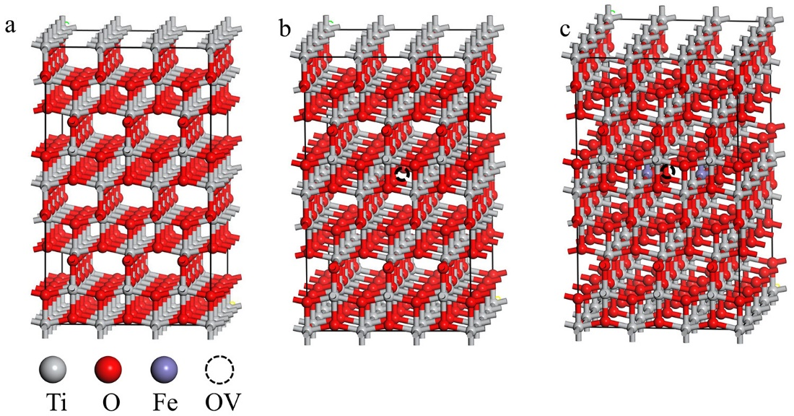
Fig. S1. The structure models of (a) TiO₂(Ti₉₆O₁₉₂), (b) OVs-TiO₂(Ti₉₆O₁₉₁), and (c) Fe–TiO₂(Ti₉₄Fe₂O₁₉₁).

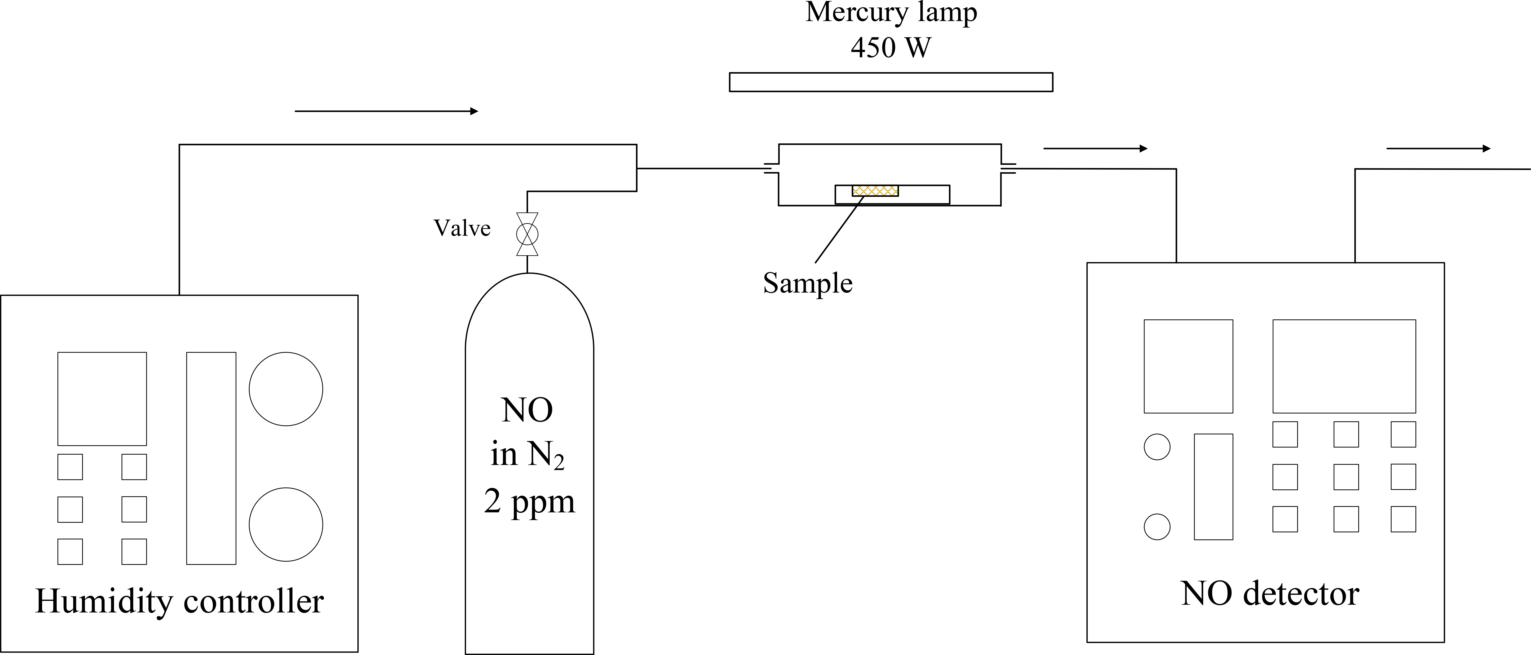
Fig. S2. The schematic illustration of NO photocatalytic removal system.

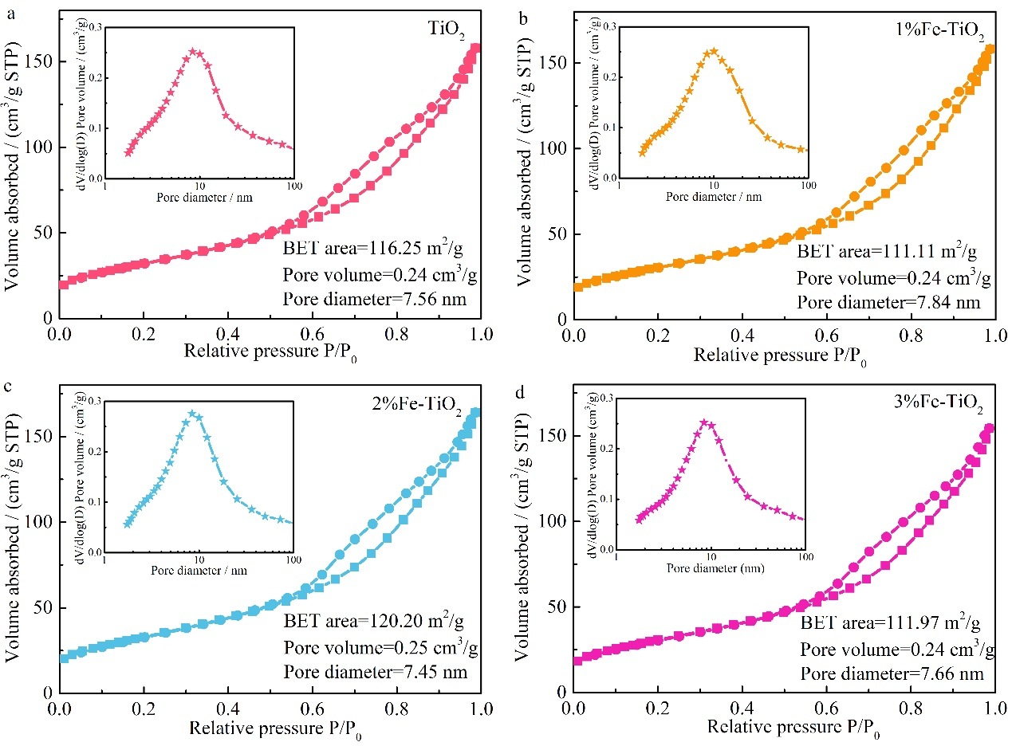
Fig. S3. The nitrogen gas adsorption isotherms of (a) TiO₂, (b) 1%Fe–TiO₂, (c) 2%Fe–TiO₂, and (d) 3%Fe–TiO₂.

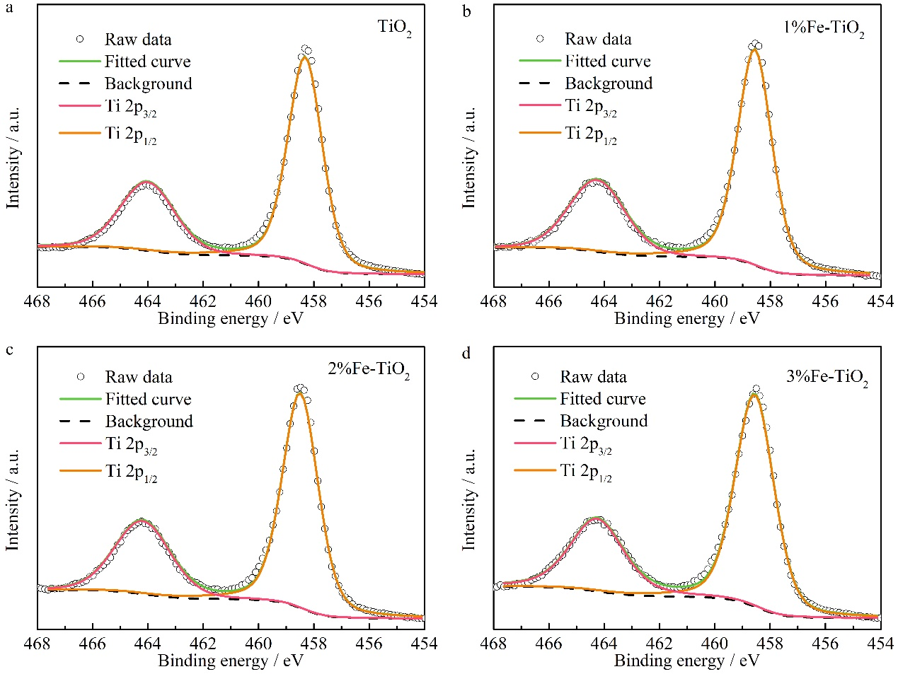
Fig. S4. Detailed analysis of Ti 2p peaks for (a) TiO₂, (b) 1%Fe–TiO₂, (c) 2%Fe–TiO₂ and (d) 3%Fe–TiO₂.

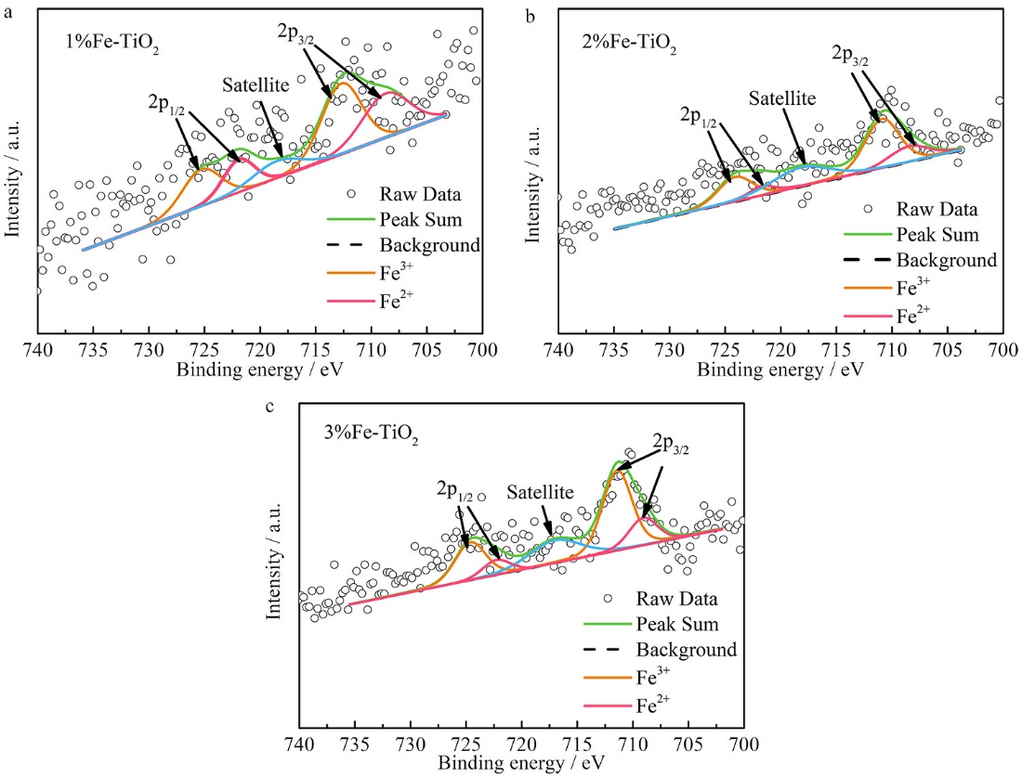
Fig. S5. Detailed analysis of Fe 2p peaks for (a) 1%Fe-TiO₂, (b) 2%Fe-TiO₂ and (c) 3%Fe-TiO₂.

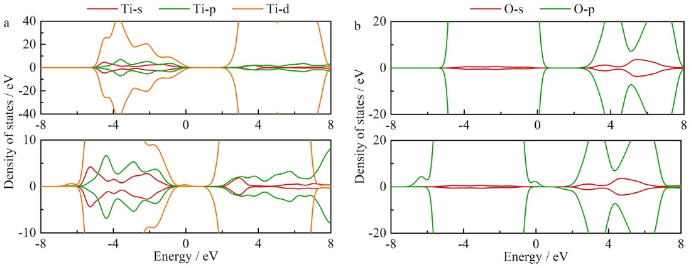
Fig. S6. (a) Ti states and (b) O states of TiO₂ and Fe–TiO₂.

Reference
[1] H. Shang, M.Q. Li, H. Li, S. Huang, C.L. Mao, Z.H. Ai, and L.Z. Zhang, Oxygen vacancies promoted the selective photocatalytic removal of NO with blue TiO₂ via simultaneous molecular oxygen activation and photogenerated hole annihilation, Environ. Sci. Technol., 53(2019), No. 11, p. 6444.
[2] X.Y. Wu, S. Yin, Q. Dong, and T. Sato, Blue/green/red colour emitting up-conversion phosphors coupled C-TiO₂ composites with UV, visible and NIR responsive photocatalytic performance, Appl. Catal. B-Environ., 156(2014), p. 257.
[3] Z.Y. Gu, Z.T. Cui, Z.J. Wang, K.S. Qin, Y. Asakura, T. Hasegawa, K. Hongo, R. Maezono, and S. Yin, Intrinsic carbon-doping induced synthesis of oxygen vacancies-mediated TiO₂ nanocrystals: Enhanced photocatalytic NO removal performance and mechanism, J. Catal., 393(2021), p. 179.
[4] Y.Y. Duan, J.M. Luo, S.C. Zhou, X.Y. Mao, M.W. Shah, F. Wang, Z.H. Chen, and C.Y. Wang, TiO₂-supported Ag nanoclusters with enhanced visible light activity for the photocatalytic removal of NO, Appl. Catal. B-Environ., 234(2018), p. 206.
[5] Y. Huang, P.G. Wang, Z.Y. Wang, Y.F. Rao, J.J. Cao, S.Y. Pu, W.K. Ho, and S.C. Lee, Protonated g-C₃N₄/Ti³⁺ self-doped TiO₂ nanocomposite films: Room-temperature preparation, hydrophilicity, and application for photocatalytic NO_{x} removal, Appl. Catal. B-Environ., 240(2019), p. 122.
[6] S.P. Li, G.Q. Zhu, Y.F. Jia, L.K. Pan, J.L. Nie, F. Rao, J.Z. Gao, F.C. Zhang, N. Kwon, and C.L. Liu, TiO₂ with exposed (001) facets/Bi₄O₅Br₂ nanosheets heterojunction with enhanced photocatalytic for NO removal, Nanotechnology, 31(2020), No. 25, p. 254002.
[7] Z. Gu, Z. Cui, Z. Wang, K.S. Qin, Y. Asakura, T. Hasegawa, S. Tsukuda, K. Hongo, R. Maezono, and S. Yin, Carbon vacancies and hydroxyls in graphitic carbon nitride: Promoted photocatalytic NO removal activity and mechanism, Appl. Catal. B-Environ., 279(2020), No. 119376.
[8] W.Y. Wang, C.X. Wen, J. Guan, H.X. Man, and J.J. Bian, Insight on photocatalytic oxidation of high concentration NO over BiOCl/Bi₂WO₆ under visible light, Journal of Industrial and Engineering Chemistry, 103(2021), p. 305.

