Supplementary Information

Mechanically mixing copper and silver into self-supporting electrocatalyst for hydrogen evolution
Xinzhuo Hu¹⁾, Zhe Liu²⁾, Yi Feng¹⁾, Yongfeng Zhang³⁾, Zhe Li⁴⁾, Zhennan Chen¹⁾, Jing Mao¹⁾, Jing Yang¹⁾, Hui Liu¹⁾, Pengfei Yin^{1),}, Lei Cui^{2),}, and Xiwen Du^{1),}
1) Institute of New Energy Materials, School of Materials Science and Engineering, Tianjin University, Tianjin 300072, China
2) Institute of Advanced Welding Technology, School of Materials Science and Engineering, Tianjin University, Tianjin 300072, China
3) Zijin Copper Co. LTD. Shanghang Country, Longyan 364200, China
4) Department of Materials Science, Fudan University, Shanghai 200433, China
Corresponding authors: Pengfei Yin E-mail: pengfeiyin@tju.edu.cn; Lei Cui E-mail: leicui@tju.edu.cn; Xiwen Du E-mail: xwdu@tju.edu.cn

Fig. S1. HER properties of Cu–xAg samples with P-Cu as the reference: (a) LSV curves; (b) overpotentials at 10 mA/cm².

Fig. S2. HER properties of Cu plate, P-Cu, and Cu–4Ag: (a) LSV curves; (b) overpotentials at 10 mA/cm².

Fig. S3. CV curves of (a) Cu plate, (b) P-Cu, and (c) Cu–4Ag.
The number of active sites on different catalysts can be determined from Fig. S3, with values of 1.50×10⁻⁹, 1.16×10⁻⁸, and 1.30×10⁻⁸ mol/cm² for Cu plate, P-Cu, and Cu–4Ag samples, respectively.

Fig. S4. HER polarization curves of Cu–4Ag before and after stability test.

Fig. S5. XRD patterns of P-Cu, Cu–1Ag, Cu–2Ag, Cu–3Ag, and Cu–4Ag: (a) survey spectra and (b) the enlarged area around Cu (111) peak.

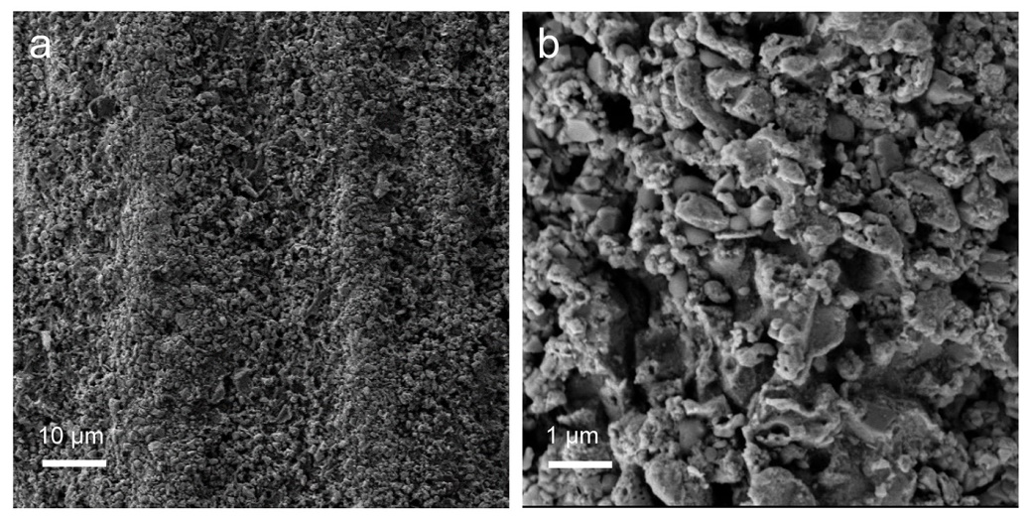
Fig. S6. SEM images of Cu–4Ag: (a) low magnification and (b) high magnification images.

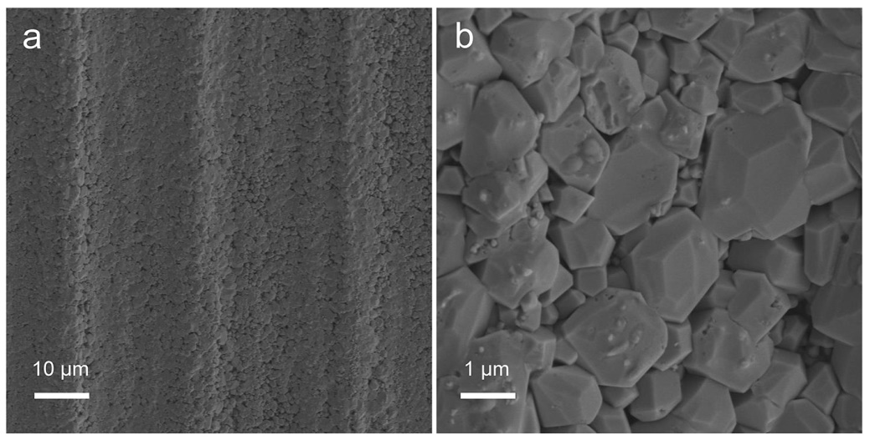
Fig. S7. SEM images of P-Cu: (a) low magnification and (b) high magnification images.

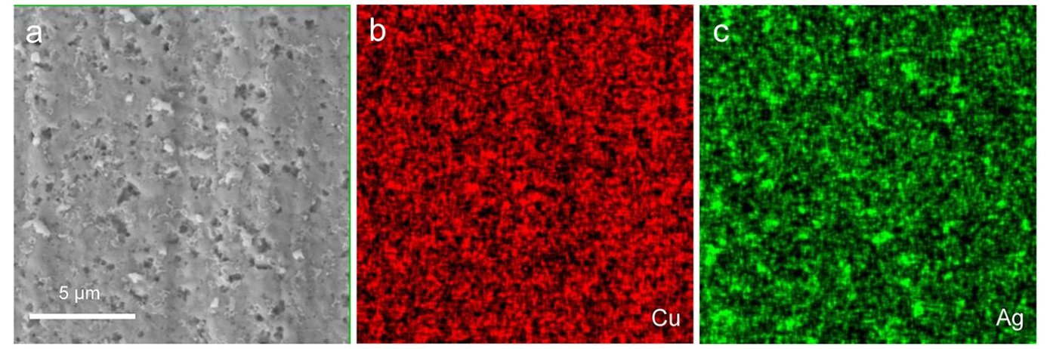
Fig. S8. (a) SEM image of Cu–1Ag. (b) and (c) are the EDS elemental mapping of Cu and Ag, respectively.

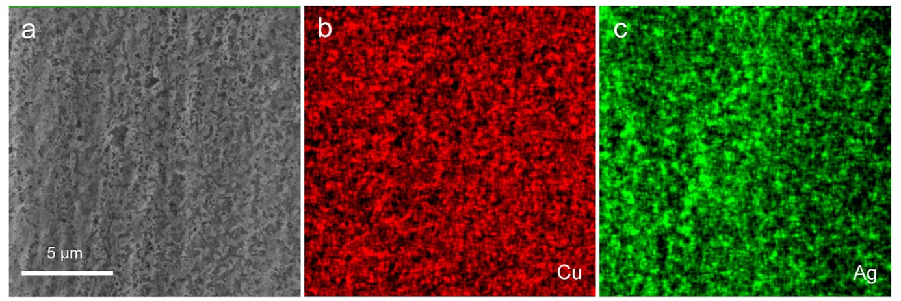
Fig. S9. (a) SEM image of Cu–2Ag. (b) and (c) are the EDS elemental mapping of Cu and Ag, respectively.

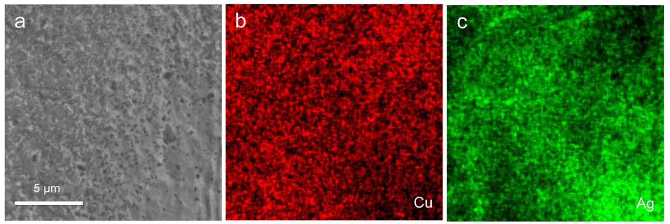
Fig. S10. (a) SEM image of Cu–3Ag. (b) and (c) are the EDS elemental mapping of Cu and Ag, respectively.

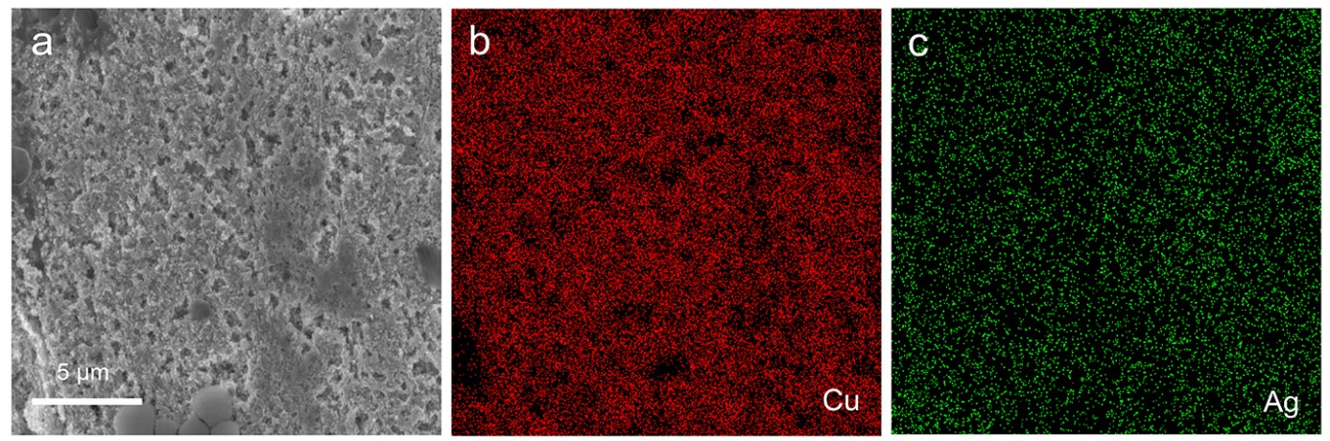
Fig. S11. (a) SEM image of Cu–4Ag after stability test. (b, c) EDS elemental mapping of Cu and Ag, respectively.

Fig. S12. XRD patterns of Cu–4Ag before and after stability test: (a) survey spectra and (b) the enlarged area around Cu (111) peak.

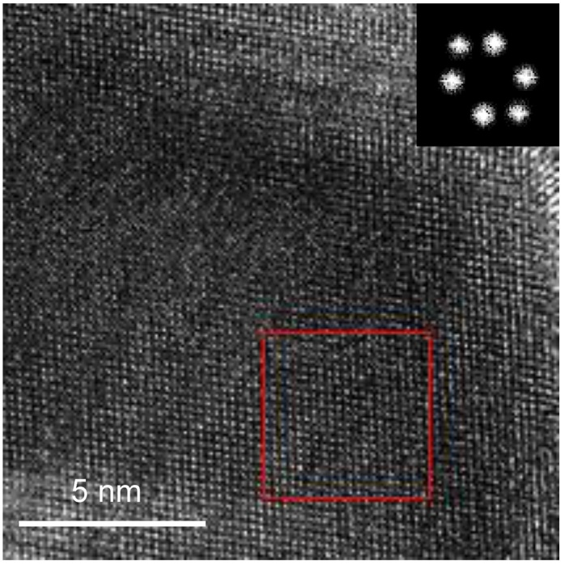
Fig. S13. HRTEM image of Cu–4Ag.

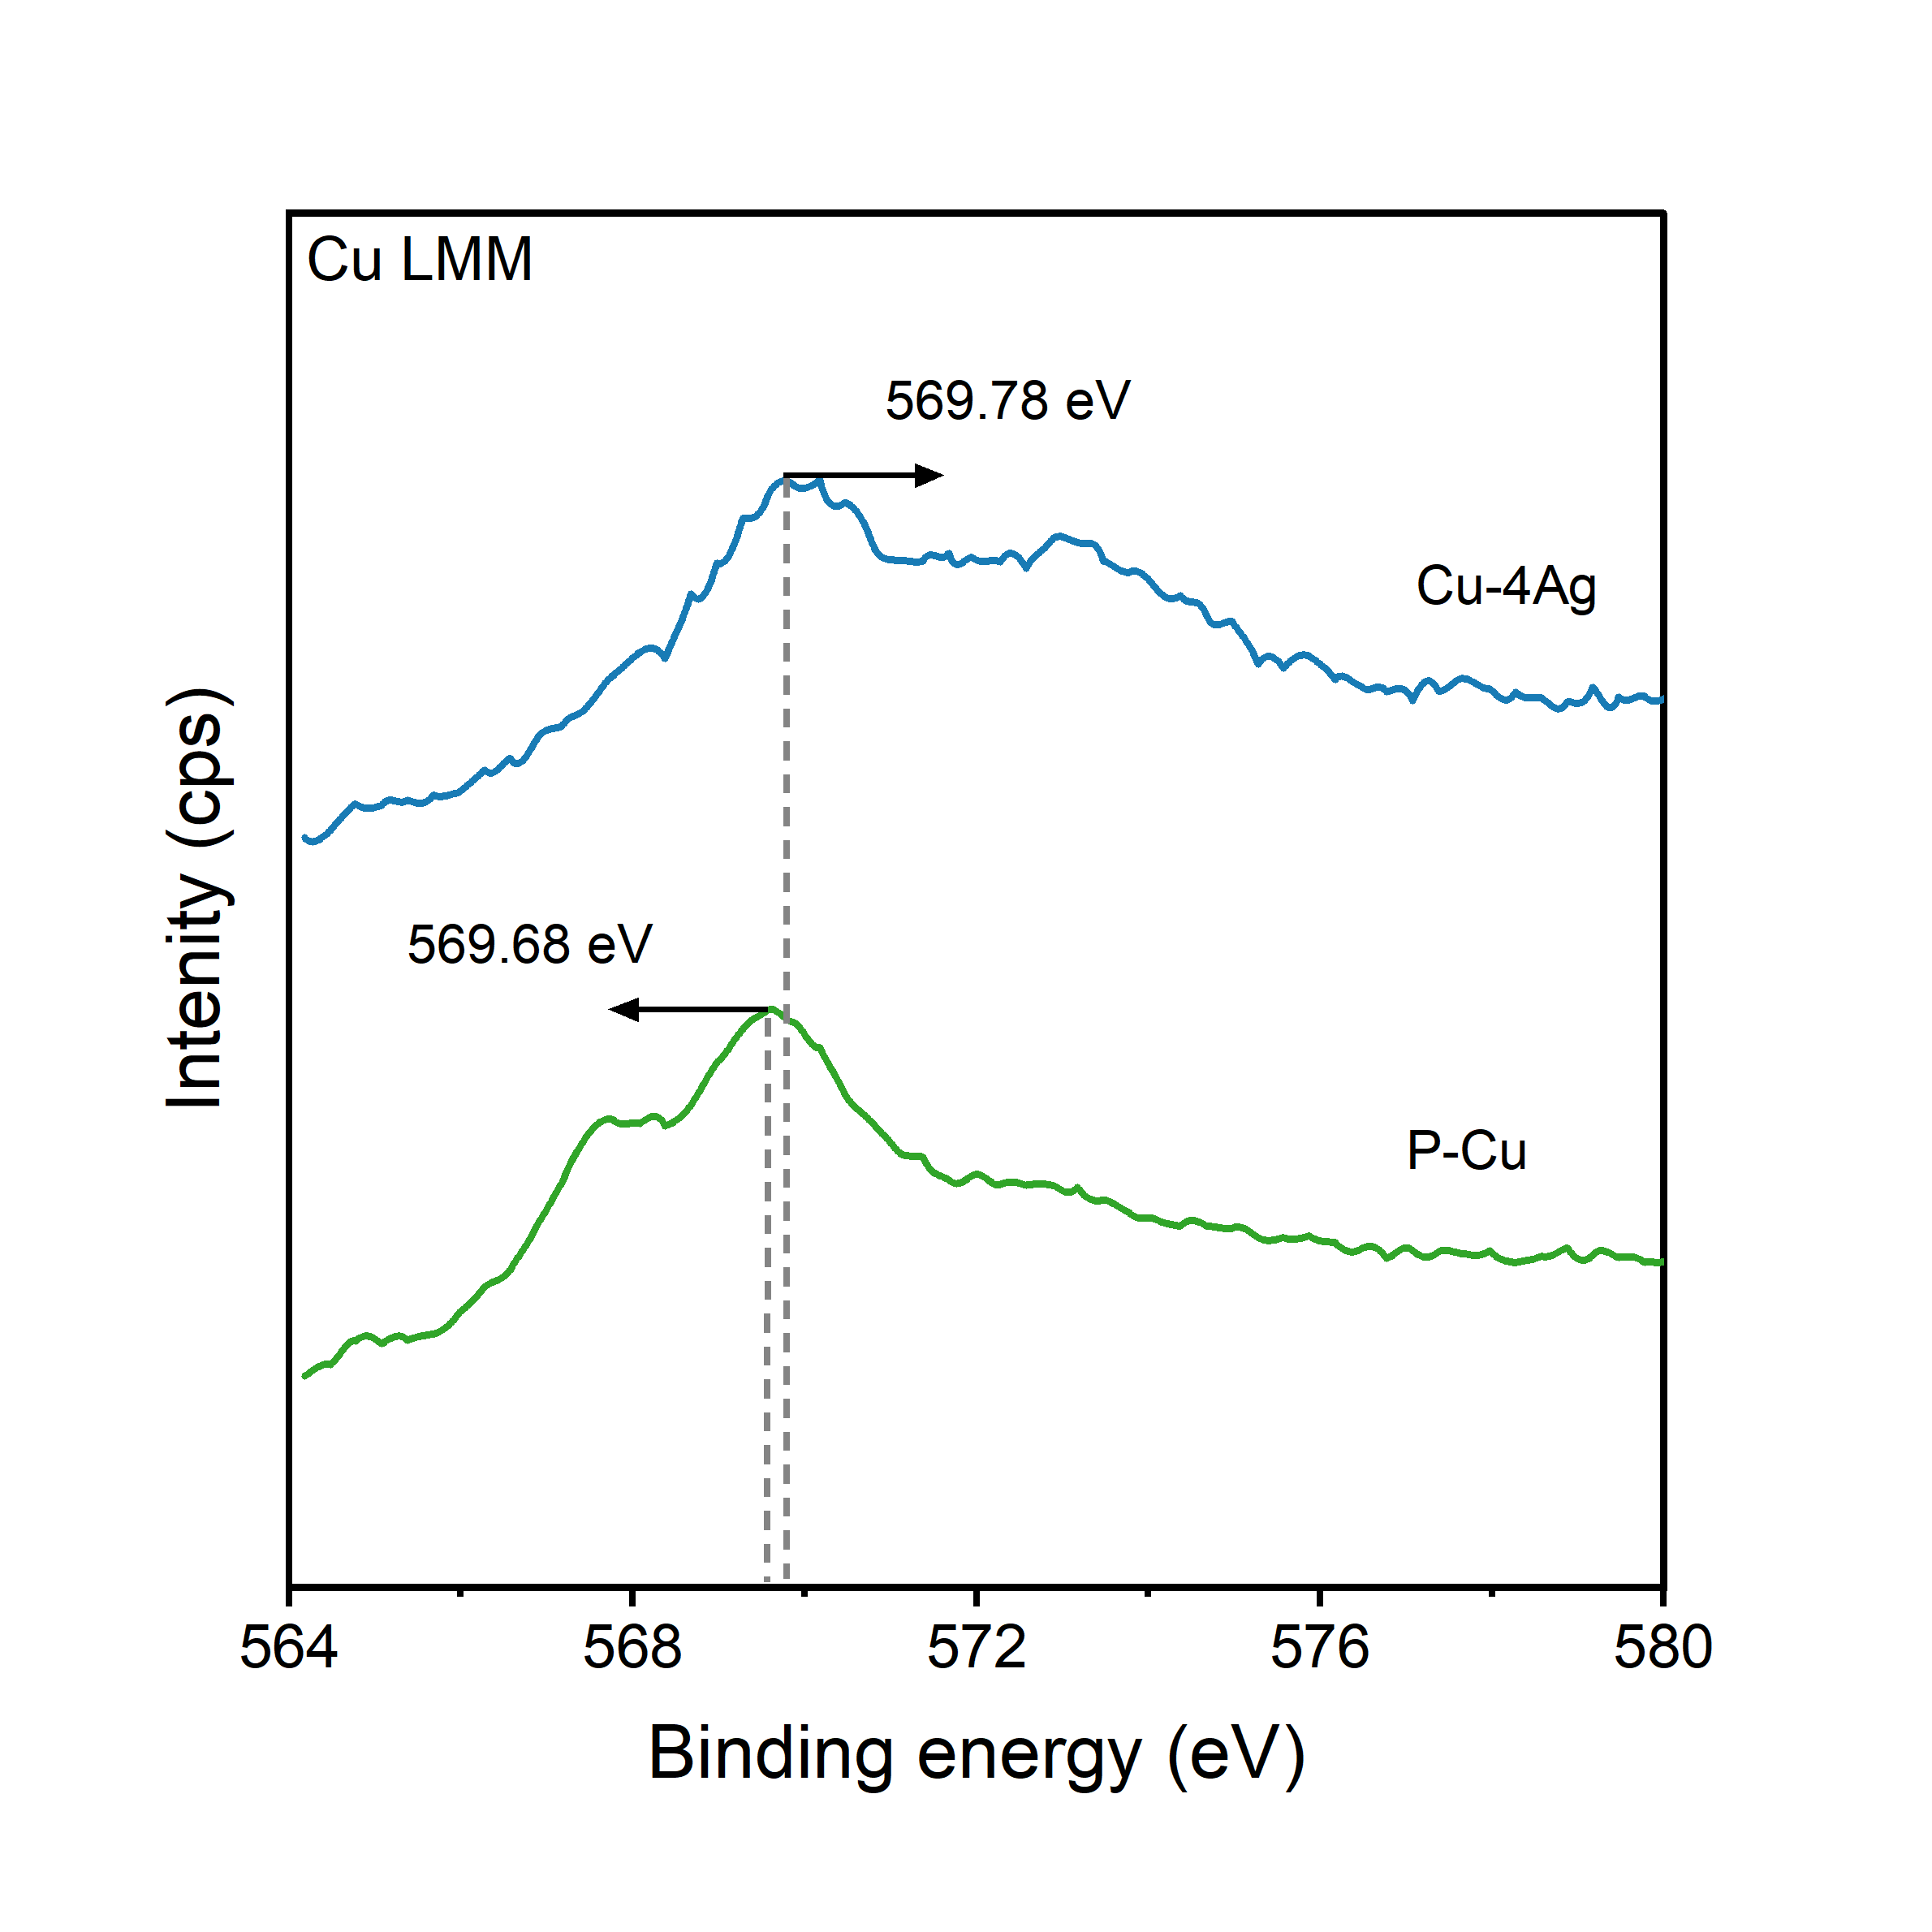
Fig. S14. Auger Cu LMM of P-Cu and Cu–4Ag.

Fig. S15. XPS of Cu–1Ag, Cu–4Ag, Cu plate, and Ag plate: (a) Cu 2p; (b) Cu 2p_{3/2}; (c) Ag 3d; (d) Ag 3d_{5/2}.

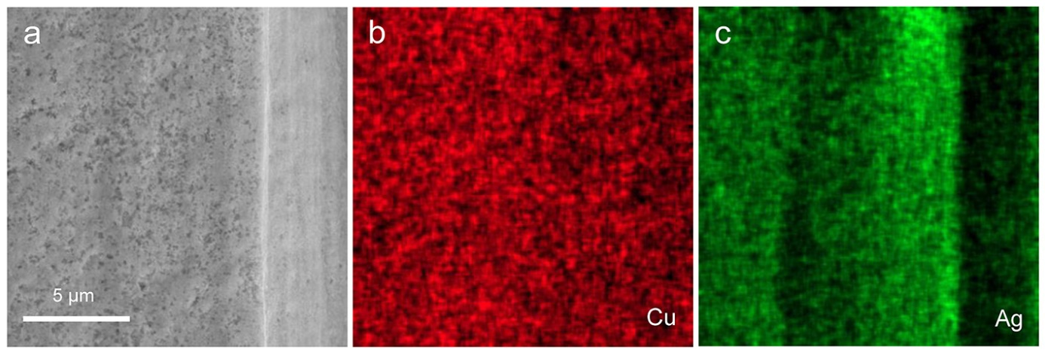
Fig. S16. (a) SEM image of Cu–4Ag D. (b) and (c) are the EDS elemental mapping of Cu and Ag, respectively.

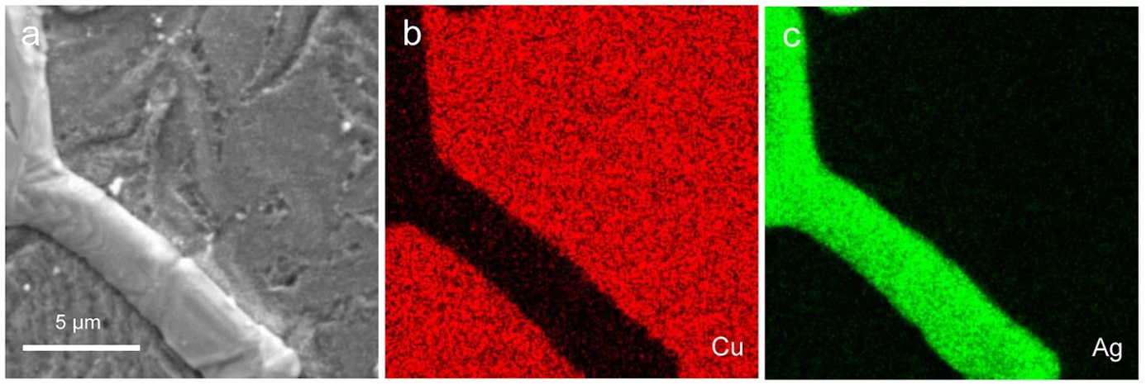
Fig. S17. (a) SEM image of Cu–4Ag A. (b) and (c) are the EDS elemental mapping of Cu and Ag, respectively.

Fig. S18. XRD patterns of Cu–4Ag and Cu–4Ag A: (a) survey spectra and (b) the enlarged area around Cu (111) peak.

Fig. S19. XRD patterns of Cu–4Ag and Cu–4Ag D: (a) survey spectra and (b) the enlarged area around Cu (111) peak.

Fig. S20. XPS of Cu–4Ag A, Cu–4Ag, Cu plate, and Ag plate: (a) Cu 2p; (b) Cu 2p_{3/2}; (c) Ag 3d; (d) Ag 3d_{5/2}.
Fig. S21. XPS of Cu–4Ag D, Cu–4Ag, Cu plate, and Ag plate: (a) Cu 2p; (b) Cu 2p_{3/2}; (c) Ag 3d; (d) Ag 3d_{5/2}.

Fig. S22. Comparison of Cu–4Ag and Cu–4Ag A: (a) LSV polarization curves and (b) Nyquist plots.

Fig. S23. Comparison of Cu–4Ag and Cu–4Ag D: (a) LSV polarization curves and (b) Nyquist plots.

Table S1. Summary on HER properties of CuAg electrocatalysts
Catalysts | Electrolyte | Overpotential at 10 mA/cm² / mV | Ref.
Cu–4Ag | 0.5 M H₂SO₄ | 256 | This work
Cu–3Ag | 0.5 M H₂SO₄ | 295 | This work
Cu–2Ag | 0.5 M H₂SO₄ | 318 | This work
Cu–1Ag | 0.5 M H₂SO₄ | 339 | This work
Cu₃Ag₁ | 0.5 M H₂SO₄ | 412 | [1]
Ag/Cu-CPE | 0.5 M H₂SO₄ | ~550 | [2]

References
- T.T. Yang, C.Q. Cheng, L.Y. Xiao, et al., A descriptor of IB alloy catalysts for hydrogen evolution reaction, SmartMat, (2023), art. No. e1204. https://doi.org/10.1002/smm2.1204
- N. Behrooz, A. Ghaffarinejad, and N. Sadeghi, Ag/Cu nano alloy as an electrocatalyst for hydrogen production, J. Electroanal. Chem., 782(2016), p. 1.

