Homogeneous distributed natural pyrite-derived composite induced by modified graphite as high-performance lithium-ion batteries anode
Juan Yu^{1),} , Yinbo Wei¹⁾, Bicheng Meng¹⁾, Jiaxin Peng¹⁾, Kai Yang¹⁾, Tianxin Chen⁴⁾, Naixing Yang³⁾, and Xiuyun Chuan²⁾
1) School of Metallurgical Engineering, Xi’an University of Architecture and Technology, Xi’an 710055, China
2) School of Earth and Space Sciences, Peking University, Beijing 100871, China
3) Shaanxi Key Laboratory of Nano-Materials and Technology, School of Mechanical and Electrical Engineering, Xi’an University of Architecture and Technology, Xi’an 710055, China
4) School of Resources Engineering, Xi’an University of Architecture Technology, Xi’an 710055, China
Corresponding author: Juan Yu E-mail: yujuan@xauat.edu.cn

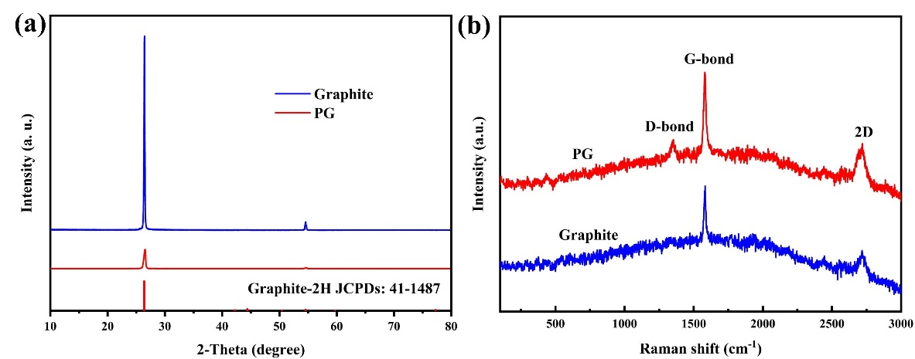
Fig. S1. (a) XRD patterns of graphite and PG. (b) Raman spectra of graphite and PG.

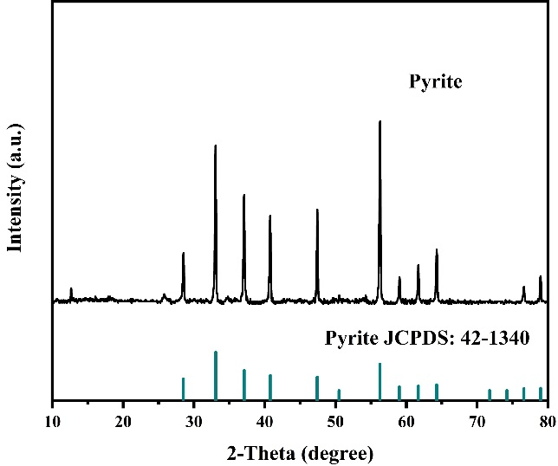
Fig. S2. XRD patterns of natural pyrite.

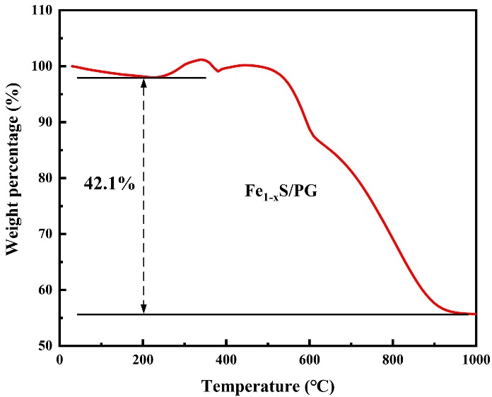
Fig. S3. TG curve of the Fe_{1-x}S/PG tested in air atmosphere from 0 to 1000 °C.
$$η({Fe}_{1-x}S) = \frac{m({Fe}_{1-x}S)}{m\left({Fe}_{1-x}S\right)+m(C)} ×100\%$$
$$m\left({Fe}_{1-x}S\right)= \frac{\frac{2}{1-x}× η({Fe}_{2}O_{3}) × M({Fe}_{1-x}S)}{M({Fe}_{2}O_{3})}$$
(η represents weight percent, m represents mass, M represents molar mass )

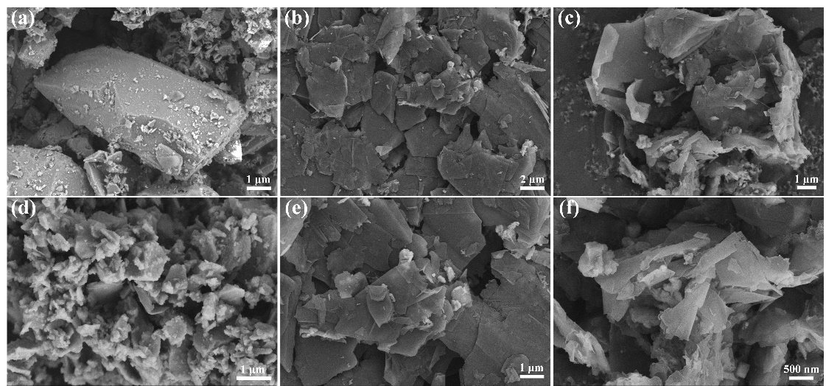
Fig. S4. (a) SEM image of pristine pyrite and (d) after ball milling. (b) and (e) SEM image of natural graphite. (c) and (f) SEM image of PG.

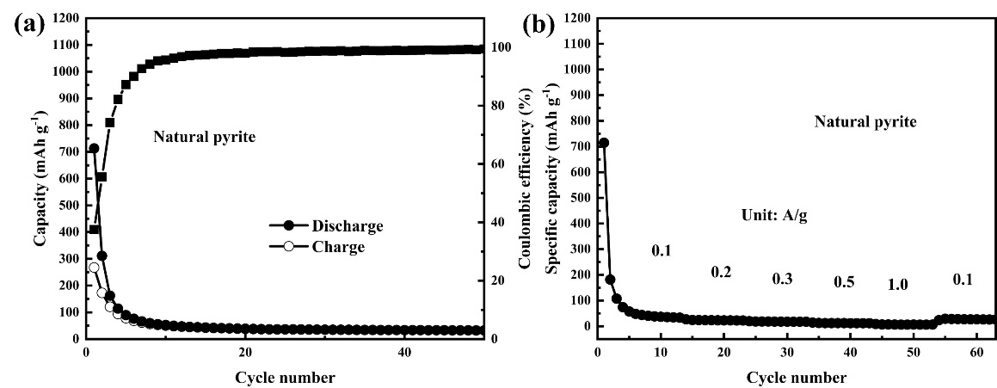
Fig. S5. (a) The cycling performance of natural pyrite at current density of 0.1 A g⁻¹; the rate performance of natural pyrite at different.

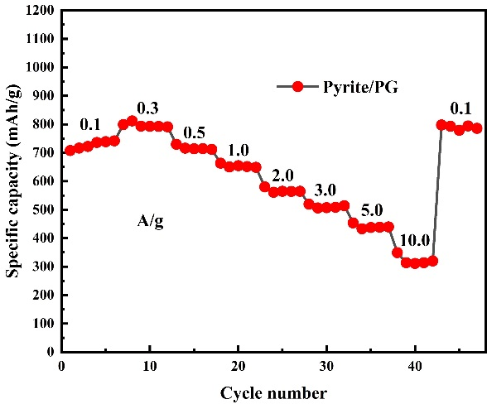
Fig. S6. The rate performance of Fe_{1-x}S/PG at current density up to 10A g⁻¹

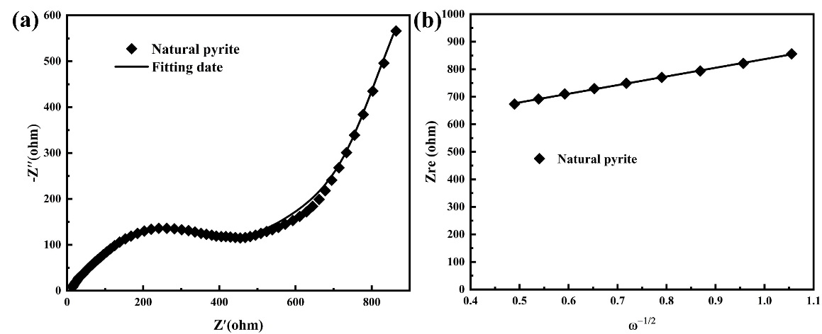
Fig.S7. (a) EIS curves of natural pyrite. (b) The relationship between Z_{re} and ω^{-1/2} at low frequencies.

Table S1. X-ray Fluorescence analysis date of natural pyrite
Element | Fe | S | Mg | Si | Ca | Al | Na | other
Wt% | 60.96 | 35.47 | 1.18 | 0.803 | 0.433 | 0.32 | 0.265 | 0.569

Table S2. Atomic percentages of Fe_{1-x}S/PG obtained from XPS spectra
Element | Fe | S | C
Atomic percentage (%) | 2.34 | 2.60 | 95.06

Table S3. The Li⁺ diffusion coefficient of Fe_{1-x}S/PG, Fe_{1-x}S/G, and pyrite
Materials | Fe_{1-x}S/PG | Fe_{1-x}S/G | Pyrite
$D_{Li+}$ (cm² s⁻¹) | 1.59×10⁻¹² | 5.81×10⁻¹³ | 5.81×10⁻¹⁴

