Supplementary Information

Microscale mechanism of tailing thickening in metal mines

Huazhe Jiao^{1,2)}, Wenbo Yang¹⁾, Zhu’en Ruan^{2),}, Jianxin Yu¹⁾, Juanhong Liu²⁾, and Yixuan Yang¹⁾
1) School of Civil Engineering, Henan Polytechnic University, Jiaozuo 454000, China
2) School of Civil and Resource Engineering, University of Science and Technology Beijing, Beijing 100083, China
Corresponding author: Zhu’en Ruan E-mail: ustb_ruanzhuen@hotmail.com

Table S1. Pilot-scale continuous thickener
Component | Dimensions and parameters
Settlement column | Diameter 10 cm, height 100 cm
Flocculant feed pump | BS100-1A
Agitator | Height 60 cm, width 10 cm
Rake | Height 90 cm, width 8 cm
Low speed motor | Speed 0–10 r/min

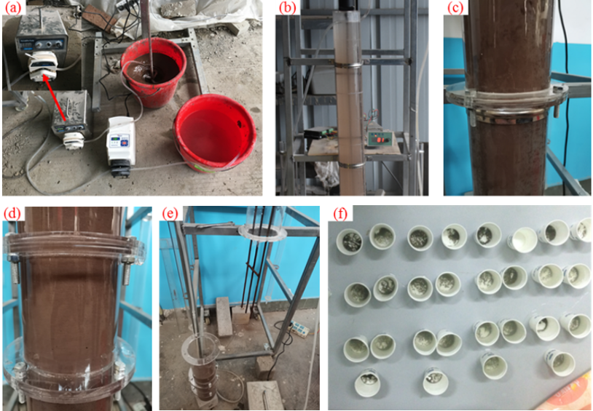
Fig. S1. Continuous shear thickening test: (a) slurry preparation, (b) settling column, (c) flocculation–sedimentation, (d) deposited bed, (e) tailing bed sampling, and (f) tailing specimen.

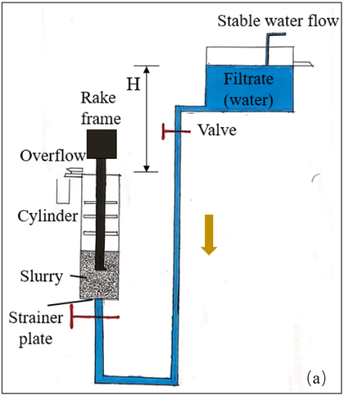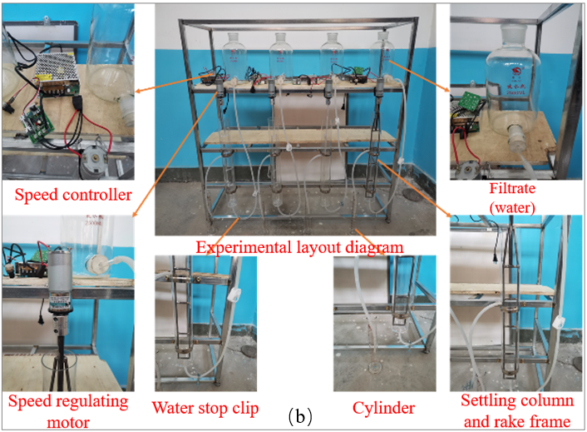
Fig. S2. Rotating reverse seepage test device: (a) experimental device scheme and (b) layout of the laboratory device

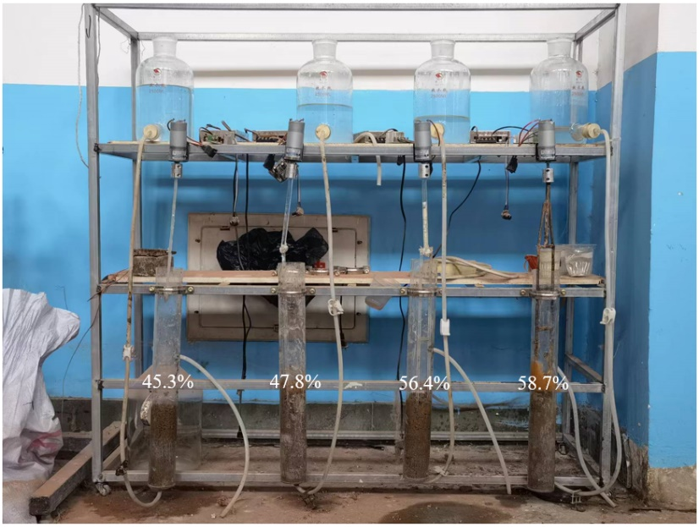
Fig. S3. Reverse seepage test device.

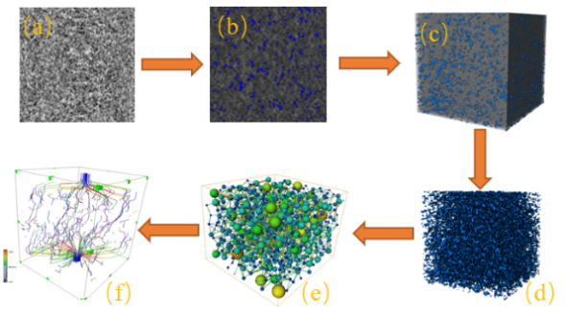
Fig. S4. Three-dimensional reconstruction process: (a) slice chart, (b) threshold segmentation, (c) binarization, (d) 3D reconstruction, (e) pore network model, and (f) channel characterization.
Table S2. Details of PNM
Parameters |  | S1 | S2 |  | S3 |  | S4
Model size / mm |  | 2$×$2$×$2 | 2$×$2$×$2 | 2$×$2$×$2 |  | 2$×$2$×$2
Shearing time / min |  | 0 | 10 |  | 30 |  | 60
Model porosity |  | 0.494 | 0.358 |  | 0.302 |  | 0.277
Number of spheres |  | 1332 | 1229 |  | 1089 |  | 806
Number of throats |  | 525 | 478 |  | 371 |  | 339
Radius of sphere / μm | Minimum value | 0.85 | 0.78 |  | 0.53 |  | 0.26
 | Maximum value | 117.62 | 115.02 |  | 106.11 |  | 94.66
 | Average value | 76.79 | 73.21 |  | 68.65 |  | 66.36
Radius of throat / μm | Minimum value | 0.93 | 0.91 |  | 0.56 |  | 0.25
 | Maximum value | 94.69 | 87.61 |  | 86.52 |  | 83.75
 | Average value | 28.66 | 31.34 |  | 25.12 |  | 20.78
Coordination number of pore throat | Minimum coordination number | 2 | 1 |  | 1 |  | 1
 | Maximum coordination number | 35 | 35 |  | 32 |  | 25
 | Average coordination number | 10.83 | 11.07 |  | 9.16 |  | 7.39
Radius ratio of pore throat | Minimum value | 1 | 1 |  | 1 |  | 1
 | Maximum value | 23.18 | 2.95 |  | 3.71 |  | 3.78
 | Average value | 2.69 | 2.34 |  | 2.74 |  | 3.19

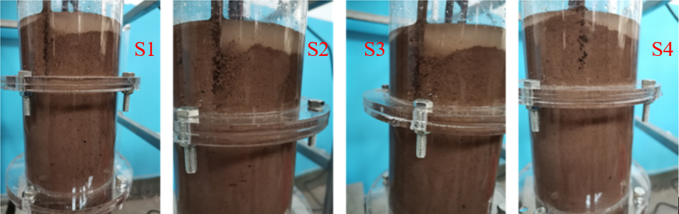
Fig. S5. Observation of the tailings bed shear thickening process.

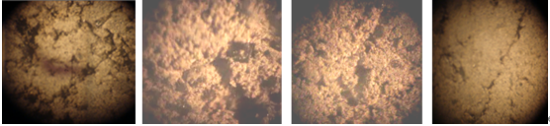
Fig. S6. Evolution of the seepage flow channel.

Table S3. Boundary parameters
Fluid density,  ρ / (kg∙m⁻³) | Dynamic viscosity,  μ / (Pa$∙$s) | Inlet pressure,  P_{in} / Pa | Outlet pressure, P_{out} / Pa | Model size,  V / mm³
1000 | 0.001 | 1.3 × 10⁵ | 1.0 × 10⁵ | 1

Table S4. Reserve direction seepage simulation result
Specimen |  | S1 | S2 | S3 | S4
Sampling time / min |  | 0 | 10 | 30 | 60
Number of flow lines |  | 452 | 489 | 423 | 363
Absolute permeability / (10⁻³ μm²) |  | 13.70 | 14.32 | 11.07 | 10.63
Pressure value / Pa | Maximum value | 129724 | 129866 | 129852 | 129906
 | Minimum value | 98820 | 99445 | 101107 | 101933
 | Average value | 104565 | 108246 | 114916 | 116794
Velocity value /  (μm$∙$s) | Maximum value | 1.457 | 1.537 | 1.183 | 1.038
 | Minimum value | 1.162 | 1.182 | 1.025 | 1.002
 | Average value | 1.283 | 1.302 | 1.104 | 1.020

