Supplementary Information

New process for treating boron-bearing iron ore by flash reduction coupled with magnetic separation

Qipeng Bao¹⁾, Lei Guo^{1),}, Hong Yong Sohn²⁾, Haibin Zuo¹⁾, Feng Liu¹⁾, Yongliang Gao³⁾, and Zhancheng Guo^{1),}
1) State Key Laboratory of Advanced Metallurgy, University of Science and Technology Beijing, Beijing 100083, China
2) Department of Materials Science & Engineering, University of Utah, Utah 84112, USA
3) China ENFI Engineering Corporation, Beijing 100038, China

Corresponding authors: Zhancheng Guo E-mail: zcguo@ustb.edu.cn;
Lei Guo E-mail: leiguo@ustb.edu.cn

In Fig. S1, the elemental content of each point corresponds to the chemical formula of each phase shown in XRD. It is seen that boron-bearing minerals mainly included ludwigite (Point 2) and szaibelyite (Point 4), iron bearing phases were mainly magnetite (Point 3) and ludwigite, and the gangue phases were mainly quartz (Point 1) and chrysotile (Point 5). A few magnetite grains were well isolated, but most of them were closely embedded in the gangue and boron-bearing minerals, which made it difficult to completely separate iron and boron through grinding and beneficiation.
The configurations of the flash reduction/melting reactor and the fixed bed pre-reduction device used in the experiment are shown in Figs. S2 and S3, respectively.
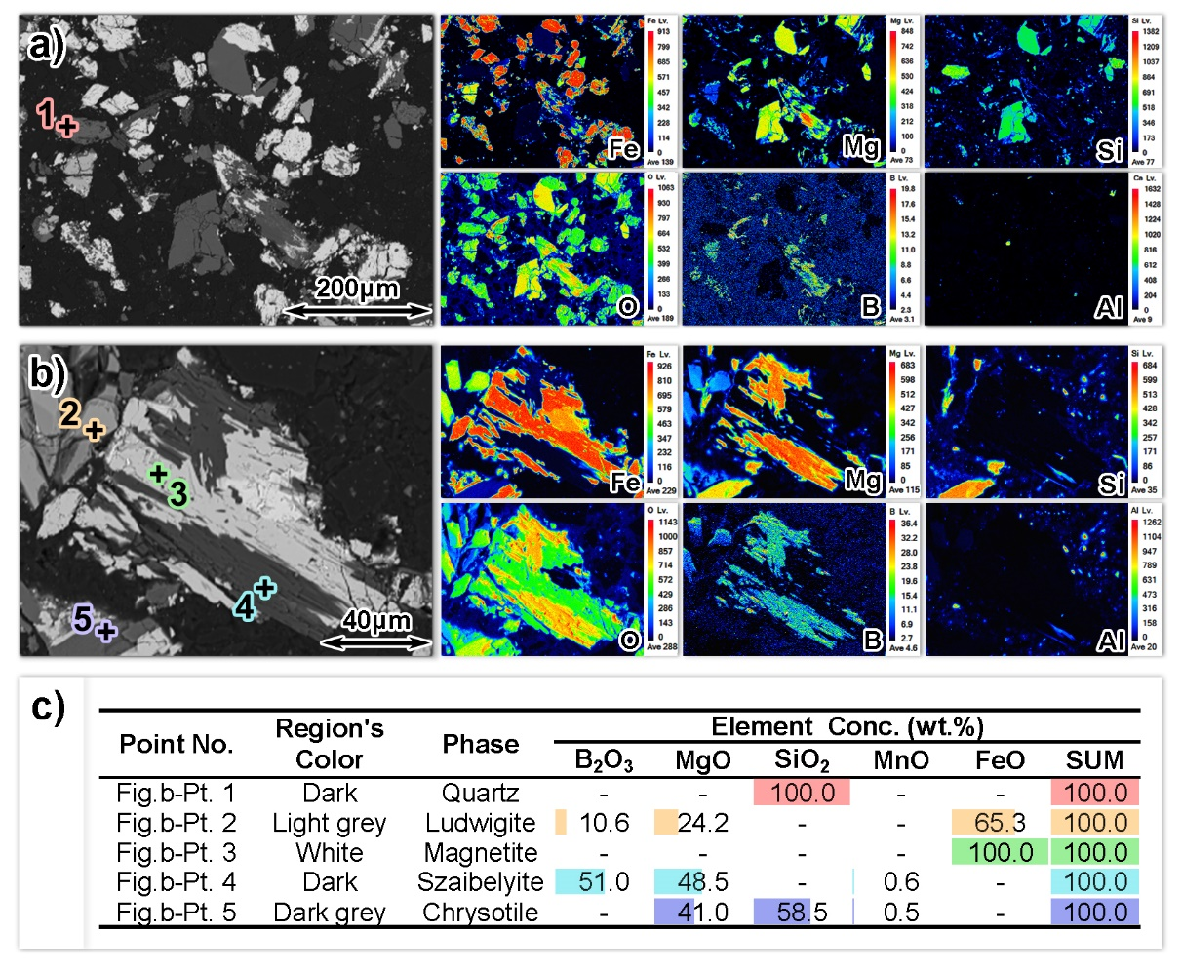
Fig. S1. Element distribution and composition of raw material boron-bearing iron concentrate determined by EPMA: (a, b) EPMA element mapping; (c) element quantification at each corresponding point in (a) and (b).
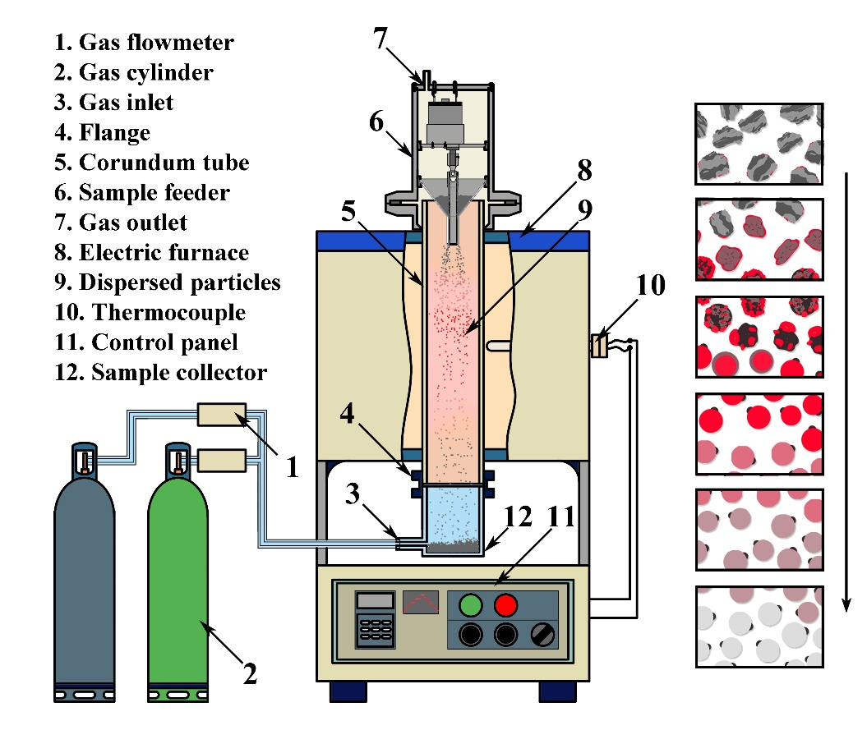
Fig. S2. Sketch of the FRMS apparatus.
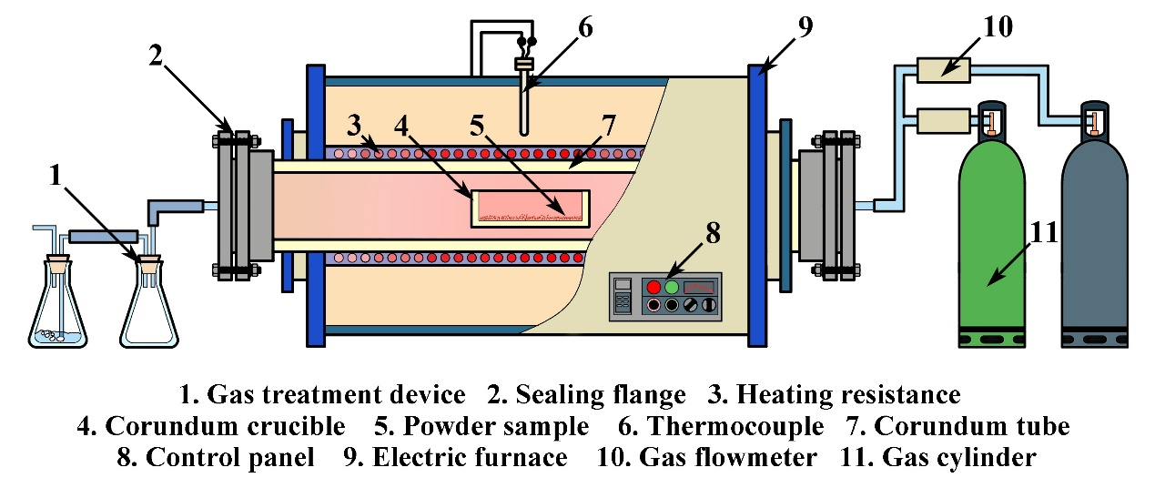
Fig. S3. Sketch of the pre-reduction apparatus.
According to the XRD analysis of the pre-reduced sample shown in Fig. S4(c), the main phase was Fe, Mg₂SiO₄, SiO₂, in which Fe was mainly originated from magnetite phase, followed by the reduction of ludwigite. Mg₂SiO₄ was formed by the high temperature decomposition of chrysotile. Due to the strong spectral peaks of metallic iron, other phases with lower contents, such as another reduction product suianite (in the form of a slab, mainly composed of MgO and B₂O₃, with the molar ratio of MgO/B₂O₃ close to 2), are not shown. Fig. S4(d) shows the particle morphology of the typical ludwigite/magnetite composite particles after reduction. According to the EPMA element mapping and point quantification, the area around Point 1 is porous metallic iron formed from the reduction of magnetite. The area around Point 2 is composed of metallic iron and suianite formed by the reduction of the ludwigite. Small particles of metallic iron are dispersed within the suianite phase, and the details of the corresponding surface morphology are shown in Fig. S4(b). The area around Point 3 is the unreduced ludwigite, with a significantly higher oxygen content than the outer circle. The area around Point 4 is formed by partial reduction of the ludwigite, where fine metallic iron particles are dispersed within the dense ludwigite phase.

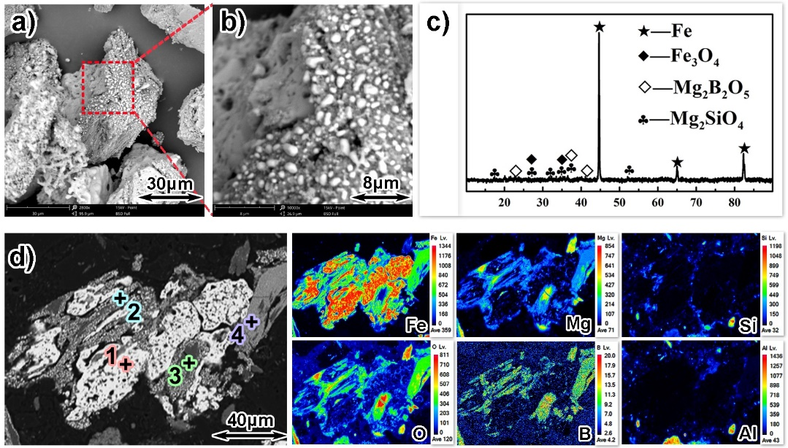
Fig. S4. Element distribution and phase analysis of the pre-reduced ore powder
(a, b) surface morphology; (c) XRD pattern; (d) EPMA element mapping; (e) EPMA element point quantification.
As shown in Fig. S5, the metallization degree of the ore particles of 50-100 μm sizes was close to 100% after pre-reduction at 900°C. Thus, there was no need to consider the reduction process in the subsequent FRMS process, and only the slag/iron melting and separation was focused on. At 1520 and 1540°C, the slag and iron melted completely, forming spherical particles made up of separate but attached slag and iron phases. The metallic iron sphere was dense, and the size of the slag particles adhering to it varied depending on the content of gangue in the raw ore particles. At 1500°C, the slag melted and formed a dense spherical shape. The small metallic iron particles also melted and spheroidized, but the larger iron particles did not melt. The metallic iron in the particles still existed as sponge-structured iron. When the temperature dropped to 1480°C, most metallic iron could not achieve melting aggregation, while the aggregation of the slag was relatively complete.
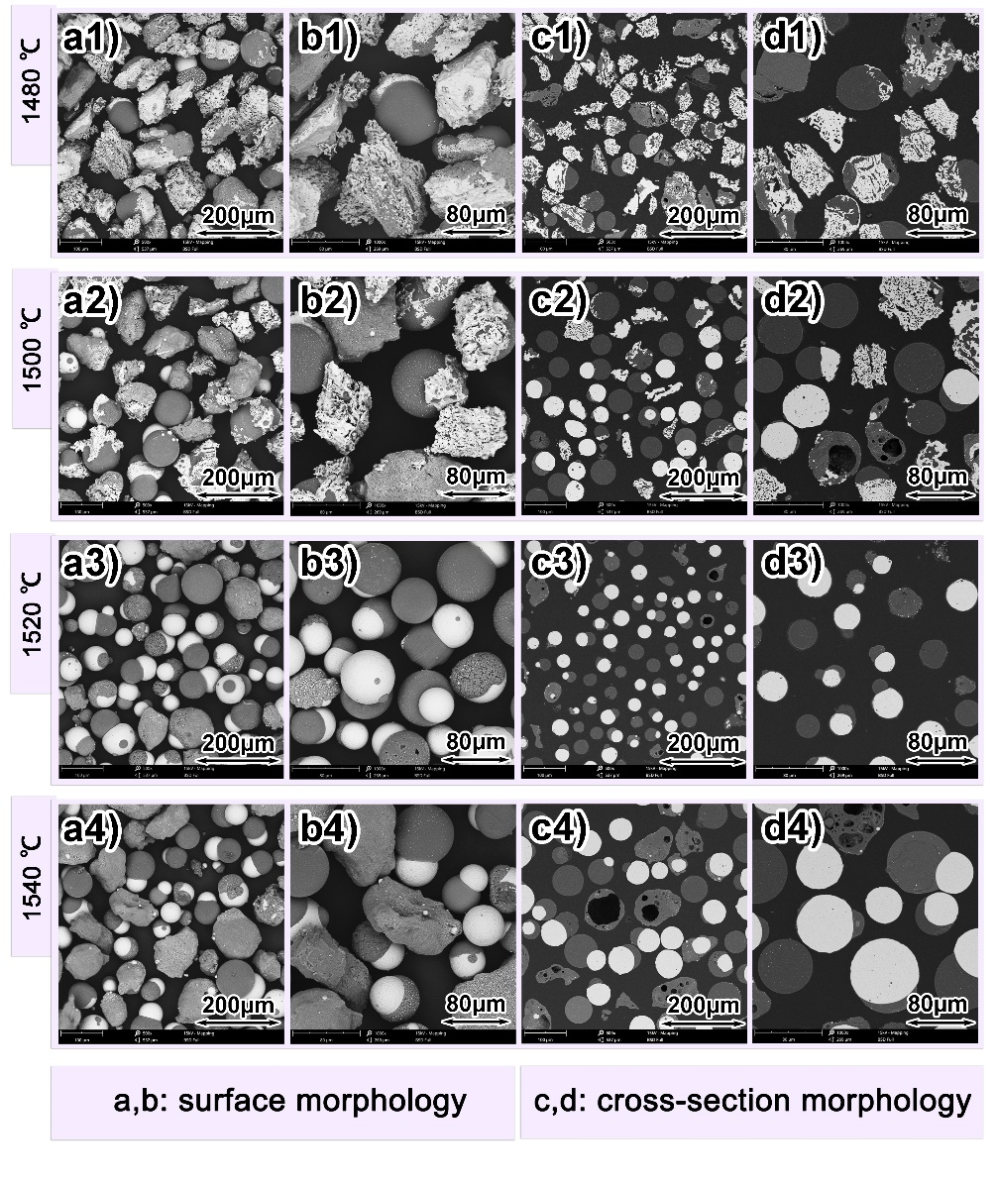
Fig. S5. Morphologies of the 50–100 μm powder after two-step FRMS treatment at different temperatures.

