Supplementary Materials
Hydrogen-based direct reduction of industrial iron ore pellets: Statistically designed experiments and computational simulation
Patrícia Metolina ^{1,2),,} , Tiago Ramos Ribeiro²⁾, and Roberto Guardani ¹⁾
1) Chemical Systems Engineering Center, Department of Chemical Engineering, University of São Paulo, São Paulo 05508-900, Brazil
2) Metallurgical Process Laboratory, Institute of Technological Research, São Paulo 05508-901, Brazil
(Received: 7 November 2021; revised: 29 March 2022; accepted: 30 March 2022)

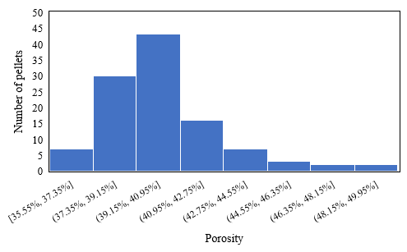
Fig. S1. Porosity distribution of the industrial pellets.

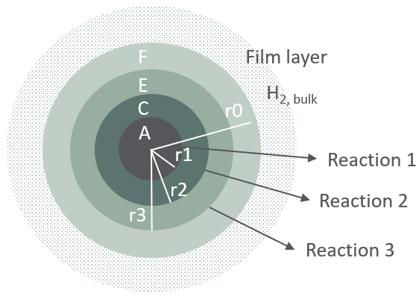
(b)
(a)

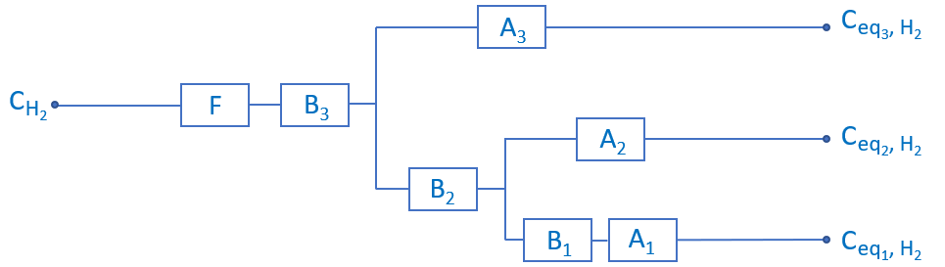
Fig. S2. Shrinking Core Model (SCM). (a) Schematic view of the pellet reduction model described by the unreacted core and the three layers of solid products separated by the sharp interfaces. (b) The reduction model represented as a stepwise resistance network, where A1, A2, and A3, represent the resistances due to chemical reactions R1, R2, and R3, respectively; B1, B2, and B3, the resistances due to the diffusion of the reacted solid layer of magnetite, wustite, and iron; and F, the resistance due to the gas film layer on the surface of the solid. Ceq_{1, H2}, Ceq_{2, H2}, Ceq_{3, H2} are the equilibrium concentrations of H₂ at the sharp interfaces for each of reactions 1, 2, and 3, respectively. (Adapted from Kinaci et al.[3])
Table S1. Pellet parameters before and after DRI experiments and the main changes for each experimental condition
Exp. | Reduction  temperature,  T / °C | Initial |  |  |  | Final |  |  |  | Changes
 |  | m₀ / g | d_{p,0} / mm | ε₀ |  | m_{f} / g | d_{p,f} / mm | ε_{f} |  | Mass / % | Volume / % | ε_{f} − ε₀
8 | 595 | 5.449 | 15.2 | 0.40 |  | 3.899 | 15.09 | 0.71 |  | −28.4 | −1.6 | 0.31
6 | 597 | 2.498 | 11.6 | 0.39 |  | 1.804 | 11.86 | 0.73 |  | −27.8 | 5.8 | 0.33
E2 | 597 | 7.108 | 16.6 | 0.41 |  | 5.115 | 16.50 | 0.71 |  | −28.0 | −1.7 | 0.31
13 | 702 | 3.024 | 12.6 | 0.43 |  | 2.193 | 12.32 | 0.70 |  | −27.5 | −7.1 | 0.28
E1 | 792 | 2.248 | 11.2 | 0.38 |  | 1.604 | 11.21 | 0.71 |  | −28.7 | 1.1 | 0.33
9 | 795 | 5.597 | 15.0 | 0.36 |  | 4.026 | 14.99 | 0.70 |  | −28.1 | 0.4 | 0.34
7 | 797 | 3.112 | 12.3 | 0.36 |  | 2.219 | 12.49 | 0.71 |  | −28.7 | 4.5 | 0.35
1'' | 898 | 4.005 | 13.6 | 0.39 |  | 2.845 | 13.87 | 0.73 |  | −29.0 | 6.1 | 0.34
1' | 899 | 4.005 | 13.6 | 0.39 |  | 2.850 | 13.99 | 0.74 |  | −28.8 | 8.8 | 0.34
2 | 901 | 7.247 | 16.5 | 0.39 |  | 5.199 | 17.12 | 0.74 |  | −28.3 | 10.8 | 0.35
5 | 904 | 1.794 | 10.5 | 0.41 |  | 1.276 | 10.71 | 0.74 |  | −28.8 | 6.7 | 0.33
1 | 905 | 3.906 | 13.6 | 0.40 |  | 2.769 | 13.84 | 0.74 |  | −29.1 | 6.5 | 0.34
4 | 1001 | 4.622 | 14.7 | 0.44 |  | 3.285 | 16.00 | 0.80 |  | −28.9 | 29.7 | 0.36
12 | 1010 | 2.214 | 11.5 | 0.45 |  | 1.572 | 12.12 | 0.78 |  | −29.0 | 16.2 | 0.33
10 | 1108 | 4.424 | 13.8 | 0.35 |  | 3.141 | 14.12 | 0.72 |  | −29.0 | 8.0 | 0.37
11 | 1190 | 2.534 | 11.7 | 0.39 |  | 1.797 | 13.14 | 0.80 |  | −29.1 | 42.2 | 0.41
3 | 1195 | 5.058 | 14.8 | 0.40 |  | 3.584 | 16.70 | 0.81 |  | −29.1 | 44.4 | 0.40
Mean | ⎯ |  |  |  |  |  |  |  |  | −28.6 | 10.6 | 0.34
Mean (< 1000°C) | ⎯ |  |  |  |  |  |  |  |  | ⎯ | 3.36 | ⎯
Mean (> 1000°C) | ⎯ |  |  |  |  |  |  |  |  | ⎯ | 28.09 | ⎯

