Supplementary Information
Enhancing performance of low-temperature processed CsPbI₂Br all-inorganic perovskite solar cells using polyethylene oxide-modified TiO₂
Xu Zhao^{1),*}, Naitao Gao^{2),*}, Shengcheng Wu²⁾, Shaozhen Li^{1),}, and Sujuan Wu^{2),}
1) School of Electrical and Electronic Engineering, Wuhan Polytechnic University, Wuhan 430023, China
2) Institute for Advanced Materials and Guangdong Provincial Key Laboratory of Quantum Engineering and Quantum Materials, South China Academy of Advanced Optoelectronics, South China Normal University, Guangzhou 510006, China
*These authors contributed equally to this work.
Corresponding authors: Sujuan Wu E-mail: sujwu@scnu.edu.cn; Shaozhen Li E-mail: origen2003@whpu.edu.cn

Table S1. Photovoltaic parameters of PEO-PSCs based on different PEO concentrations. V_{oc}, J_{sc}, and FF represent open circuit voltage, short-circuit current density, and fill factor, respectively
PEO concentration / (mg·mL⁻¹) | V_{oc} / V | J_{sc} / (mA·cm⁻²) | FF | PCE / %
0 | 1.104 | 13.23 | 0.625 | 9.13
0.06 | 1.101 | 13.44 | 0.642 | 9.51
0.12 | 1.172 | 13.80 | 0.660 | 10.68
0.18 | 1.213 | 13.73 | 0.675 | 11.24
0.24 | 1.170 | 13.66 | 0.658 | 10.51

Table S2. Photovoltaic parameter statistics of reported carbon-based CsPbI₂Br PSCs
Device architecture | V_{oc} / V | J_{sc} / (mA·cm⁻²) | FF | PCE / % | Ref.
FTO/TiO₂/PEO/CsPbI₂Br/Carbon | 1.213 | 13.79 | 0.675 | 11.24 | This work
FTO/c-TiO₂/CsPbI₂Br/Carbon | 1.150 | 13.54 | 0.642 | 10.00 | [1]
FTO/TiO₂/CsPbI₂Br/P3HT-MWCNT/Carbon | 1.210 | 13.35 | 0.620 | 10.01 | [2]
FTO/TiO₂/CsCl/CsPbI₂Br/Carbon | 1.150 | 14.39 | 0.691 | 11.45 | [3]
FTO/TiO₂-TiCl_{x}/CsPbI₂Br/Carbon | 1.280 | 14.21 | 0.794 | 14.46 | [4]
FTO/TiO₂/BMIMPF₆/CsPbI₂Br/Carbon | 1.220 | 14.33 | 0.753 | 13.19 | [5]
FTO/TiO₂/CsPbI₂Br/CuPc/Carbon | 1.220 | 14.33 | 0.750 | 13.16 | [7]
FTO/TiO₂/CsPbI₂Br/Cs₂SnI₆ NCs/Carbon | 1.267 | 14.51 | 0.798 | 14.67 | [8]
FTO/TiO₂/CsPbI₂Br/BN-DHI/Carbon | 1.280 | 14.12 | 0.781 | 14.14 | [9]
FTO/TiO₂@Sb₂S₃-MPA/CsPbI₂Br/Carbon | 1.290 | 14.50 | 0.775 | 14.59 | [10]
FTO/TiO2-Mxene/CsPbI2Br/Carbon (Reported the best PCE) | 1.289 | 14.96 | 0.803 | 15.48 | [11]

Table S3. Summary of photovoltaic parameters for Reference-PSCs
Reference-PSCs | V_{oc} / V | J_{sc} / (mA·cm⁻²) | FF | PCE / %
1 | 1.064 | 13.15 | 0.604 | 8.45
2 | 1.073 | 13.15 | 0.617 | 8.70
3 | 1.066 | 13.17 | 0.625 | 8.77
4 | 1.064 | 13.21 | 0.610 | 8.57
5 | 1.069 | 13.14 | 0.608 | 8.54
6 | 1.082 | 13.15 | 0.607 | 8.64
7 | 1.084 | 13.23 | 0.620 | 8.89
8 | 1.091 | 13.26 | 0.618 | 8.94
9 | 1.092 | 13.28 | 0.616 | 8.93
10 | 1.099 | 13.21 | 0.614 | 8.91
11 | 1.076 | 13.13 | 0.605 | 8.55
12 | 1.075 | 13.14 | 0.603 | 8.52
13 | 1.085 | 13.18 | 0.602 | 8.61
14 | 1.089 | 13.31 | 0.611 | 8.86
15 | 1.092 | 13.23 | 0.609 | 8.80
16 | 1.093 | 13.20 | 0.611 | 8.82
17 | 1.094 | 13.33 | 0.613 | 8.94
18 | 1.092 | 13.21 | 0.615 | 8.87
19 | 1.088 | 13.09 | 0.607 | 8.64
20 | 1.089 | 13.13 | 0.605 | 8.65
21 | 1.089 | 13.14 | 0.595 | 8.51
22 | 1.099 | 13.18 | 0.597 | 8.65
23 | 1.093 | 13.17 | 0.599 | 8.62
24 | 1.089 | 13.09 | 0.619 | 8.82
25 | 1.094 | 13.19 | 0.608 | 8.77
26 | 1.096 | 13.19 | 0.612 | 8.85
27 | 1.099 | 13.09 | 0.613 | 8.82
28 | 1.101 | 13.09 | 0.606 | 8.73
29 | 1.104 | 13.19 | 0.607 | 8.84
30 | 1.109 | 13.19 | 0.590 | 8.63
31 | 1.089 | 13.17 | 0.591 | 8.48
32 | 1.098 | 13.18 | 0.594 | 8.60
33 | 1.087 | 13.18 | 0.596 | 8.54
34 | 1.089 | 13.16 | 0.603 | 8.64
35 | 1.095 | 13.18 | 0.601 | 8.67
Average | 1.088 | 13.18 | 0.607 | 8.70

Table S4. Summary of photovoltaic parameters for PEO-PSCs
PEO-PSCs | V_{oc} / V | J_{sc} / (mA·cm⁻²) | FF | PCE / %
1 | 1.171 | 13.77 | 0.673 | 10.85
2 | 1.172 | 13.74 | 0.670 | 10.79
3 | 1.182 | 13.82 | 0.664 | 10.85
4 | 1.185 | 13.81 | 0.662 | 10.83
5 | 1.187 | 13.81 | 0.666 | 10.92
6 | 1.196 | 13.85 | 0.659 | 10.92
7 | 1.211 | 13.82 | 0.663 | 11.10
8 | 1.213 | 13.73 | 0.675 | 11.24
9 | 1.190 | 13.84 | 0.658 | 10.84
10 | 1.186 | 13.82 | 0.664 | 10.88
11 | 1.179 | 13.80 | 0.665 | 10.82
12 | 1.176 | 13.82 | 0.667 | 10.84
13 | 1.182 | 13.85 | 0.665 | 10.89
14 | 1.184 | 13.82 | 0.668 | 10.93
15 | 1.186 | 13.82 | 0.655 | 10.74
16 | 1.183 | 13.85 | 0.667 | 10.93
17 | 1.181 | 13.81 | 0.668 | 10.89
18 | 1.191 | 13.85 | 0.661 | 10.90
19 | 1.193 | 13.79 | 0.660 | 10.86
20 | 1.189 | 13.81 | 0.663 | 10.89
21 | 1.188 | 13.81 | 0.671 | 11.01
22 | 1.180 | 13.81 | 0.666 | 10.85
23 | 1.182 | 13.80 | 0.658 | 10.73
24 | 1.185 | 13.78 | 0.670 | 10.94
25 | 1.190 | 13.77 | 0.675 | 11.06
26 | 1.189 | 13.75 | 0.674 | 11.02
27 | 1.189 | 13.75 | 0.672 | 10.99
28 | 1.177 | 13.76 | 0.659 | 10.67
29 | 1.189 | 13.84 | 0.667 | 10.98
30 | 1.186 | 13.88 | 0.665 | 10.95
31 | 1.185 | 13.79 | 0.663 | 10.83
32 | 1.188 | 13.85 | 0.661 | 10.88
33 | 1.187 | 13.85 | 0.659 | 10.83
34 | 1.184 | 13.81 | 0.657 | 10.74
35 | 1.187 | 13.82 | 0.655 | 10.74
Average | 1.186 | 13.81 | 0.665 | 10.89

Table S5. Summary of HI values for Reference- and PEO-PSCs
Number of devices | HI in Reference-PSC | HI in PEO-PSC
1 | 0.202 | 0.074
2 | 0.198 | 0.090
3 | 0.196 | 0.075
4 | 0.198 | 0.082
5 | 0.203 | 0.091
6 | 0.201 | 0.091
7 | 0.200 | 0.091
8 | 0.198 | 0.091
9 | 0.195 | 0.091
10 | 0.204 | 0.081
11 | 0.210 | 0.081
12 | 0.200 | 0.080
13 | 0.212 | 0.080
14 | 0.222 | 0.080
15 | 0.231 | 0.076
16 | 0.240 | 0.078
17 | 0.221 | 0.080
18 | 0.226 | 0.079
19 | 0.223 | 0.071
20 | 0.215 | 0.076
21 | 0.214 | 0.078
22 | 0.209 | 0.081
23 | 0.207 | 0.078
24 | 0.208 | 0.070
25 | 0.234 | 0.092
26 | 0.221 | 0.086
27 | 0.218 | 0.087
28 | 0.230 | 0.084
29 | 0.221 | 0.088
30 | 0.220 | 0.083
31 | 0.235 | 0.082
32 | 0.240 | 0.074
33 | 0.215 | 0.073
34 | 0.216 | 0.072
35 | 0.218 | 0.071
Average | 0.214 | 0.081

Table S6. Fitting data obtained from Nyquist plots of Reference- and PEO-PSC. The CPE-T and CPE-P correspond to capacitor and dispersion index, respectively.
Device | R_{s} / (Ω·cm²) | R_{tra} / (Ω·cm²) | R_{rec} / (Ω·cm²) | CPE_{tra}-T / (nF·cm⁻²) | CPE_{rec}-T / (nF·cm⁻²) | CPE_{tra}-P | CPE_{rec}-P
Reference-PSC | 2.88 | 15.01 | 72.61 | 757.36 | 138.33 | 0.984 | 0.992
PEO-PSC | 2.73 | 9.45 | 109.24 | 1189.89 | 149.56 | 0.989 | 0.981

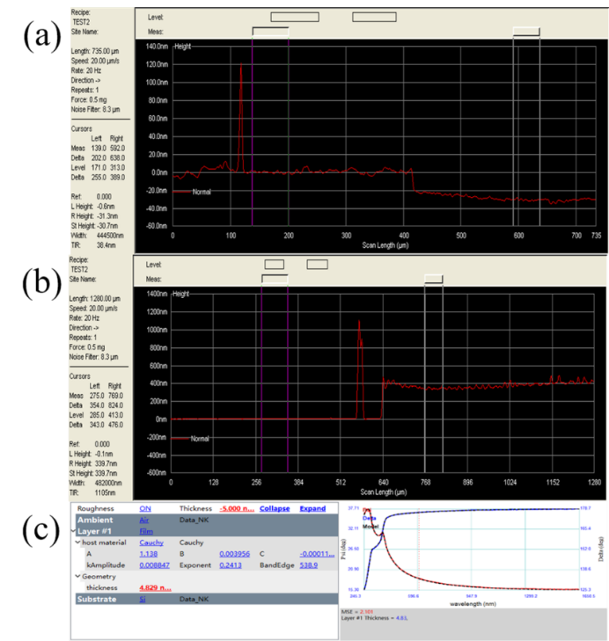
Fig. S1. Thickness of (a) TiO₂, (b) TiO₂/CsPbI₂Br, and (c) PEO layer.
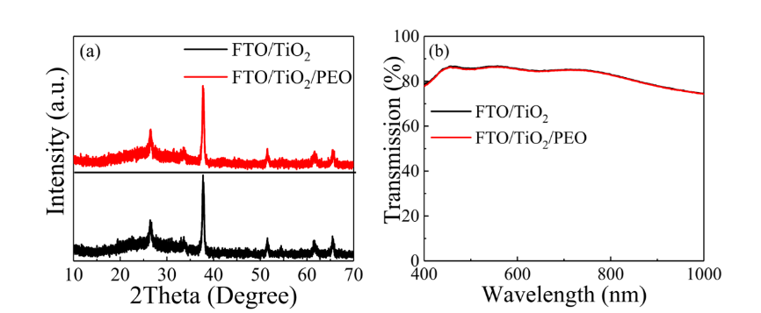
Fig. S2. (a) XRD patterns. (b) Transmittance spectra of TiO₂ and TiO₂/PEO film deposited on FTO substrate (FTO/TiO₂/PEO).
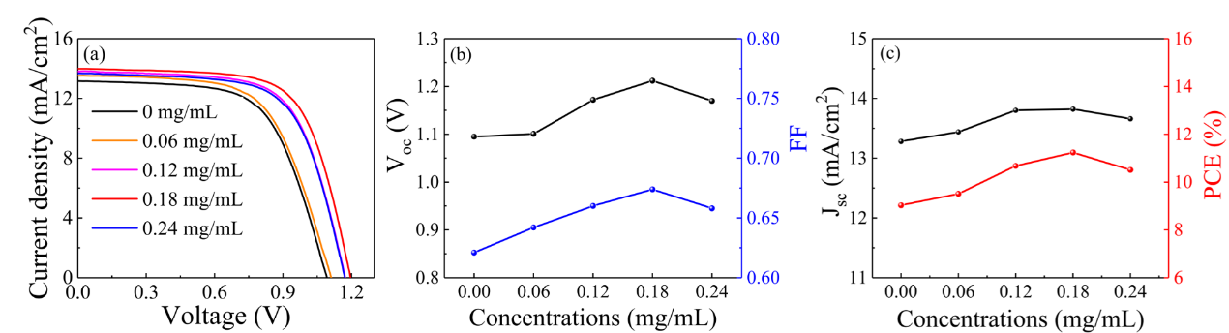
Fig. S3. (a) J–V curves of PEO-PSCs with different PEO concentrations. (b, c) V_{oc}, FF, J_{sc}, and PCE as a function of PEO concentrations.
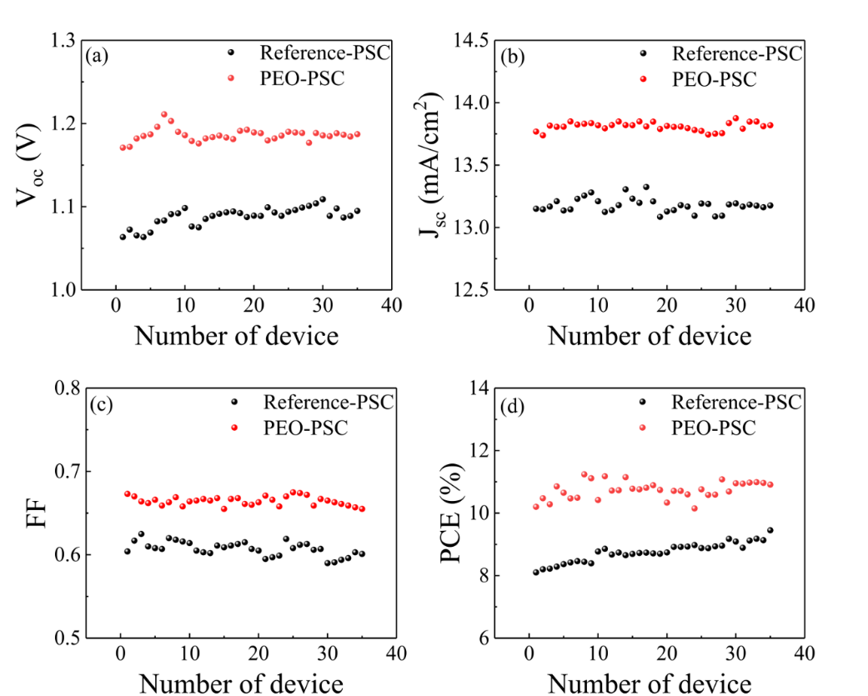
Fig. S4. Photovoltaic parameter distributions of Reference- and PEO-PSCs for 35 samples each batch: (a) V_{oc}, (b) J_{sc}, (c) FF, (d) PCE.
Fig. S5. Hysteresis indexes of Reference- and PEO-PSCs for 35 samples each batch.

References:
[1] C. Dong, X.X. Han, Y. Zhao, J.J. Li, L. Chang, and W.N. Zhao, A green anti-solvent process for high performance carbon-based CsPbI₂Br all-inorganic perovskite solar cell, Sol. RRL, 2(2018), No. 9, art. No. 1800139.
[2] G.Q. Wang, J.Q. Liu, K. Chen, R. Pathak, A. Gurung, and Q.Q. Qiao, High-performance carbon electrode-based CsPbI₂Br inorganic perovskite solar cell based on poly(3-hexylthiophene)-carbon nanotubes composite hole-transporting layer, J. Colloid Interface Sci., 555(2019), p. 180.
[3] W.X. Cai, Y.Q. Lv, K.C. Chen, Z.B. Zhang, Y.Z. Jin, and X.F. Zhou, Carbon-based all-inorganic CsPbI₂Br perovskite solar cells using TiO₂ nanorod arrays: Interface modification and the enhanced photovoltaic performance, Energy Fuels, 34(2020), No. 9, p. 11670.
[4] W.R. Wang, Y. Lin, G.Z. Zhang, et al., Modification of compact TiO₂ layer by TiCl₄–TiCl₃ mixture treatment and construction of high-efficiency carbon-based CsPbI₂Br perovskite solar cells, J. Energy Chem., 63(2021), p. 442.
[5] R. Yin, K.X. Wang, S. Cui, et al., Dual-interface modification with BMIMPF₆ for high-efficiency and stable carbon-based CsPbI₂Br perovskite solar cells, ACS Appl. Energy Mater., 4(2021), No. 9, p. 9294.
[6] G.Z. Zhang, P.F. Xie, Z.S. Huang, et al., Modification of energy level alignment for boosting carbon-based CsPbI₂Br solar cells with 14% certified efficiency, Adv. Funct. Mater., 31(2021), No. 19, art. No. 2011187.
[7] Z.G. Tang, L.J. Zhang, Z.H. Su, et al., A study of interfacial electronic structure at the CuPc/CsPbI₂Br interface, Crystals, 11(2021), No. 5, art. No. 547.
[8] G.Z. Zhang, J.X. Zhang, Y.Y. Liao, Z.X. Pan, H.S. Rao, and X.H. Zhong, Cs₂SnI₆ nanocrystals enhancing hole extraction for efficient carbon-based CsPbI₂Br perovskite solar cells, Chem. Eng. J., 440(2022), art. No. 135710.
[9] Q.Y. Guo, J.L. Duan, J.S. Zhang, et al., Universal dynamic liquid interface for healing perovskite solar cells, Adv. Mater., 34(2022), No. 26, art. No. e2202301.
[10] Y. Jing, X. Liu, Y. Xu, et al., Amorphous antimony sulfide nanoparticles construct multi-contact electron transport layers for efficient carbon-based all-inorganic CsPbI₂Br perovskite solar cells, Chem. Eng. J., 455(2023), art. No. 140871.
[11] Y. Xu, F.L. Liu, R.S. Li, et al., Mxene regulates the stress of perovskite and improves interface contact for high-efficiency carbon-based all-inorganic solar cells, Chem. Eng. J., 461(2023), art. No. 141895.

